……… Academic Year ………………………. Secondary School 1st Term 2nd English Exam
Name & Surname
Class | 7- | Number |  | Date
Grade
A. Match the questions with the answers. (5 x 2 = 10)
1. What is this animal? .......... a) It lives in the wild in Thailand.
2. Where does it live? .......... b) It’s a Prayoon Thonjon.
3. What does it look like? .......... c) It eats meat.
4. What does it eat? .......... d) It’s one metre long.
5. How long is it? .......... e) It has got short legs, hard scales and very sharp teeth.

B. Match the words with their meanings. (5 x 2 = 10)
6. habitat .......... a) to continue to live in a difficult or dangerous situation
7. prey .......... b) very large or very big
8. jungle .......... c) the natural home of a plant or an animal
9. survive .......... d) forest in a tropical part of the world
10. enormous .......... e) a hunted animal for food by another animal

C. Fill in the gaps with the correct question word. (5 x 2 = 10)
A: 11. .................................................. pets have you got?
How much
How old
How often
How many
What

B: Only one. It’s a dog.
A: 12. .................................................. does it look like?
B: It’s very beautiful. It’s brown.
A: 13. .................................................. is it?
B: It’s two years old.
A: 14. .................................................. does it weigh?
B: About 15 kilos.
A: 15. .................................................. does it eat?
B: Three times a day.

D. Classify the animals under each category. (10 x 1 = 10)
piranha - crocodile - eagle - tortoise – shark - giraffe - parrot - cheetah - snake - kangaroo

BIRDS | FISH | MAMMALS | REPTILES

E. Fill in the gaps with at, on or in. (3 x 3 = 9)
16. We go on holiday ........... August. 17. His birthday is ........... 1st March.
18. I usually go to bed ........... 10 o’clock.

F. Write the years. (3 x 3 = 9)
19. 1863 : ................................................................................................
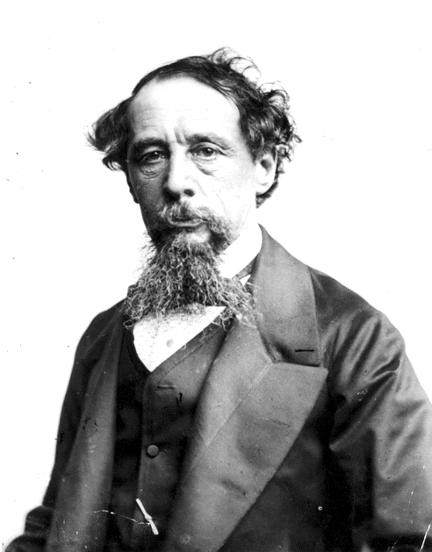
20. 1989 : ................................................................................................
21. 2005 : ................................................................................................

G. Use the following sentences to complete the dialogue. (4 x 3 = 12)
A: 22. ..............................................................................................
B: He was a British writer.
A: Where was he born?
When was he born?
In 1870.
In Portsmouth, England.
Who was Charles Dickens?
B: 23. ..............................................................................................
A: 24. ..............................................................................................
B: In 1812.
A: When did he die?
B: 25. ..............................................................................................

H. Use the following sentences to complete the dialogue. (5 x 3 = 15)
draw
final score
medal
hit
spectators

26. Every athlete’s dream is to win a gold ................................................ at the Olympic Games.
27. Today’s basketball game is very close. The ................................................ is 70 to 78.
28. ................................................ can add a lot to sporting events by creating an exciting atmosphere.
29. In tennis, you ................................................ the ball with a racket.
30. The score was 2-1, but the losing team scored a goal and the game ended in a 2-2 ........................... .

I. Read the descriptions and complete the sentences. (5 x 3 = 15)
forgetful
honest
hardworking
generous
selfish
31. John always thinks about himself. He’s very .....................................
32. Anna always does her homework. She’s .....................................
33. Mike always shares his sandwich with me. He’s very .....................................
34. Hande always tells the truth. She’s very .....................................
35. Murat often forgets things. He’s …………………………


Fill in was, were or did. (5 x 2 = 10)
1. ......................... Einstein an inventor?
2. ......................... you walk to school yesterday?
BAŞARILAR
3. ......................... he play tennis yesterday?
4. ......................... they at the park yesterday?
………………
5. ......................... she call you yesterday?

