Ş.KADİR CİHAN KARAGÖZLÜ MIDDLE SCHOOL FIRST TERM SECOND ENGLISH EXAM GRADE 6
NAME SURNAME CLASS NUMBER:
Uptown/Skyscraper / Downtown / Traffic Jam / Kiosk
A-) WRITE THE WORDS UNDER THE PICTURE (10 p)
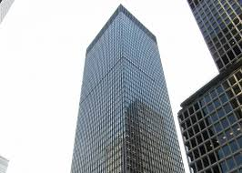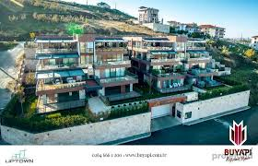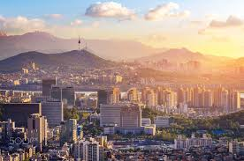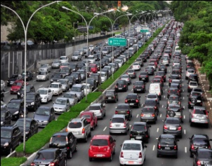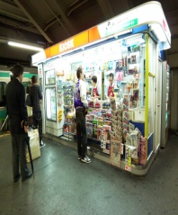
………………………… ………………………………. ……………………………… ……………………………… …………………………
B-) COMPLETE THE SENTENCES WITH COMPARATIVES (18 p )
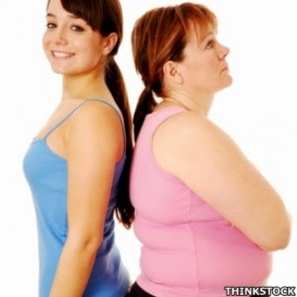
Burcu is …………………………….(slim) than Banu
Banu is …………………………….. ( fat ) than Burcu
Burcu .Banu
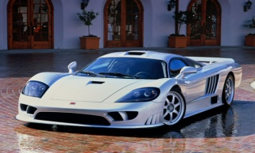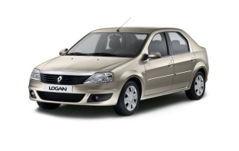 Ferrari is …………………..(expensive)than Renault
Ferrari 1.000.000 TL Renault 100.000 TL Renault is ……………………………….(cheap ) than Ferrari
John’s Maths is ………………..…(bad ) than Tom’s Maths
John’s Maths 55 Tom’s Maths 80 Tom’s Maths is ………..………..(good ) than John’s Maths
HAILING / WINDY /RAINY /SUNNY / CLOUDY /SNOWY /
C-) WRITE THE WEATHER UNDER THE PICTURES (12 P )
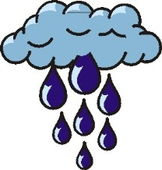

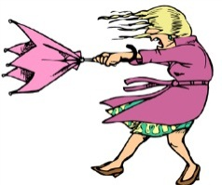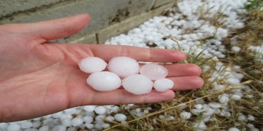
D-) WRITE THE PEOPLE’S NAMES ON THE PICTURE ( 12 P )
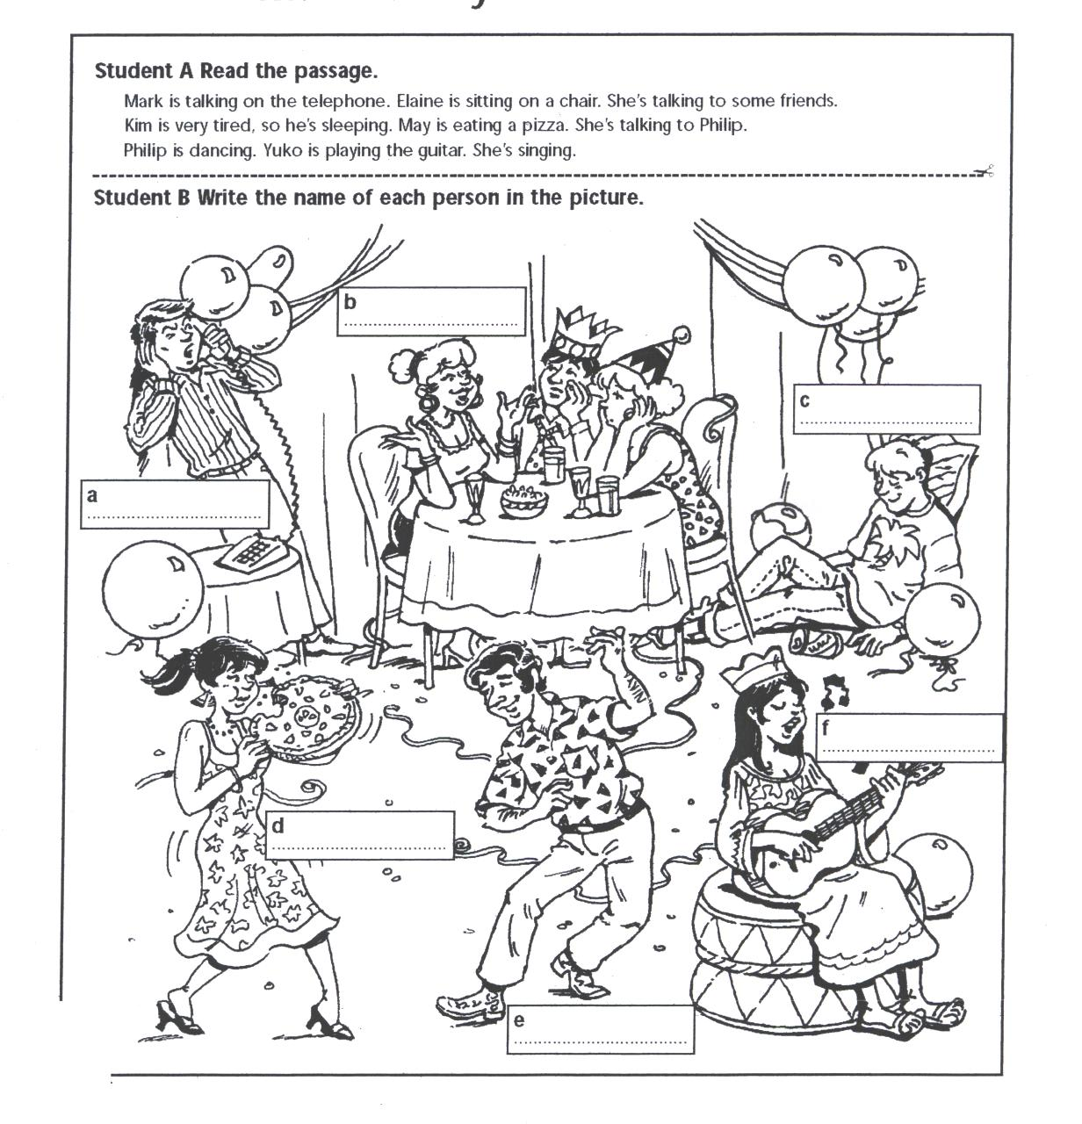
Mark is talking on the phone. Elaine is sitting on a chair. She’s talking to some friends. Kim is very tired, so he’s sleeping. Mary is eating a pizza. Philip is dancing. Carol is playing the guitar.

E-) WRITE EMOTIONS UNDER THE PICTURES ( 12 P )
SCARED ANGRY UPSET SLEEPY HAPPY ANXIOUS
F-) WRITE MONTHS UNDER THE SEASONS ( 24 P )
December - July - August - January - April - October - May - February - November - March - June - September
4)Spring
_____________
_____________
_____________

3)Winter
_____________
_____________
_____________

2)Autumn
_____________
_____________
_____________

1)Summer
_____________
_____________
_____________

G-) MATCH THE PLACES WITH DEFINITIONS (12 P )
- You can see different animals. _______
- You put money here. _______
- You can read books there. _______
- You can buy stamps, send your letter here. _______
- You can have lunch or dinner here. _______
- You can watch movies here. _______
- Bank
- Cinema
- Post Office
- Zoo
- Restaurant
- Library

GOOD LUCK STUDENTS MR.İZGİ ENGLISH TEACHER

