………… Eğitim-Öğretim Yılı Kadışehri İmam-Hatip Ortaokulu 6. Sınıf Birinci Dönem İkinci Yazılı
Name: Surname: Number: Class:
- Answer to the questions according to the pictures. (21 points)
A: What is the weather like in Adana?  B: ……………………………………………………. | 
A: What is the weather like in İzmir?  B: ……………………………………………………. | 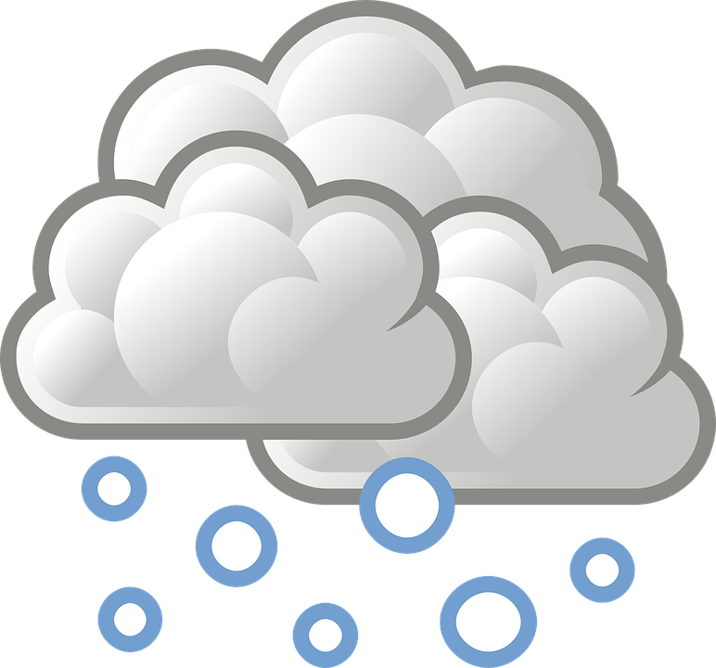
A: What is the weather like in Trabzon?  B: ……………………………………………………. | 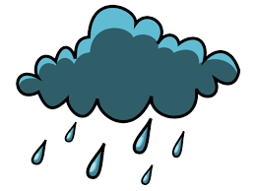
A: What is the weather like in Yozgat?  B: ……………………………………………………. | 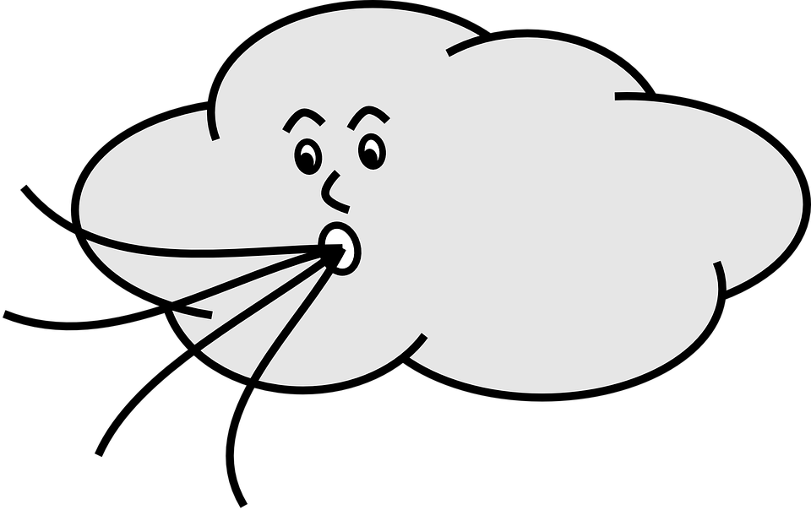
A: What is the weather like in Ankara?  B: ……………………………………………………. | 
A: What is the weather like in İstanbul?  B: ……………………………………………………. | 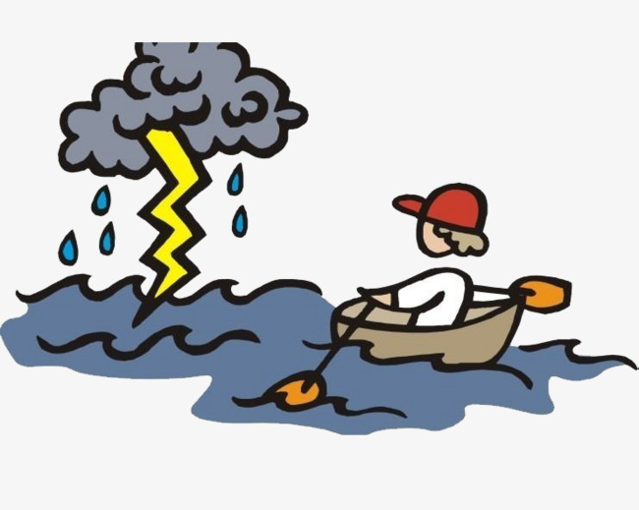
A: What is the weather like in Erzurum?  B: ……………………………………………………. | 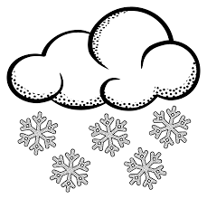

- 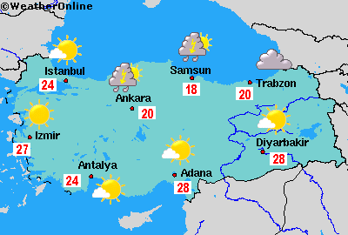Write ‘TRUE’ or ’FALSE’ near the sentence according to the map of Turkey. (14 points)

……….. 1. İstanbul is twenty four degrees Celsius.
……….. 2. İzmir is lightning.
……….. 3. Antalya is hot.
……….. 4. Tranzon is twenty degrees Celsius.

……….. 5. Ankara is foggy.
……….. 6. Diyarbakır is freezing.
……….. 7. Samsun is eighteen degrees Celsius.

- Match the vocabulary items with the pictures. (24 points)
a.Happy – b.Upset – c.Sleepy – d.Tired – e.Angry – f.Energetic – g.Angry – h.Suprised

1……………….….2……………....3………………..4………………5………………..6……………..7………………8………………..
- Write the names of the seasons. (12 points)
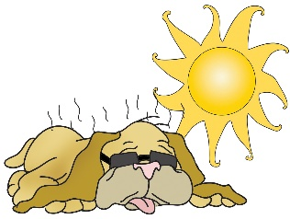
1…………………………… 2…………………………… 3……………………………………… 4…………………………………….
- Put a tick or a cross acording to the sentences. (16 points)
 |  |  | 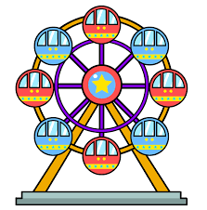 | 
Ferid
Mustafa
Selim
Oğuzhan

- Ferid thinks bumper cars are fantastic.
- Mustafa thinks ferris wheel is dull.
- Selim thinks carousel is fun.
- Oğuzhan thinks roller coaster is terrifying.
- Ferid doesn’t like carousel.
- Mustafa thinks roller coaster is fun.
- Selim hates bumper cars.
- Oğuzhan thinks ferris wheel is exciting.

- Answer to the question. (13 points)

- How do you feel on sunny days?
- How do you feel on rainy days?
Good Luck!
Halil İbrahim Güran
Teacher of English
- How do you feel on snowy days?
- How do you feel on cloudy days?

