………………… EDUCATION YEAR ……………………………..SCHOOL
  A |   B |   C |   D |   E
1 | 2 |   3 |   4 | 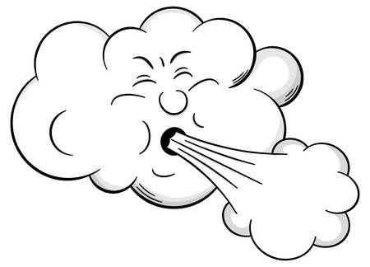  5
1ST TERM 2ND WRITTEN EXAM FOR 6th GRADES
A-Match emotions with the weather( Duygu ifadelerini hava durumları ile eşleştiriniz)(5*3:15pts)
1- Ayşe feels anxious in foggy weather
2- I feel happy on snowy days
3- My mother feels moody in stormy weather
4- I don’t like windy weathers because I feel depressed
5- On cloudy days, I feel sleepy MATCH HERE

B- Fill in the blanks with the comparative form of the adjectives. (Boşlukları sıfatların karşılaştırma halleriyle doldurunuz) (5*3:15pts)

1- Bungee jumping is ……………………………….(exciting) than playing tennis
2-İstanbul is …………………………..(crowded) than Ağrı
3-An uptown is…………………………………(green) than a city
4- My English grade ......................(good) than my math grade. I don’t like Math
5- Bmw is...........................(expensive) than Renault

A- 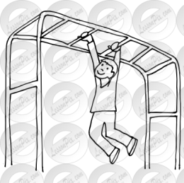 | B- |   C- | 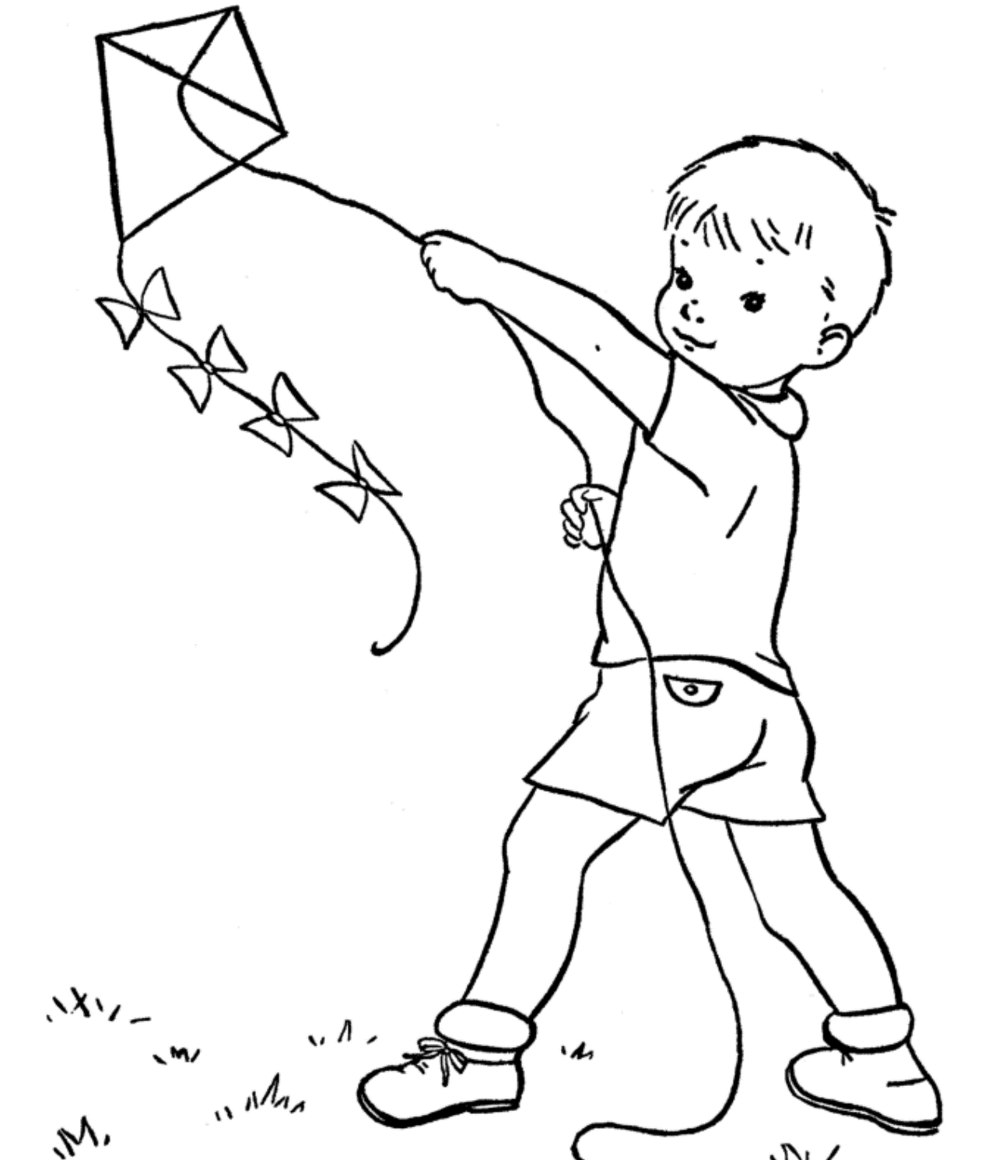  D- | E-
C- Match the sentences with correct picture( Cümleleri doğru resimler ile eşleştiriniz)(5*3:15pts)

1- She is skipping rope at the moment ……………
2- They are flying a kite now ……….....
3- Andy is playing on monkey bars …………..
4- My sister is playing badminton ……………
5- He is waiting in a line for ticket …………….

D-Match questions with their answers( Soruları cevapları ile eşleştiriniz)(5*3:15pts)
1- What is the weather like in Erzurum ? | 1- | a-Because it is cheaper
2- Who is studying English now? | 2- | b- Snowy and freezing
3- How do you feel in sunny weather? | 3- | c- Olives and some cheese
4- What do you like for breakfast? | 4- | d- Excited
5- Why do you rent this house? | 5- | e- Nurettin

I’m Nicole. I live in uptown. The buildings are smaller in here. You can walk everywhere in my hometown, you don’t need a car. The people have a lot of free time to do some activities like fishing, hiking…etc. In spring the weather is rainy and cold and also sometimes it is stormy. In winter it is snowy and cold, I don’t like this season because I feel depressed in cold weathers but in summer you can see the sun and enjoy hot weather

E-Read the text and circle True or False ( Paragrafı okuyunuz ve doğru ise ‘T’ yada yanlış ise ‘F’ şıkkını seçiniz ) (5*3:15pts)

1- You can see skyscrapers at Nicole’s hometown T / F
2-She feels scared in cold weathers T / F
3-The weather is bad in spring and winter T / F
4-The people are busy in the uptown T / F
5-There isn’t traffic jam in her hometown T / F

F-Circle the correct options (Anlama gore doğru şıkkı yuvarlak içine alınız ) (5*3:15pts)

My family and I go on holiday in summer because we don’t like(1) ……………weather also I feel anxious and (2)……….in winter. We prefer quiet places in small town, we dislike(3)…………..places like big hotels. In holiday I go (4)……. and sit on the beach. I eat healthy and (5)……...foods. I think health is more important than delicious foods. This is our family’s typical holiday.

1- hot – windy - cold
2- excited – moody - happy
3- crowded – small - high
4- hiking – taking a nap - swimming
5- hot – nutritious- traditional

G-Match the words with the correct pictures( Kelimeleri doğru resim ile eşleştiriniz)(5*2:10pts)

1- Quiet 2- Kiosk 3- Muffin 4- Lightning 5- Freezing

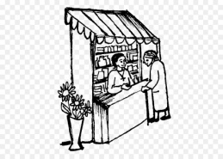 |  | 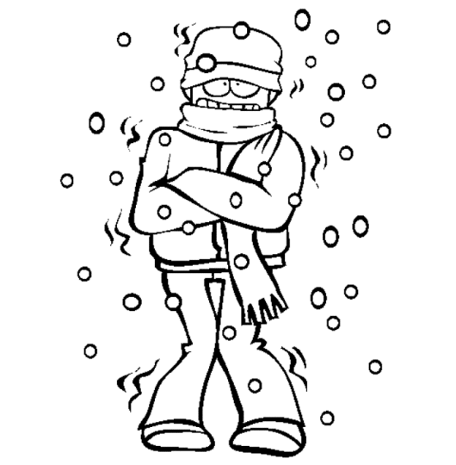 |  |  |  |  |  | 

GOOD LUCK By SRKNGNS

