... SECONDARY SCHOOL
1st TERM 2rd ENGLISH EXAM FOR 6th GRADE

NAME : NUMBER :

- HAVA KOŞULLARININ İNGİLİZCE'LERİNİ YAZIN.(10)
sunny - cold - windy - foggy - hailing - hot - snowy - lightning - cloudy - stormy
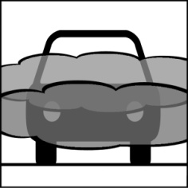
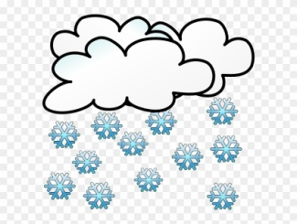




… cloudy……… … sunny... … snowy…. … windy… … foggy….
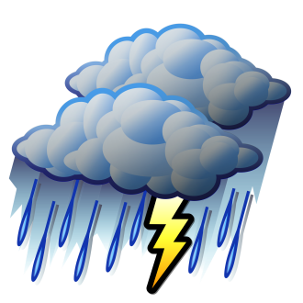


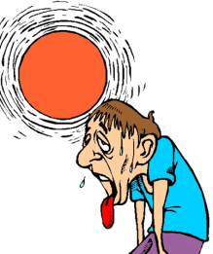
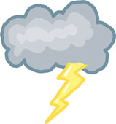

… hailing… … lightning... …… hot………. …… cold…… … stormy…

- RESİMLERİ VERİLEN DUYGULARI İNGİLİZCE KARŞILIKLARIYLA EŞLEŞTİRİNİZ.(10)

1. Energetic 2. Scared 3. Happy 4. Angry 5. Tired
6. Moody 7. Sleepy 8. Sad/Upset 9. Bored 10. Anxious









4 8 1 10 5




9 7 6 2 3

- DOĞRU ŞIKKI İŞARETLEYİNİZ(20)

- Talha: ……………………………………………………?

Yusuf: It is cold and rainy.

a) What time is it?
b) What’s the weather like in Erzurum?
c) Where are you from?
d) How often do you go to cinema?

- Enes : ..........................?
Kerim : It is 18 degrees celcius.

a) How is the weather? b) How do you feel?
c) What is the weather? d) What’s the temperature?

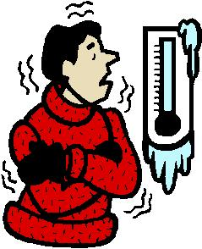
- What’s the weather like?

a) It is hot and sunny.
b) It is stormy.
c) It is freezing.
d) It is rainy and wet.

……………………… on stormy days.

a) I feel happy b) I feel sleepy
c) I feel scared d) I feel energetic

- A rabbit is ………………… than a turtle.
a) faster b) fast
c) more fast d) fasting

- The city is ................. than the country.

a) crowded b) crowding
c) more crowded d) crowder

- Kelime grubunda anlamca dışarıda kalanı işaretleyin.

a) autumn b) summer
c) december d) spring


- I feel ……………. , because it’s ……………… today.

a) moody/foggy b)happy/sunny
c) scared/windy d)upset/snowy

- Which is a winter month?
a) january b) march c) september d) june

- Resimdeki yiyeceğin adı nedir?
a) sausages b) bagels
c) pancake d) muffin

- SORULARLA CEVAPLARINI EŞLEŞTİRİN. (10)
1. What is the weather like in Geyve today? ( m ) a. Roller coaster
2. What is the temperature? ( e ) b. She is cooking dinner.
3. How do you feel on stormy days? ( h ) c. Ted
4. What do you need in Geyve in Winter? ( f ) d. I think, they are exciting.
5. Do you like carousel? ( g ) e. It’s 16 C.
6. What is your favourite ride in a fair? ( a ) f. A coat, a hat and gloves.
7. What do you think about bumper cars? ( d ) g. No,I don’t.
8. What is your mother doing now? ( b ) h. I feel anxious.
9. Who is washing the car? ( c ) k. I'm doing my homework.
10. What are you doing at the moment? ( k ) m. It is cold and rainy.

- DİYALOGLARI VERİLEN İFADELERLE TAMAMLAYIN. (10)

I'm full - I'm hungry - Tea, cheese and egg - I'm thirsty - It's all gone

1. A: _ I'm hungry __________ 2. A: Would you like to eat a sandwich?
B: Let's go to a cafe and eat pizza. B: No, thank you. _ I'm full__
A: Ok! Let's go.

3. A: __ I'm thirsty_______ 4. A:Can I have some eggs, please?
B: What would you like to drink? B: I'm sorry, __ It's all gone________
A: A glass of water, please

5. A: What do you have for breakfast?
B: ___ Tea, cheese and egg________________

------------------------------------------------------------------------------------------

- CÜMLELERİ ŞİMDİKİ ZAMANA GÖRE TAMAMLAYIN. (am/is/are kullanmayı unutmayın) (5)
1. I am _playing football___________ _______ in the garden now. ( play football )
2.My brother __is sleeping__________________at the moment. ( sleep )
3.We __are having a barbeque______________ now. ( have a barbeque )
4. I _am watcing___________________ TV now. ( watch )
5. Nazlı __is drinking_______________ at a cafe with her friends now ( drink tea)

- ARAÇLARIN İNGİLİZCELERİNİ YAZIN (10)
ghost train - bumper car - roller coaster - carrousel - big wheel

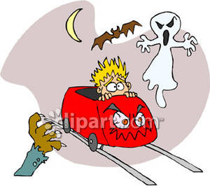
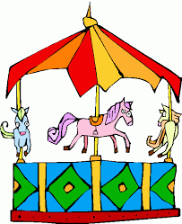
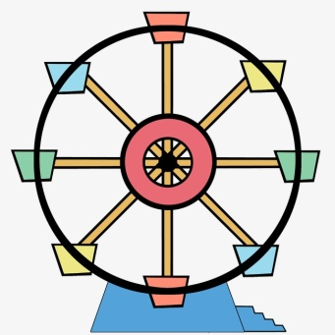
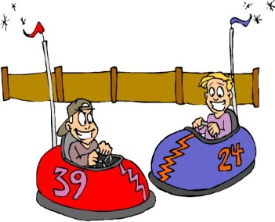

1-- bumper car---- 3-- carrousel------ 5 -- ghost train------
2---- big wheel------ 4 --- roller coaster-------

- DOĞRU İFADEYİ YUVARLAK İÇİNE ALIN (10)

1. Donald: I think / I don’t think roller coasters are terrifying.
Michelle: Yes, you are right. I hate roller coasters.

2. Donald: I love ghost trains.
Michelle: I disagree / I agree they are boring.

3. Donald: There are many funny / boring things at the fair.
Michelle: I agree. Bumper cars and ferris wheel are crazy.

4. Donald: What do you think about carrousels?
Michelle: I think they are dull / fantastic. I like them.

5. Donald: I think fairs are exciting / boring places.
Michelle: I agree / I disagree. I think they are thrilling.
- SIFATLARIN “COMPARATIVE ( DAHA ... )” HALLERİNİ YANLARINA YAZIN.(8)

1. crowded : more crowded 4. high : higher 7. nutritious : more nutritious
2. cold : colder 5.: big bigger 8. good : better
3. Happy : happier 6. beautiful: more beautiful

- TABLOYA GÖRE CÜMLELERİN SONUNA DOĞRUYSA “TRUE” YANLIŞSA “FALSE” YAZIN (7P)
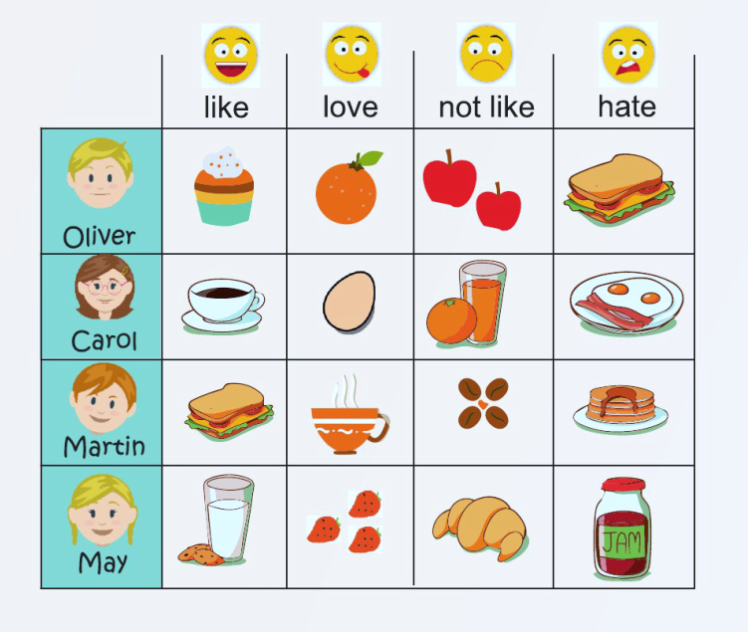

- Carol likes coffee. __T________.
- Carol hates boiled eggs.__F________
- May likes croissants. ___F_______
- Oliver likes cupcakes. __T________
- Carol doesn’t like orange juice , but
she likes coffee. __T________.
- Oliver likes milk. _F_________.
- May loves jam. __F________.

