…………….. ACADEMIC YEAR BARDAS SECONDARY SCHOOL 1st Term 2ND EXAM FOR 6TH GRADERS
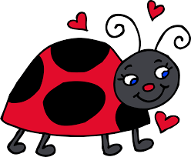
NAME:
A)Write the correct words under the pictures.(1*5=5 p)
Carousel - bumper car - ghost train - ferris Wheel - roller coaster
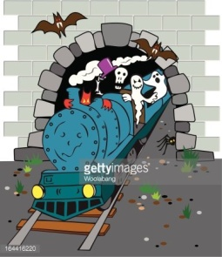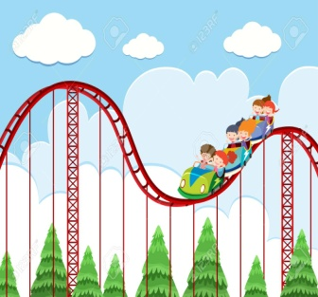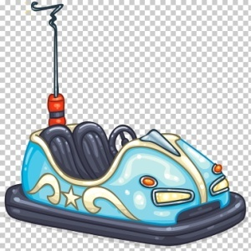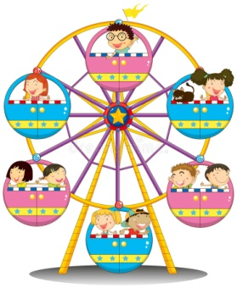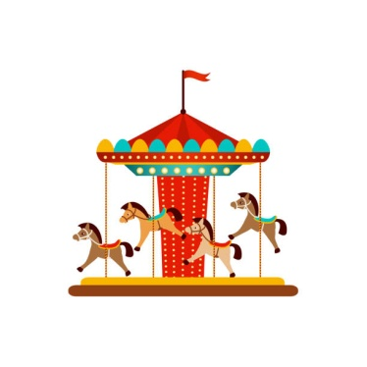
__ ghost train____ ___ roller coaster_____ __bumper car____ __ ferris Wheel____ __ carousel___
B)Circle the correct options.(3*4=12 p)
4.A:What do you think about carousel and ferris Wheel?
B:I think ferris Wheel is better / gooder than carousel.
3.A:Fairs are fabulous.I like them.
B:I agree / disagree.I hate fairs.They are very crowded and noisy.
1.A:I think carousel is boring.
B:I agree / disagree.They are dull. I don’t like them.
2.A:What do you think about roller coaster?
B:I think they are boring/fantastic.I love them.

C)Answer the questions.(3*6=18 p)
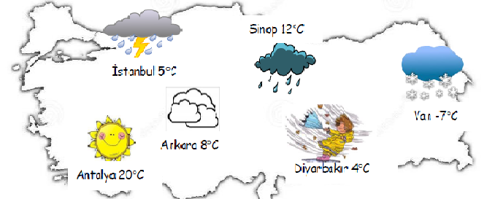

1.What is the weather like in Sinop?
_It’s rainy.___________________________
2.What is the temperature in İstanbul?
_It’s 5 C.___________________________
3.What is the weather like in Ankara?
_It’s cloudy.___________________________
4.What is the temperature in Van?
__It’s -7 C.___________________________
5.What is the weather like in Antalya?
__It’s sunny.___________________________
6.What is the temperature in Diyarbakır?
__It’s 4 C.___________________________




D)Match the feelings with the sentences.(2*5=10 p)
I feel sleepy on cloudy days. (_C_)
I feel scared on stormy days. (_D_)


I feel happy on sunny days. (_A_) A B C
I feel moody on foggy days. (_B_)
I feel energetic on snowy days. (_E_)

D E

E)Complete the sentences with the comparatives.(4*6=24 p)
1.İstanbul is ___more crowded_______________ (crowded) than Ankara.
2.Sidney is ____hotter__________________ (hot) than Moscow.
3.English is___easier___________________(easy) than French.
4.My grades are ___better_______________(good) than Beyza’s marks.
5.Cheese is __more nutritious____________ (nutritious) than chips.
6.Samsung is ___cheaper_______________________(cheap) than IphonE.
F)Write the names of the children under the pictures.(3*4=12 p)
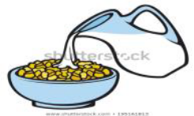
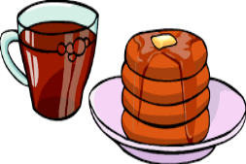
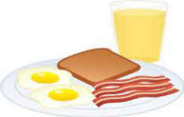
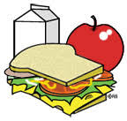

(__Emel_____) (__Anıl____) (__Onur____) (__Yeşim___)

Hi! My name is Onur. I like eating eggs, sausages and toast at breakfast. My favourite drink is orange juice.

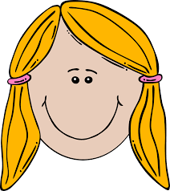
Hello! I’m Yeşim. My favourite food is pancake at breakfast and I like tea.


Hello! My name is Anıl. I love eating cereal with milk at breakfast.


Hi! I’m Emel. I eat an apple and toast at breakfast. I like milk.

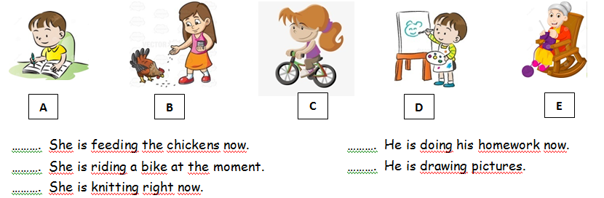
G)Match the sentences with the pictures.(3*5=15 p)

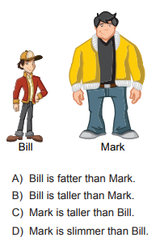
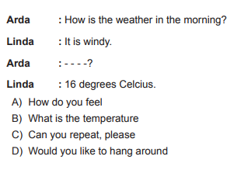
H)Choose the best option.(1*4=4 p)

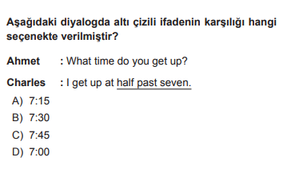
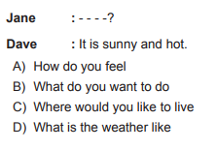



ZEHRA SAADET KURŞUN

