………………… EDUCATIONAL YEAR FSM SECONDARY SCHOOL THE 1ST TERM THE 2ND EXAM FOR 6 GRADES

NAME/SURNAME: NUMBER/ CLASS:

- Write the correct numbers under the pictures.. (8x2=16 Pts)
1.Freezing 2.stormy 3.sunny 4.foggy 5.windy 6.cloudy 7.snowy 8.rainy


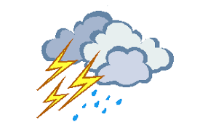




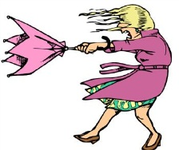

6 3 2
8 1 5 7 4
B) Write the seasons.(4*2=8P)

SUMMER WINTER SPRING AUTUMN
4) SPRING
March
April
May
3)WINTER
December
January
February
2) AUTUMN
September
October
November
1)SUMMER
June
July
August

C) Write the emotions under the pictures. (6*2=12P)
HOW DO YOU FEEL?
A. SCARED B. SLEEPY C. SAD D. ANXIOUS E. HAPPY F. MOODY

 |  |  |  |  | 
ANXIOUS | SLEEPY | HAPPY | SCARED | SAD | MOODY

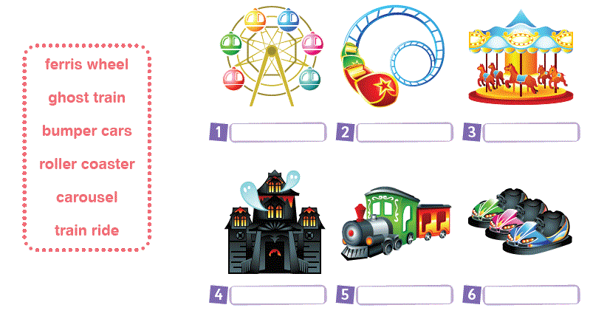
D)Match the pictures with the words. (6x2=12 pts)

E) Put a tick or a cross acording to the sentences. (8*2=16 points)
 | 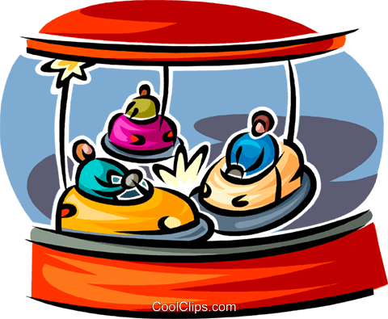 |  | 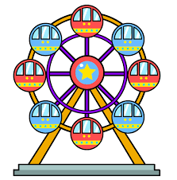 | 
Ferid | 1 | 5
Mustafa |  |  | 2 | 6
Selim |  | 3
Oğuzhan |  |  |  | 4

- Ferid thinks bumper cars are fantastic.
- Mustafa thinks ferris wheel is dull.
- Selim thinks carousel is fun.
- Oğuzhan thinks roller coaster is terrifying.
- Ferid doesn’t like carousel.
- Mustafa thinks roller coaster is fun.
- Selim hates bumper cars.
- Oğuzhan thinks ferris wheel is exciting.

F)Write “TRUE” or “FALSE” (8*2=16 P)
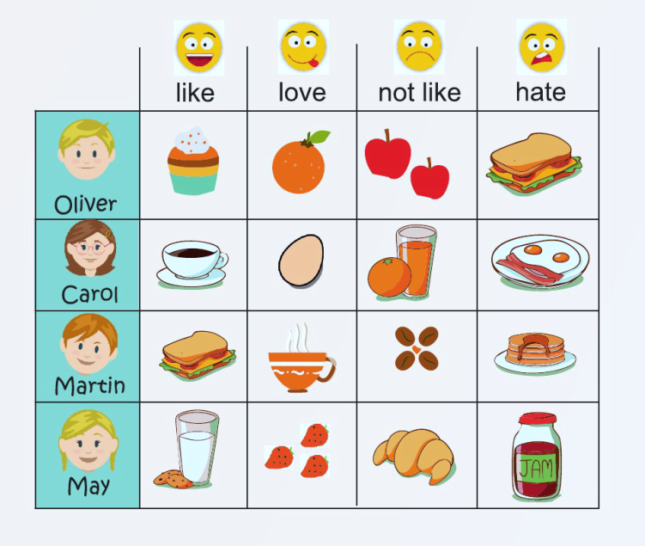

- Carol likes coffee. __T________.
- Carol hates boiled eggs.__T________
- May likes croissants. ___F_______
- Oliver likes cupcakes. __T________
- Martin doesn’t like omelette , but
he likes olives . ___F_______.
- Oliver likes milk. __F________.
- May loves jam. ___F_______.

- Martin likes toast and coffee.__T______.

G) Match the sentences. (10*2=20 pts)
1. What is the weather like in Kastamonu today? ( f ) a. Roller coaster
2. What is the temperature? ( e ) b. She is cooking dinner.
3. How do you feel on stormy days? ( h ) c. On the second of January
4. What are you doing now? ( k ) d. I think, they are exciting.
5. Do you like carousel? ( g ) e. It’s 16 C.
6. What is your favourite ride in a fair? ( a ) f. It is cold and rainy.
7. What do you think about bumper cars? ( d ) g. No,I don’t.
8. What is your mother doing now? ( b ) h. I feel anxious.
9. Who is washing the car? ( l ) k. I'm doing my homework.
10. When is your exam? ( c ) l. My brother, Ayhan

GOOD LUCK
Nihan ALTAN - ELT

