…………… EDUCATION YEAR HURSUNLU SECONDARY SCHOOL 1ST TERM
2ND ENGLISH EXAM FOR 5TH GRADE

NAME SURNAME: NUMBER:

- Resimlerle dersleri eşleştiriniz. (7x3=21p)

Turkish Music Maths Computer English Art Science






______________ ______________ ______________ ______________
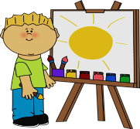

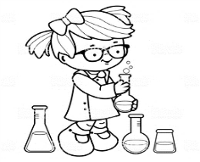
_____________ ______________ ______________

B)Cümlelerle resimleri eşleştiriniz.(5x4=20)
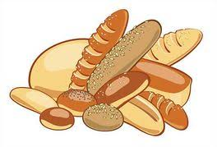
............... ............... ............... ............... ...............
- I’m at the hospital.
- I’m at the bakery.
- I’m at the cinema
- I’m at the school.
- I’m at the library.

C)Saatlerle cümleleri eşleştiriniz. (7x3=21p)
_____ | - 10:00 | - It is ten past five
_____ | - 05:10 | - It is nine o’clock.
_____ | - 13:30 | - It is half past one.
_____ | - 9:00 | - It is quarter past eleven.
_____ | - 11:15 | - It is twenty-five past two.
_____ | - 02:25 | - It is quarter past four.
_____ | - 04:15 | - It is ten o’clock.

D)Boşlukları tabloya göre “can” ya da “can’t” ile doldurunuz. (7x3=21p)
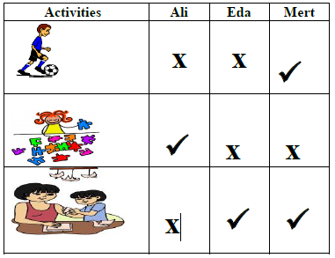
1) Ali …………………………..... do origami.
2) Eda ………………………..…. play soccer.
3) Mert …………………….…….. do origami..
4) Eda and Mert ……………….………. do puzzles.
5) Ali and Eda…………………………….. play soccer.
6) Mert …………………………….….. play soccer.
7) Eda …………………….…………. do origami.

- Resimlerle oyun isimlerini eşleştiriniz. (6x3=18p)

Camping Swimming Ride a bike

Take photos Play football Play chess


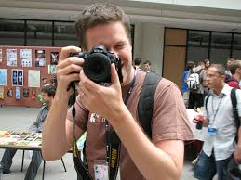



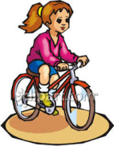
__________________ __________________ __________________
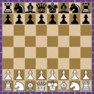

__________________ __________________ __________________

GOOD LUCK
NESİBE NESLİHAN ONARAN

