…………… EDUCATION YEAR HURSUNLU SECONDARY SCHOOL 1ST TERM
2ND ENGLISH EXAM FOR 5TH GRADE

NAME SURNAME: NUMBER:

- Resimlerle dersleri eşleştiriniz. (7x3=21p)

Turkish Music Maths Computer English Art Science






__ Turkish ______ __ Music ______ _ English_______ _Computer______
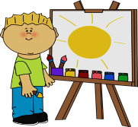

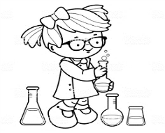
___ Maths _______ ___ Science ____ ____ Art_____

B)Cümlelerle resimleri eşleştiriniz.(5x4=20)
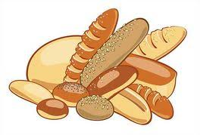
.....c.......... ......b......... .......a........ .....e.......... ......d.........
- I’m at the hospital.
- I’m at the bakery.
- I’m at the cinema
- I’m at the school.
- I’m at the library.

C)Saatlerle cümleleri eşleştiriniz. (7x3=21p)
__g___ | - 10:00 | - It is ten past five
__a___ | - 05:10 | - It is nine o’clock.
__c___ | - 13:30 | - It is half past one.
__b___ | - 9:00 | - It is quarter past eleven.
__d___ | - 11:15 | - It is twenty-five past two.
__e___ | - 02:25 | - It is quarter past four.
__f___ | - 04:15 | - It is ten o’clock.

D)Boşlukları tabloya göre “can” ya da “can’t” ile doldurunuz. (7x3=21p)
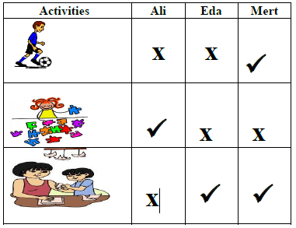
1) Ali ……can’t……………………..... do origami.
2) Eda …can’t…………………..…. play soccer.
3) Mert …can………………….…….. do origami..
4) Eda and Mert …can’t………….………. do puzzles.
5) Ali and Eda……can’t……………….. play soccer.
6) Mert ……can……………………….….. play soccer.
7) Eda ……can……………….…………. do origami.

- Resimlerle oyun isimlerini eşleştiriniz. (6x3=18p)

Camping Swimming Ride a bike

Take photos Play football Play chess


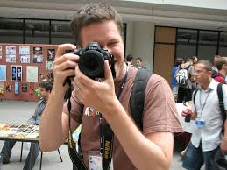


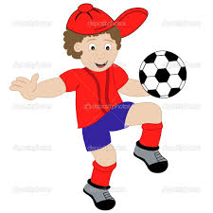
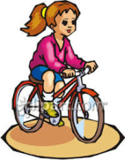
___ Swimming ______ ___ Take photos____ __ Camping ________
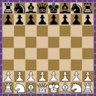

__Ride a bike___ __ Play football _____ __ Play chess ________

GOOD LUCK
NESİBE NESLİHAN ONARAN

