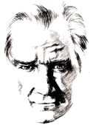 |  | ………………….. EDUCATIONAL YEAR FSM SCHOOL  5TH GRADERS’ 1ST TERM 2ND WRITTEN EXAM. | 
Name/Surname: Class/No:
A) Read the speech bubble and complete the map. (4x3= 12 Points)

Hi, I’m Mehmet. Here’s a map of my neighbourhood. I live in a big house. There is a hospital behind my house. There is a grocery, a school and a pharmacy opposite my house. The school is between the pharmacy and the grocery. There is a cafè in the park.
 | 1)………hospital………
Police Station | Mehmet’s House | Playground | Cinema
2)…pharmacy.. | 3)……school……… | Grocery
Park

4)………cafe………………

B) Match. (6x2= 12 Points)

- keepy uppy
- hide and seek
- hopscotch
- yoyo
- dodgeball
- origami

 |  | 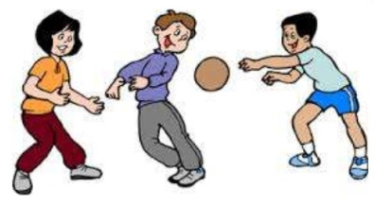 | 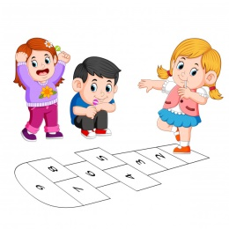 |  | 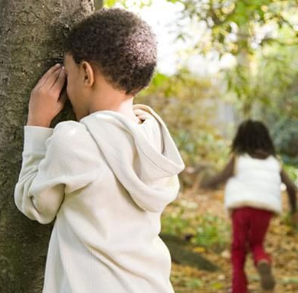
yoyo | origami | dodgeball | hopscotch | keepy uppy | hide and seek

C) Read the texts below. Draw or .(4x2= 8 Points)

Ali lives in Kastamonu and his hobby is playing basketball with his friends. He also likes playing soccer, but he doesn’t like collecting stamps . At home, he doesn’t play computer games.
 |  |  | 

D) What time is it? (5x3=15 Points)
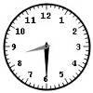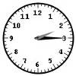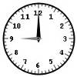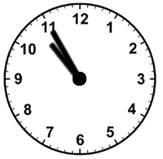
It’s half past eight It’s twenty past two It’s quarter past two It’s nine o’clock It’s five to eleven

E) Match the words.(5x3= 15 Points)

- get dressed
- brush teeth
- go to school
- get up
- play soccer

 |  |  |  | 
d c b e a
- Match the words with the pictures. (7*2=14 points)

a- Water b- hospital c- Plaster d- Bed e- Medicine f- doctor g- Lemon and mint tea
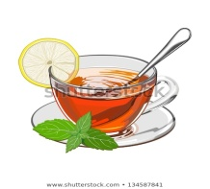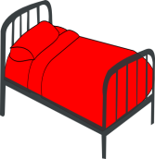
h c a g d e f

- Write the names of the people under their pictures. (6*2=12 points)

- My name is Merve. I have a stomachache.
- My name is Murat. I have a sore throat.
- My name is Ayşe. I have a fever.
- My name is Osman. I have a broken arm.
- My name is Elif. I have a headache.
- My name is Ahmet. I have the flu.


(4) (3) (6) (5) (2) (1)

- Answer the questions (4*3=12 points)
- What is your hobby / favourite game? …My favorite game is yoyo…………………
- Do you have breakfast at home? …Yes, I do…………………………………………
- What is your favourite class? …My favorite class is math…………………………………………..

- Where are you from? …I am from Mersin………………………………………………….
Nihan ALTAN
Teacher of English

