………………….. Eğitim-Öğretim Yılı Kadışehri İmam-Hatip Ortaokulu 5. Sınıf Birinci Dönem İkinci Yazılı
Name: Surname: Number: Class:
- Match the words with the pictures.
a. Get dressed b. Wash face c. Get up d. Go to bed e. Have breakfast f. Brush teeth
g. Watch tv h. Comb hair i. Go to school j. Read a book
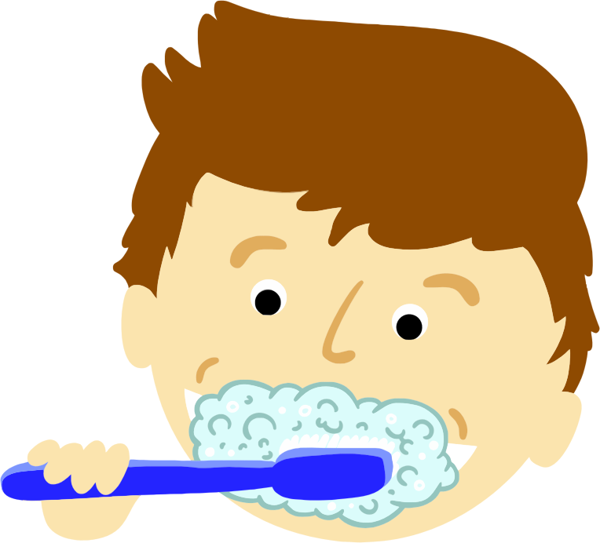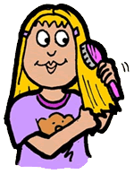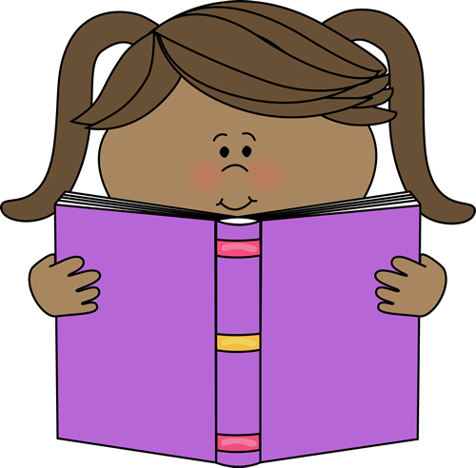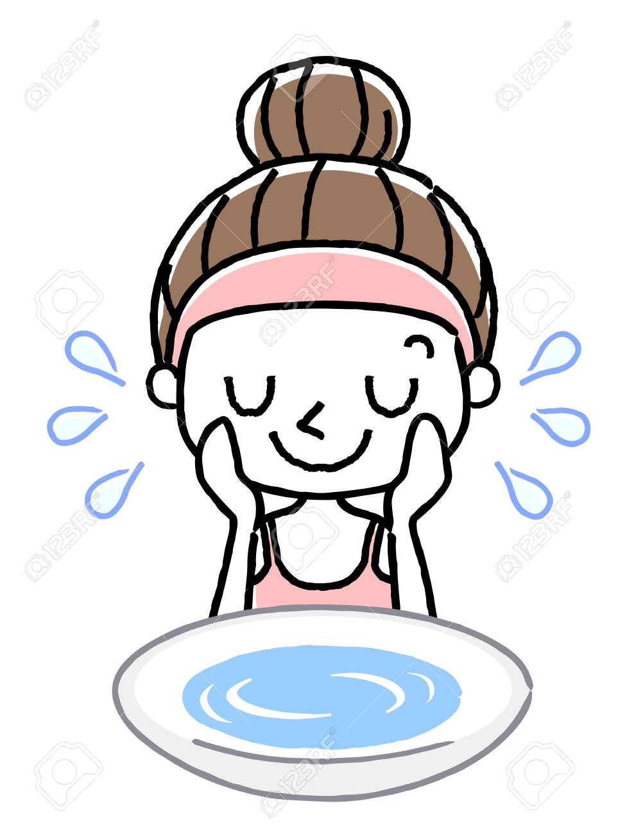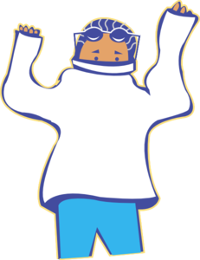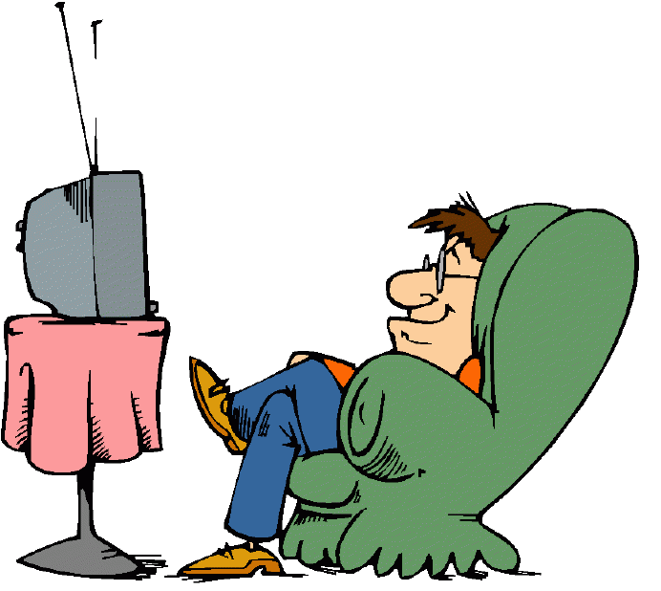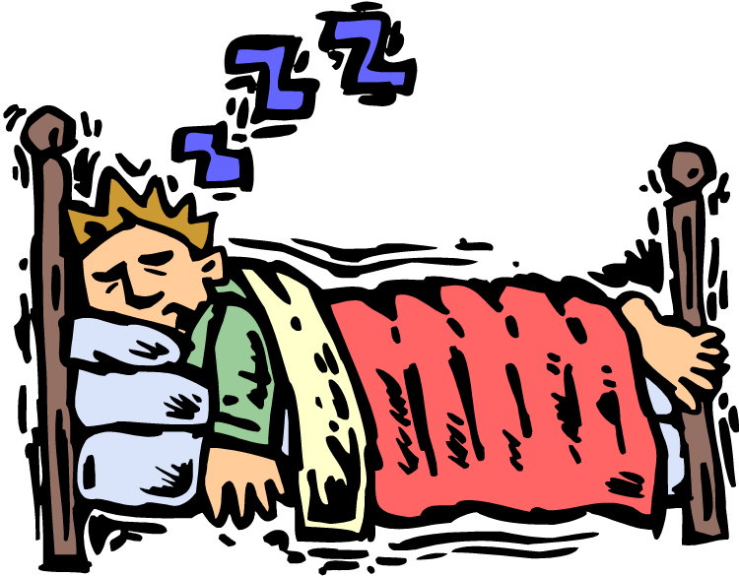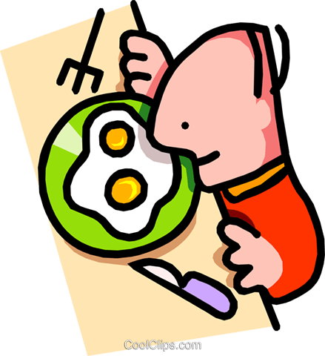
1……………….2……………3………………….4………………5……………..6…………………….7………………………..8…………………

- Look at the digital clocks and write the time.
09.00 |  | 01.00  03.45
07.15
11.00  10.30 |  | 02.30
06.45 |  | 08.15
 |  | 04.00

- 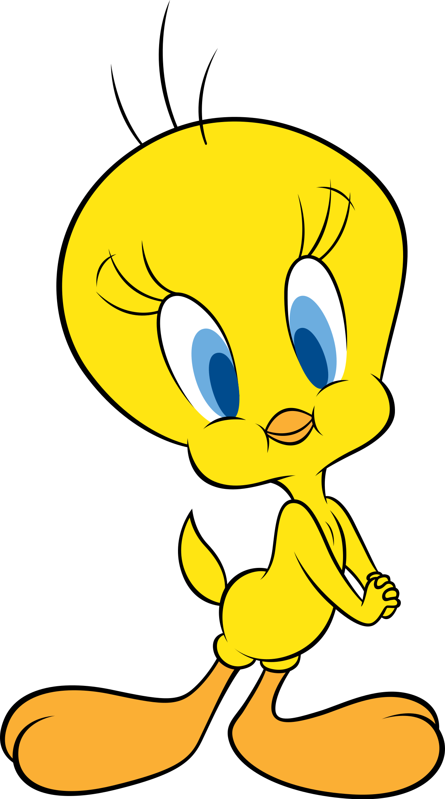Answer to the questions according to the text below.
Hello. My name is Tweety. I am a bird and I can fly. I will talk about my daily routine. I get up at half past seven. I wash my face and hands. I have breakfast at eight o’clock. I get dressed and I go to school at quarter past eight. I have lunch at twelve o’clock. I come back home at quarter to four. I play computer games after school. I do my homework at quarter past six. I have dinner at seven o‘clock. I drink tea after dinner. I listen to music at quarter past nine. Then I go to bed at half past nine.

- What time does Tweety have breakfast?

- What times does Tweety go to school?

- What time does Tweety come back home?

- What time does Tweety do homework?

- What time does Tweety go to bed?

- Match the words with the pictures.
a- Medicine b- Soup c- Lemon and mint tea d- Plaster e- Cola
f- Hospital g- School h- Bed i- Water k- Doctor
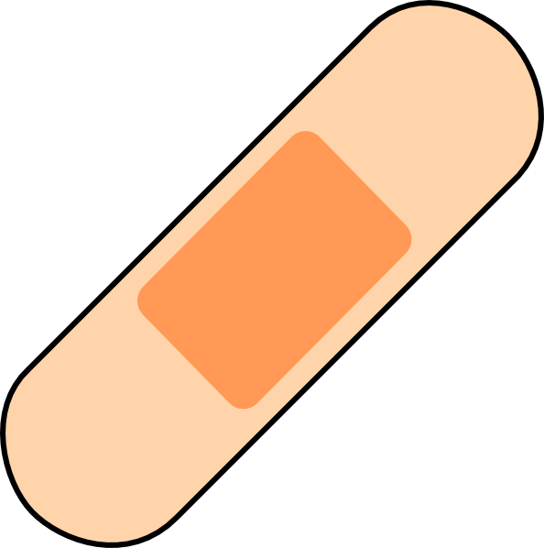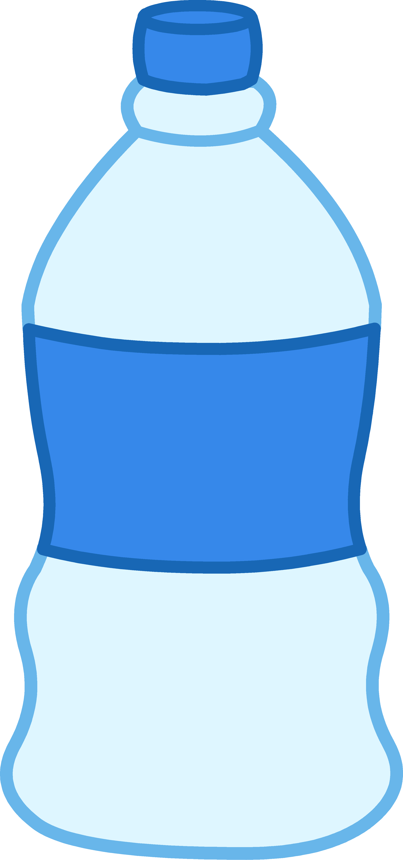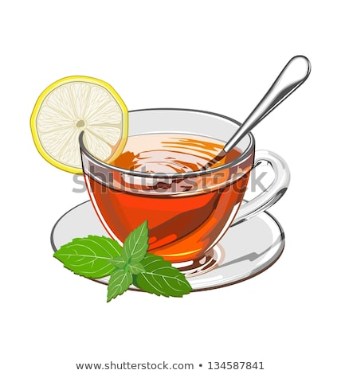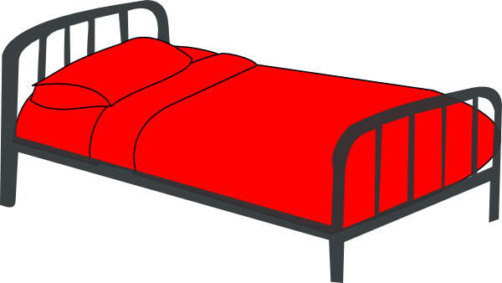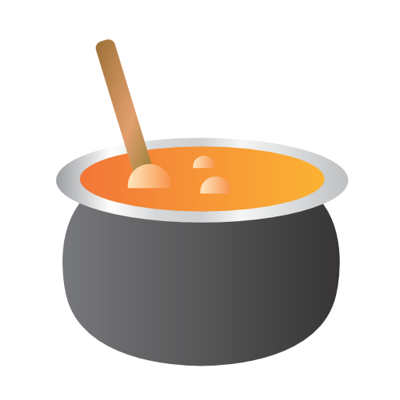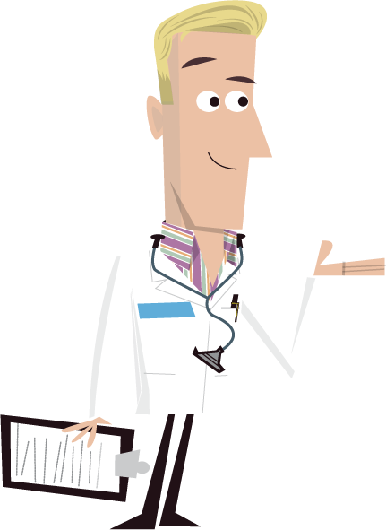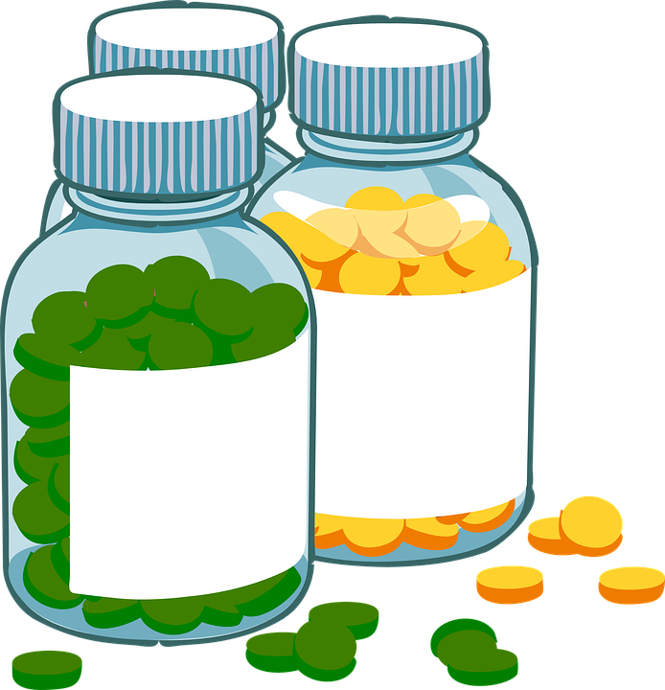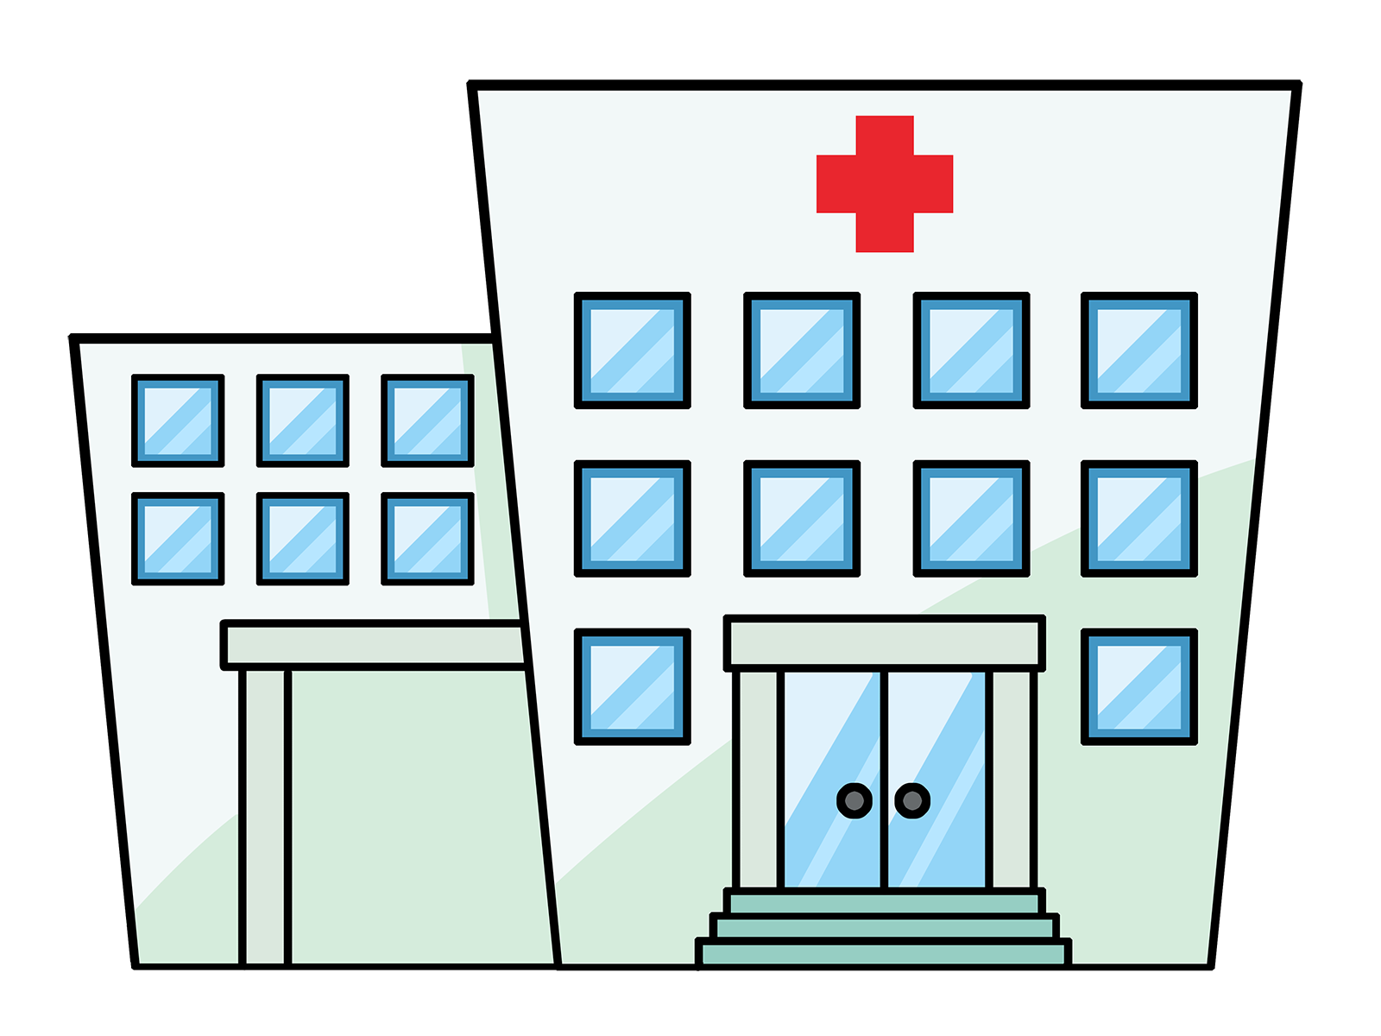
1……………..2…………..3……………….4……………………….5………………6………………7…………………..8…………………..
- Write the names of the people under their pictures.

- My name is Ayşe. I have a stomachache.
- My name is Ahmet. I have a sore throat.
- My name is Merve. I have a fever.
- My name is Osman. I have a broken arm.
- My name is Elif. I have a headache.
- My name is Murat. I have a flu.

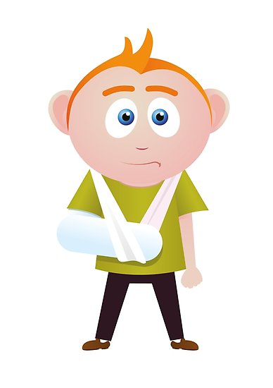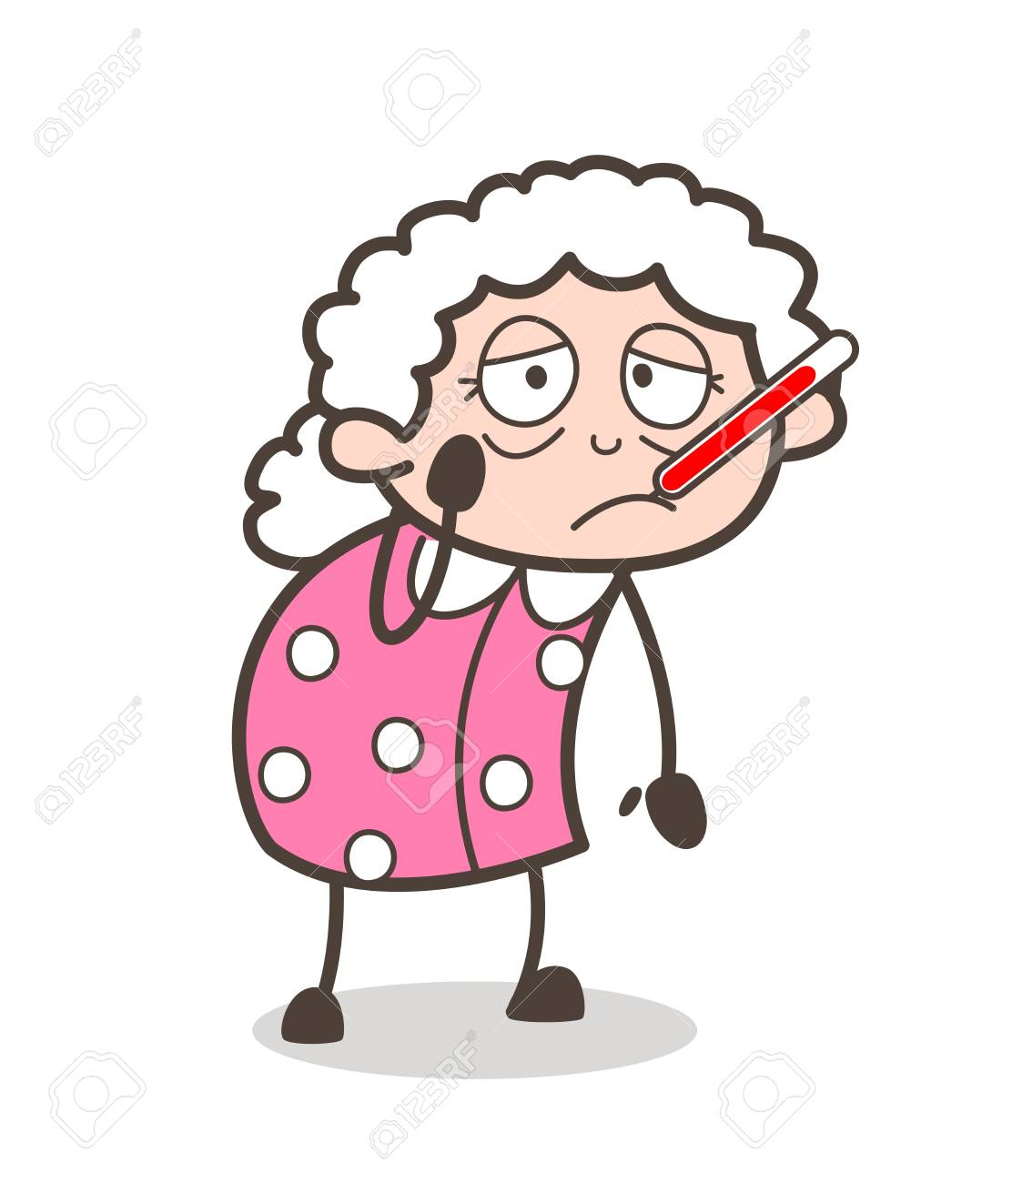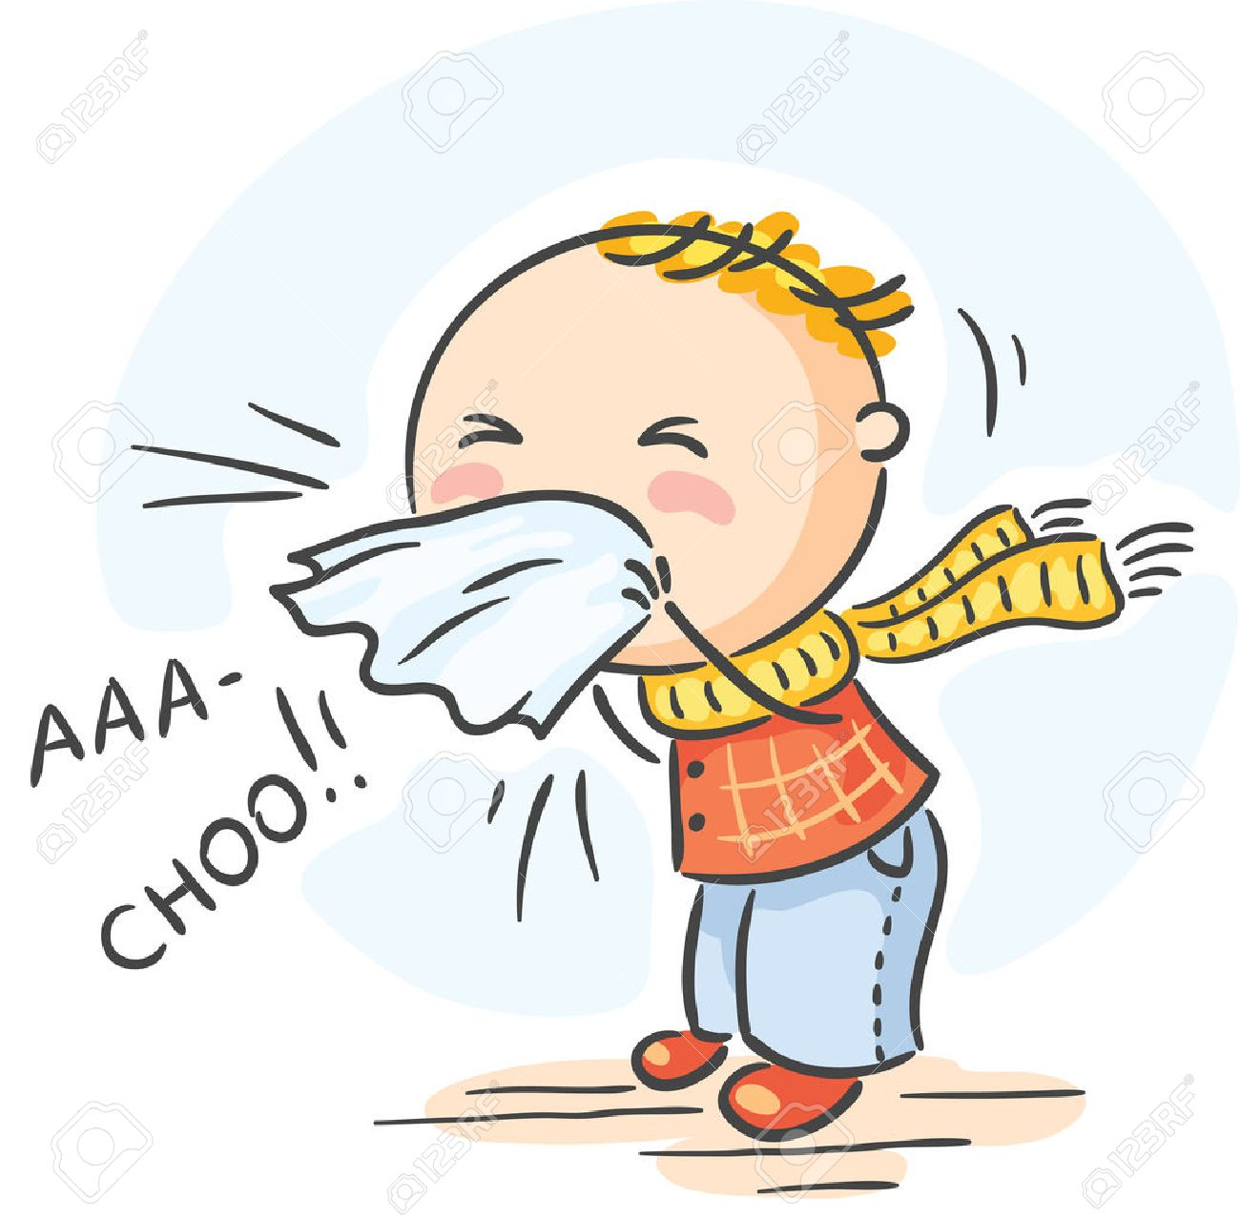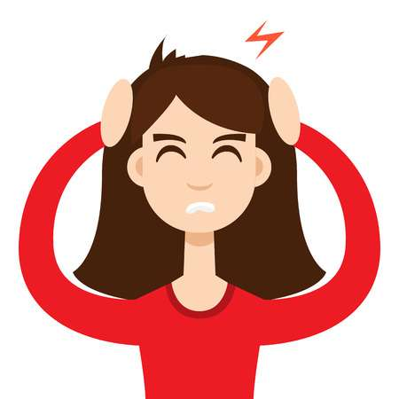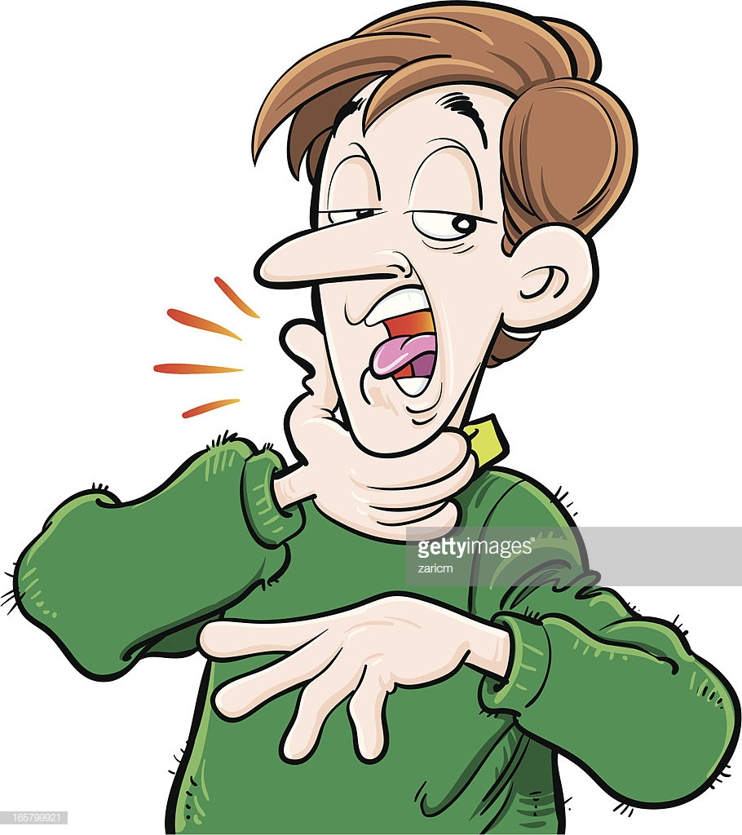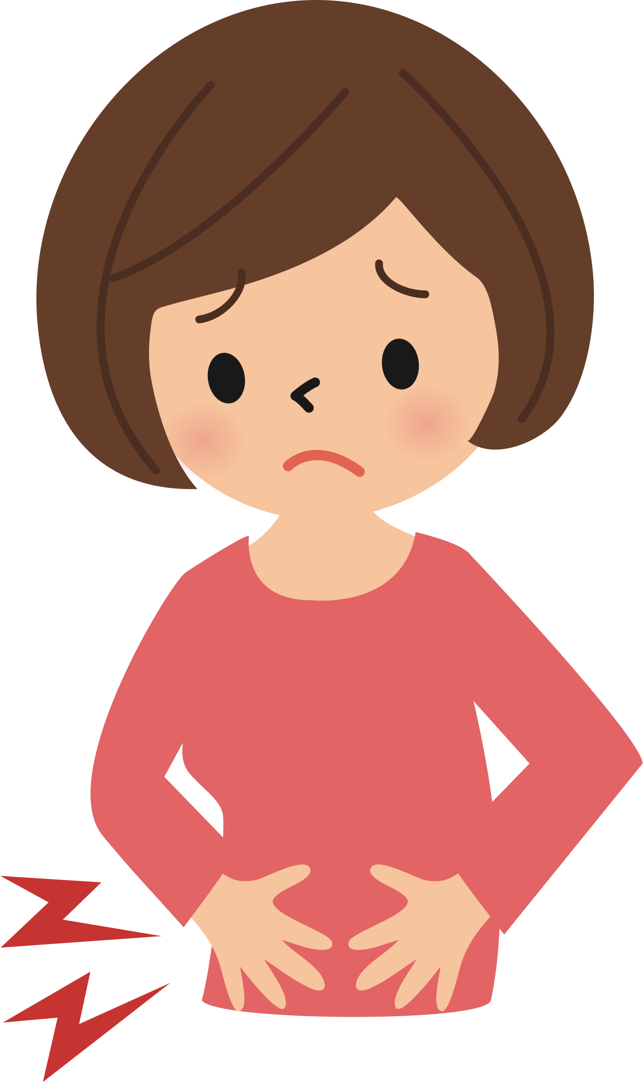
Good Luck!
Halil İbrahim Güran
Teacher of English
1…………………2………………….……3……………………………4…………………………5…………………………6……………………

- Choose the correct options.

- You are ill. You ……………………………. go to the school.
- should b) shouldn’t
- Cola is unhealthy. You ……………………………. drink cola.
- should b) shouldn’t
- Your teeth are not healthy. You …………………………….. brush your teeth.
- should b) shouldn’t
- You ……………………………… eat a lot of sweets.
- should b) shouldn’t
- You ……………………………. eat fruit and vegetables.
- should b) shouldn’t
- I have a sore throat. I ………………………… drink cold water.
- should b) shouldn’t
- You are ill. You ……………………………. go to the hospital.
- should b) shouldn’t
- I have a headache. I ……………………………… listen to music.
- should b) shouldn’t
- You have a toothache. You ………………………… see the dentist.
- should b) shouldn’t
- You ………………………….. wash your hands before meals.
- should b) shouldn’t

