Name – Surname:__________________________ Class:_______ Number:_______
…………….. Academic Year ……………………………….. 5th Grades 1st Term 2nd Exam

- Soruları uygun cevap ile eşleştiriniz. **Her soru 2 puandır.
1-What is your name? ( c ) a-This is a pencil.
2-Are you Japanese? ( e ) b-No,I can’t because I don’t have a bike.
3-What is this? ( a ) c-My name is Kevin.
4-Can you ride a bike? ( b ) d-Yes, she can.
5-Can your sister speak French? ( d ) e-No,I’m not. I’m French.

B) Hobi ve oyunları; boşluklara doğru şıkkı yazarak, resimleriyle eşleştiriniz.
a)camping b)ride a bike c)take photos d)play chess e)hide and seek f)do origami
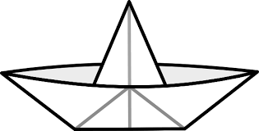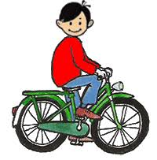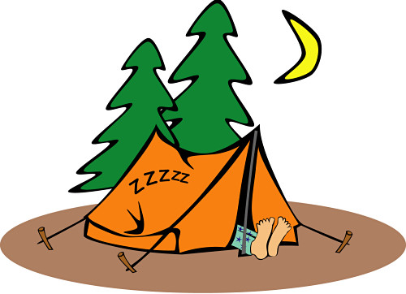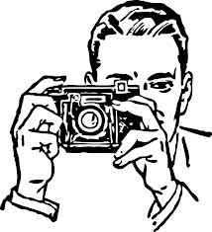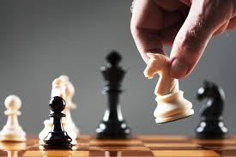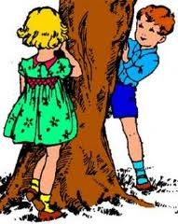
1-( f ) 2-( b ) 3-( a ) 4-( c ) 5-( d ) 6-( e )

C)Koyu yazılan fiillerden doğru olanı yuvarlak içine alınız.
1-Linda swim – swims in the pool. 5-We brush – brushes our teeth after dinner.
2-I go – goes to school every day. 6-Ali do – does his homework every morning.
3-My mother cook – cooks fish every week. 7-Tom and Bill like – likes chess.
4-The dog sleep – sleeps in the garden. 8-They drink – drinks tea at breakfast.

D) Aşağıdaki ifadeleri doğru resmin altına yazınız.
Sleep – Wash hands – Get on the bus – Get off the bus – Brush teeth - Go online – Get dressed – Do homework – Comb hair – Wash face
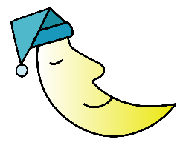
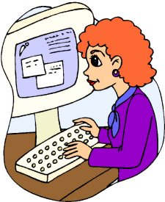
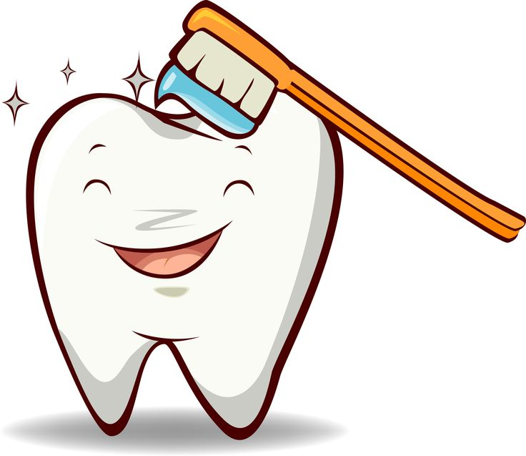
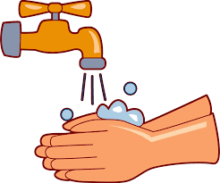
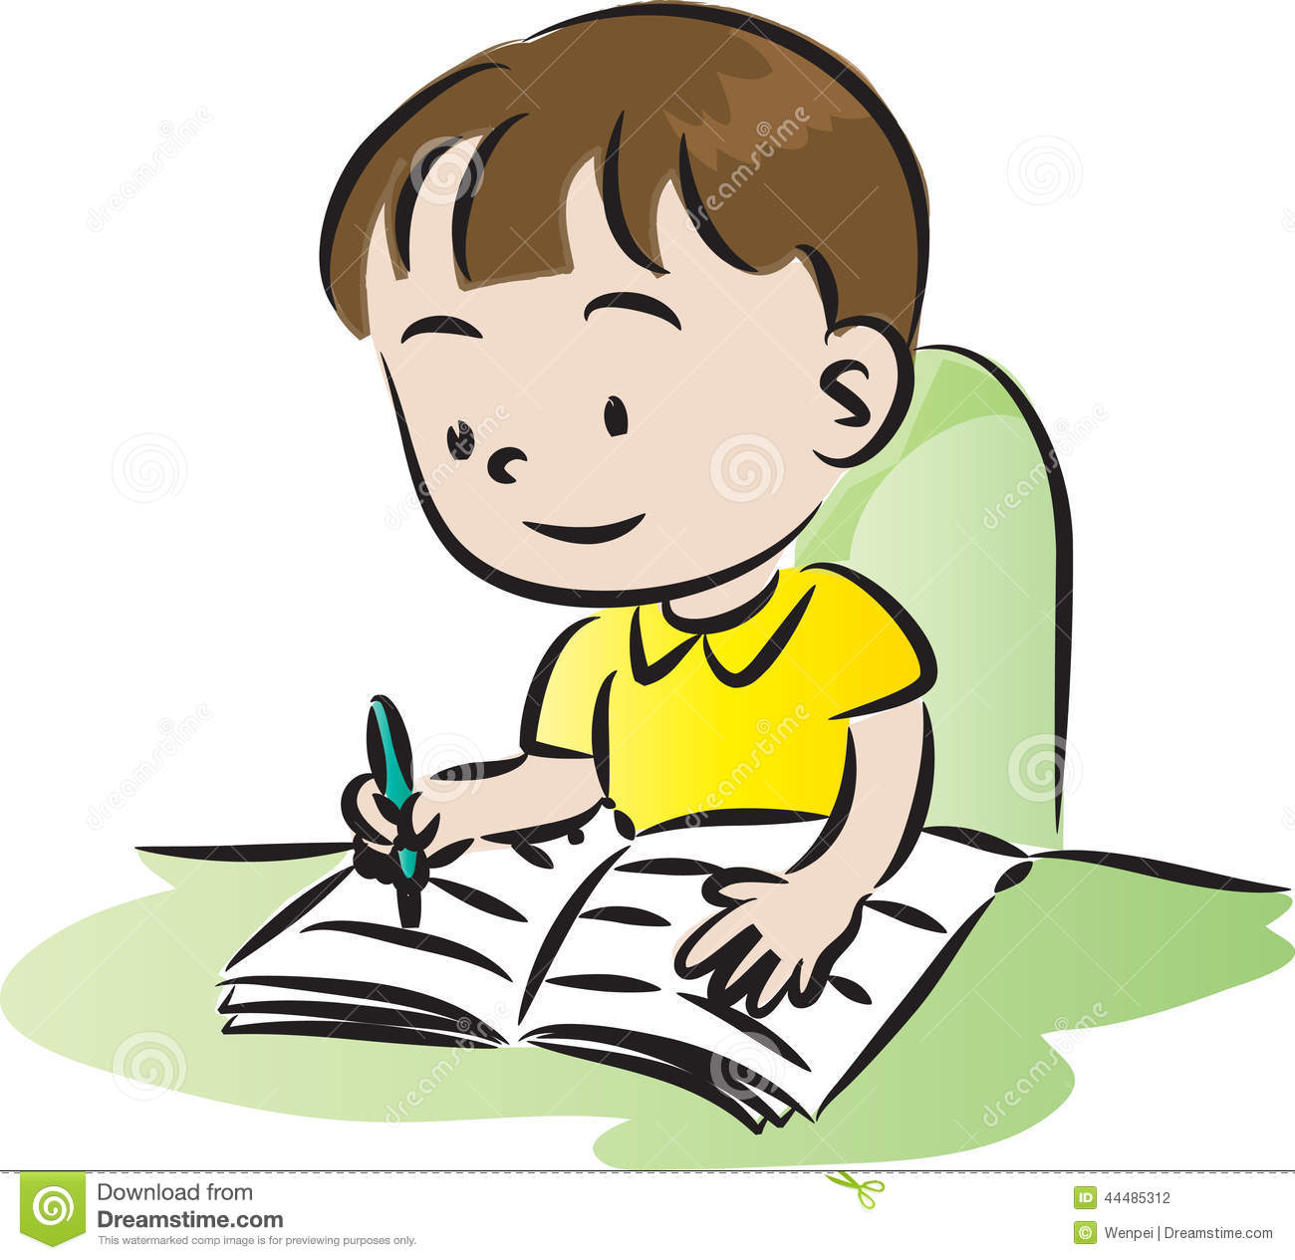
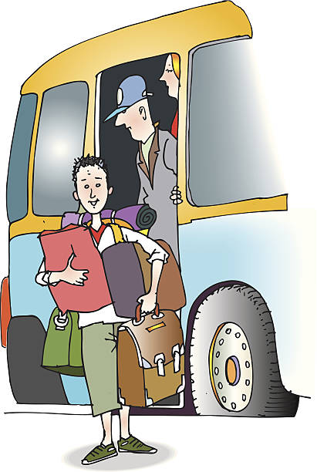
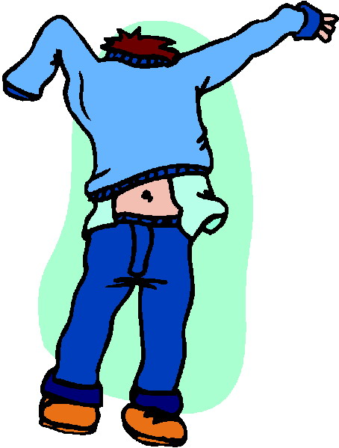
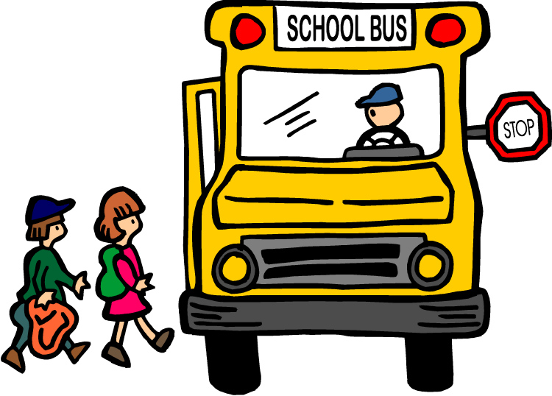
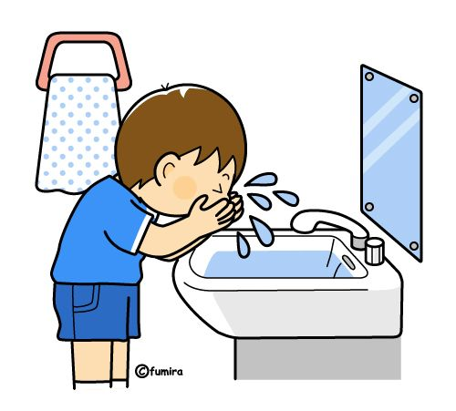
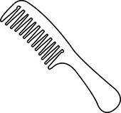

1-…get on the bus…… 2-…get dressed… 3-…wash face…….. 4-…comb hair……. 5-……sleep…………

6-…get off the bus…. 7-…do homework…… 8-…wash hands………… 9-…brush teeth 10…go online
E) Verilen resmi inceleyip, boşluklara between – next to – opposite yazınız.
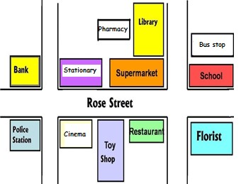
1-The school is__opposite________the florist.
2-The toy shop is__between_____the cinema and
the restaurant.
3-The stationary is__next to___the supermarket.
F) Aşağıdaki metni okuyup, cümlelerin yanına doğruysa T (True), yanlışsa F (False) yazınız.
Hello! My name is Hans. I’m ten years old. I’m from Germany. I get up early. I wash my face and have breakfast. I eat cheese and egg, I drink milk at breakfast. I get on the school bus and go to school at 09:00. I have lunch at the school canteen. I arrive home at 16:00. I do my homework before dinner. I have dinner with my family. Then, I read books and watch TV. I brush my teeth and I wear my pyjamas. I go to bed at 09:30.
1-He is 10 years old.__T___ 5-He has lunch at home.__F____
2-He gets up late.__F___ 6-He does homework before dinner.__T____
3-He drinks tea at breakfast.__F___ 7-He eats cheese and egg at dinner.__F____
4-He goes to school by bus._T____ 8-He reads books and watches TV after dinner.__T___

G)Boşlukları verilen kelimelerden uygun olanıyla doldurunuz.
Restaurant
1-You read books in the__library__________
Cinema
2-You can buy toys at the___toy shop________
Hospital
3-Doctors and nurses work at the__hospital_________
Toy shop
4-You can have lunch or dinner at the__restaurant______
Library
5-You can watch movies at the__cinema_________

H)Boşlukları uygun şekilde doldurunuz.
Hello! I _am____Aslı. I’m _from___Türkiye. I _go__to school. I 😊_like__Art, but I ☹_don’t like____Science.

BONUS: What is your favourite color?_My favorite color is black__________
What is your surname?__My surname is Bebek______________________

