
……………… ACADEMIC YEAR BARDAS SECONDARY SCHOOL 1st Term 2ND EXAM FOR 5TH GRADERS
NAME:

A)Write the correct words under the images.(3*6=18 pts)
hopscotch - skip rope - football - chinese whispers - hide and seek - tic tac toe
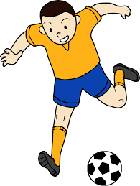
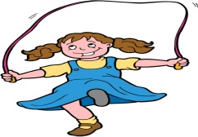
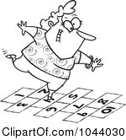
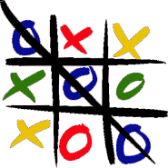
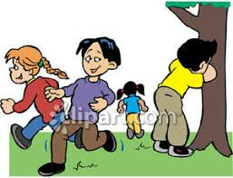


__________ ___________ _____________ __________ ___________ __________
B)Match.(3*8=24 pts)
The measles - flu - toothache - broken arm - sore throat - headache - stomachache - fever
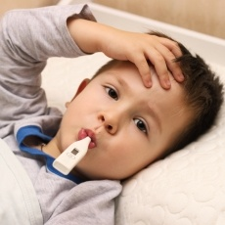


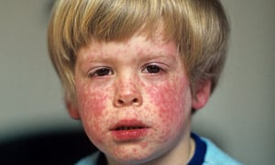

____________ _________________ _________________ ___________________

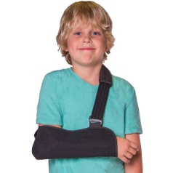



______________ ___________________ _________________ ________________
C)Write the time.(3*6=18 PTS)
1-It is half past two. 4-It is half past three.
2-It is ten o’clock. 5-It is nine o’clock.
3-It is quarter past one. 6-It is quarter past seven.

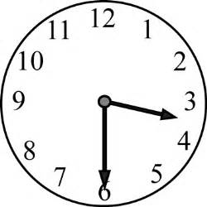
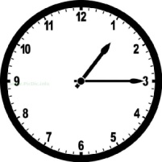
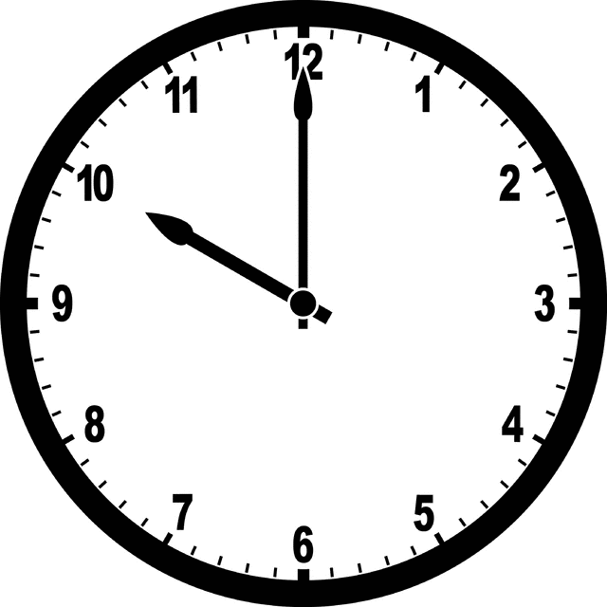

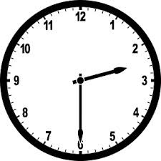
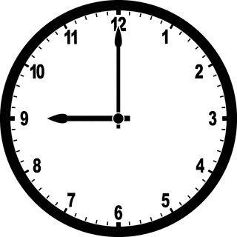
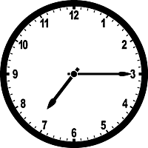
________________________ ________________________ _________________________

_______________________ _________________________ _________________________

D)Boşlukları tabloya göre “can” ya da “can’t” ile doldurunuz.(2*8=16 pts)
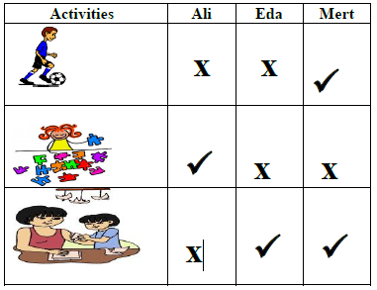
1)Ali …………………………..... do origami.
2)Eda ………………………..…. play soccer.
3)Mert …………………….…….. do origami..
4)Eda and Mert ……………….………. do puzzles.
5)Ali and Eda…………………………….. play soccer.
6)Mert …………………………….….. play soccer.
7)Eda …………………….…………. do origami.
8)Ali ………………………………do puzzles.

E)Circle the correct option.(3*8=24 pts)
1)We have breakfast ___ seven o’clock.
A)in B) on C)at D)under
2)She plays volleyball ___ Sundays.
A)in B)on C)at D)under
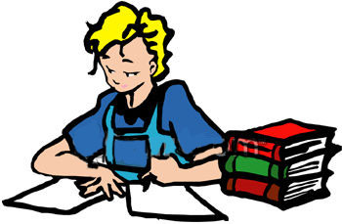
3)

Mehmet ____________ in the evenings
A)does homework
B)plays chess
C)watches TV
D)has dinner

4) Mark enjoys P.E classes. He loves .................
A) solving problems
B) doing experiments
C) playing football
D) drawing pictures

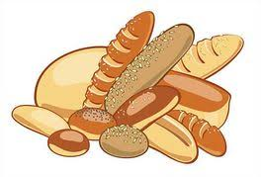
5) ) I go to the _________ to buy breads in the mornings.
A)hospital
B)bakery
C)pharmacy
D)stationary
6)My father goes to _________ on Fridays.
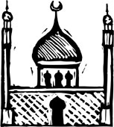
A)mosque
B)post Office
C)library
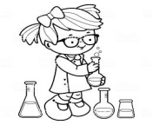
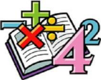
D)supermarket
7) Jane likes but she dislikes

A)maths – P.E
B)english – science
C)maths – science
D)social studies – P.E
8) Mark enjoys P.E classes. He loves .................
A) solving problems
B) doing experiments
C) playing football
D) drawing pictures

