
……………… ACADEMIC YEAR BARDAS SECONDARY SCHOOL 1st Term 2ND EXAM FOR 5TH GRADERS
NAME:

A)Write the correct words under the images.(3*6=18 pts)
hopscotch - skip rope - football - chinese whispers - hide and seek - tic tac toe
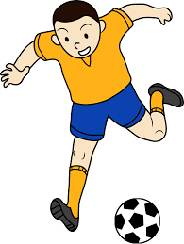

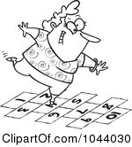
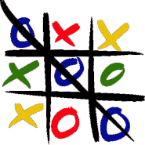
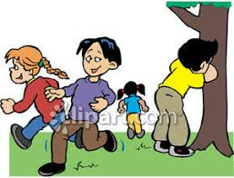


_ hopscotch_ _chinese whispers_ _ hide and seek_ __tic tac toe__ _skip rope __ _ football___
B)Match.(3*8=24 pts)
The measles - flu - toothache - broken arm - sore throat - headache - stomachache - fever
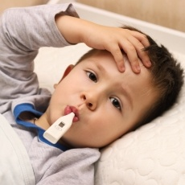


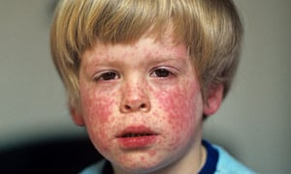

__fever______ ______flu___________ __ sore throat_____ __ the measles______

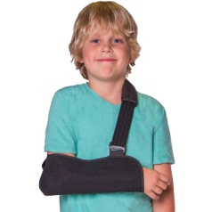



__ headache______ __ toothache______ __ broken arm _____ __ stomachache__
C)Write the time.(3*6=18 PTS)
1-It is half past two. 4-It is half past three.
2-It is ten o’clock. 5-It is nine o’clock.
3-It is quarter past one. 6-It is quarter past seven.

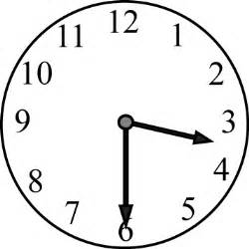
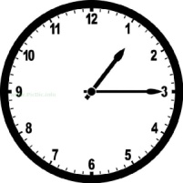
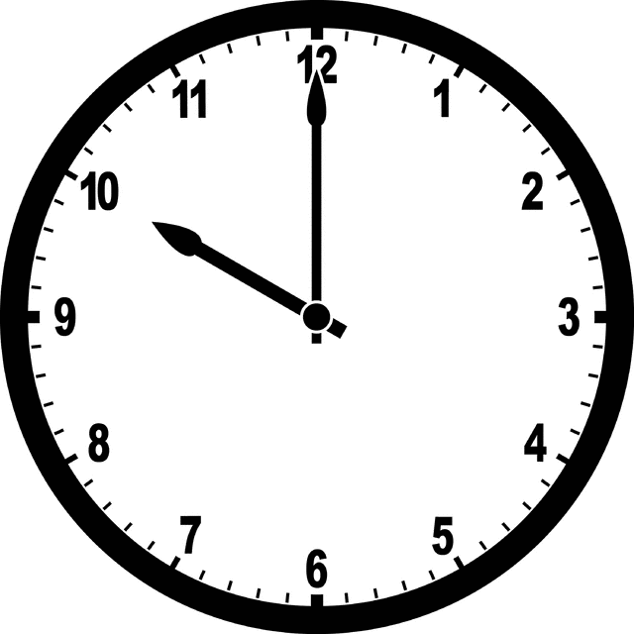

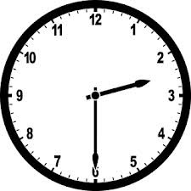
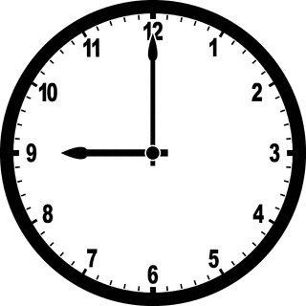
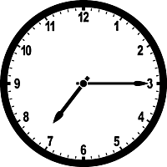
_________2_______________ ___________3_____________ ____________4____________

_________6______________ __________5______________ ___________1______________

D)Boşlukları tabloya göre “can” ya da “can’t” ile doldurunuz.(2*8=16 pts)
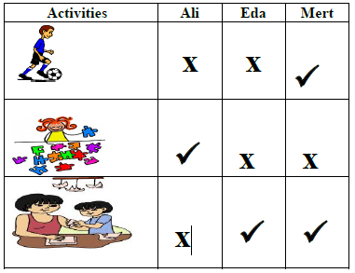
1)Ali ………can’t…………………..... do origami.
2)Eda ……can’t………………..…. play soccer.
3)Mert ……can……………….…….. do origami..
4)Eda and Mert ……can’t………….………. do puzzles.
5)Ali and Eda………can’t…………………….. play soccer.
6)Mert ……can……………………….….. play soccer.
7)Eda ……can……………….…………. do origami.
8)Ali ……can………………………do puzzles.

E)Circle the correct option.(3*8=24 pts)
1)We have breakfast ___ seven o’clock.
A)in B) on C)at D)under
2)She plays volleyball ___ Sundays.
A)in B)on C)at D)under

3)

Mehmet ____________ in the evenings
A)does homework
B)plays chess
C)watches TV
D)has dinner

4) Mark enjoys P.E classes. He loves .................
A) solving problems
B) doing experiments
C) playing football
D) drawing pictures

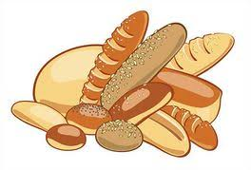
5) ) I go to the _________ to buy breads in the mornings.
A)hospital
B)bakery
C)pharmacy
D)stationary
6)My father goes to _________ on Fridays.

A)mosque
B)post Office
C)library


D)supermarket
7) Jane likes but she dislikes

A)maths – P.E
B)english – science
C)maths – science
D)social studies – P.E
8) Mark enjoys P.E classes. He loves .................
A) solving problems
B) doing experiments
C) playing football
D) drawing pictures

