NAME- SURNAME : | ……………. EDUCATION YEAR  GÜVERCİNTEPE SECONDARY SCHOOL  5th GRADE 1st TERM 2nd ENGLISH EXAM
CLASS :
NUMBER :

1.Match the time the clocks. (Saatleri doğru görsellerle eşleştiriniz) -5x2=10 pts-

- It is half past five. c. It is three o’clock.
- It is quarter past two. d. . It is twenty-five past twelve e. It is quarter to ten
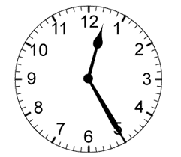
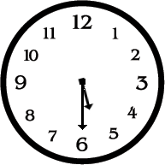
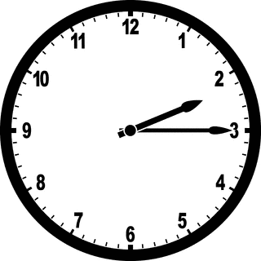
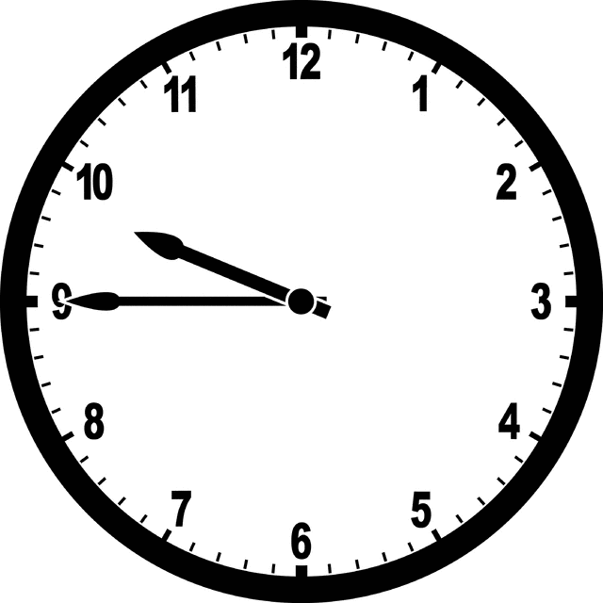
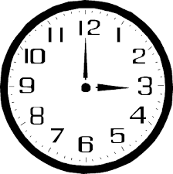

____ ____ ____ ____ ____

2. Match the words with the pictures. (Kelimeleri resimlerle eşleştiriniz.) -5x4=20 pts-

a.Dodgeball b.hopsckotch c.hide and seek d.doing puzzle e. chess
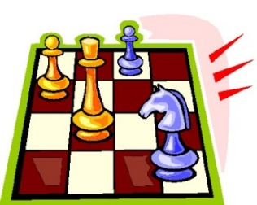
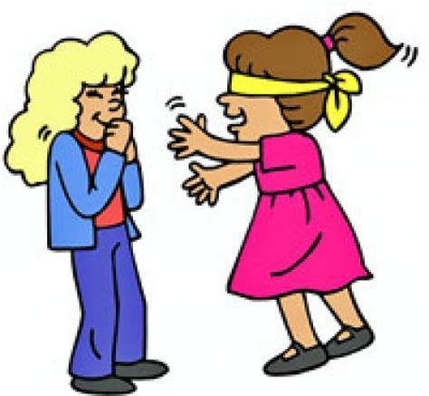
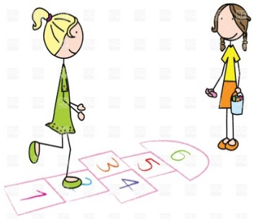
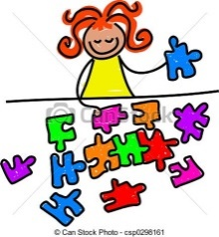
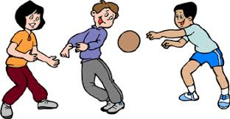
____________ ____________ ____________ ____________ ____________

3. Fill in the blanks with “Daily routine” words. (Cümleleri günlük rutin kelimeleriyle doldurunuz.) 10x2=20
dinner / goes / gets / returns / washes / drinks / brushes / combs / does / breakfast

Marry________up at six o’clock everyday. She ________her face and __________her teeth.
She gets dressed then she_________ hair. She has ________at 6.30 am. She ________ milk and eat cheese.
She ________to school by bus. Her school starts at 7.00 am. She ________ home at 3.00 pm.
She ________her homework until 4 pm to 6 pm. She has ________with her family in the evenings. She goes to bed at 9.00pm.

4. Fill in the blanks with “can” or “can’t”. (Boşlukları tabloya göre “can” veya “can’t” ile doldurun.) 20 P

Activities | John | i  Linda | Peter | Susan
Football
Doing Puzzle
Play Piano
Draw Picture
1.John ___________ play the piano.
2.Susan __________ draw picture.
3.Peter and Linda ______ do puzzle.
4. Susan _________ play the piano.
5. Linda _________ play football.
6. John _________ draw picture.
7. Peter _________ draw picture.
8. Susan and John ________ do puzzle.
9. Linda _________ play the piano.
10. Peter _________ play the football.

 |  |  |  |  |  |  |  |  |  | ₄
 |  | _{1.T} |  |  |  |  |  | ₃
 | ₉ | _{W} |  |  | ₂ |  | ₁₁
 |  | _{E} |  |  |  |  |  |  |  |  |  |  |  |  | ₅
 | ₁₀ | _{L} |  |  |  | ₇ |  | ₁₅ |  |  |  | ₆
 |  | _{V} |  |  | ₁₂
 |  | _{E}
 |  |  |  |  |  |  |  |  |  |  | ₈
 |  |  |  |  |  |  |  |  |  | ₁₄
 |  |  | ₁₃
5.Do the puzzle with numbers on the right. (Sağdaki sayıların İngilizcelerini bulmacada doldurunuz.) 30p

Down:
1- 12
2- 26
3- 15
4- 14
5- 40
6- 10
7- 92
8- 90 Across:
9- 2
10- 11
11- 56
12- 9
13 67
14- 80
15-20

