NAME- SURNAME : | ……………. EDUCATION YEAR  GÜVERCİNTEPE SECONDARY SCHOOL  5th GRADE 1st TERM 2nd ENGLISH EXAM
CLASS :
NUMBER :

1.Match the time the clocks. (Saatleri doğru görsellerle eşleştiriniz) -5x2=10 pts-

- It is half past five. c. It is three o’clock.
- It is quarter past two. d. . It is twenty-five past twelve e. It is quarter to ten
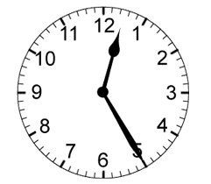
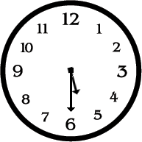
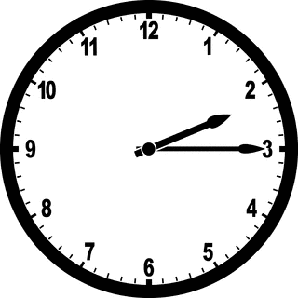
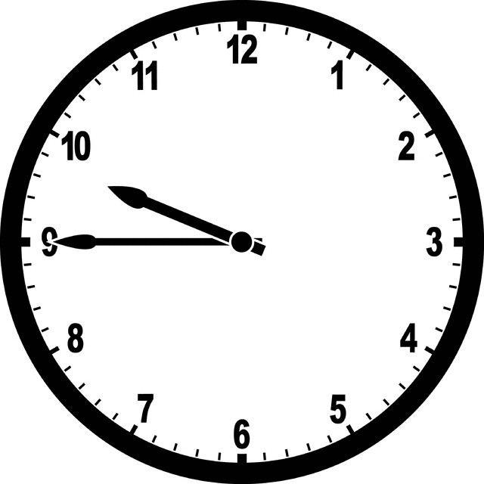
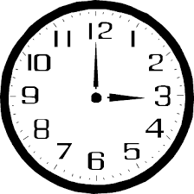

__c__ __e__ __b__ __a__ ____

2. Match the words with the pictures. (Kelimeleri resimlerle eşleştiriniz.) -5x4=20 pts-

a.Dodgeball b.hopsckotch c.hide and seek d.doing puzzle e. chess
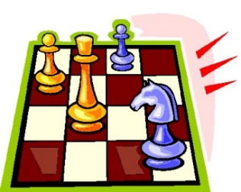
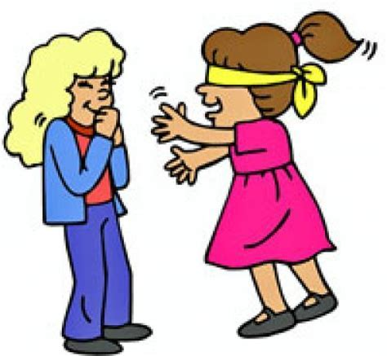
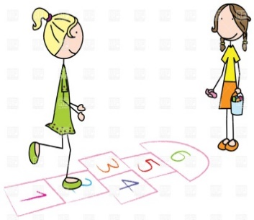
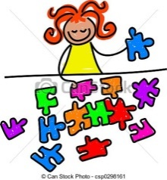
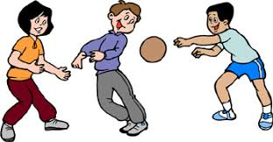
____chess____ _ dodgeball______ __doing puzzle _ hide and seek__ _ hopsckotch __

3. Fill in the blanks with “Daily routine” words. (Cümleleri günlük rutin kelimeleriyle doldurunuz.) 10x2=20
dinner / goes / gets / returns / washes / drinks / brushes / combs / does / breakfast

Marry__gets______up at six o’clock everyday. She _washes ___her face and __ brushes __her teeth.
She gets dressed then she__combs___ hair. She has _breakfast_at 6.30 am. She _drinks___ milk and eat cheese.
She _goes_______to school by bus. Her school starts at 7.00 am. She _returns___ home at 3.00 pm.
She _does_______her homework until 4 pm to 6 pm. She has _dinner_______with her family in the evenings. She goes to bed at 9.00pm.

4. Fill in the blanks with “can” or “can’t”. (Boşlukları tabloya göre “can” veya “can’t” ile doldurun.) 20 P

Activities | John | i  Linda | Peter | Susan
Football
Doing Puzzle
Play Piano
Draw Picture
1.John __can’t_______ play the piano.
2.Susan __can________ draw picture.
3.Peter and Linda _can’t_____ do puzzle.
4. Susan _can’t________ play the piano.
5. Linda _can’t________ play football.
6. John __can_______ draw picture.
7. Peter _can’t________ draw picture.
8. Susan and John _can_____ do puzzle.
9. Linda _can________ play the piano.
10. Peter _can______ play the football.

 |  |  |  |  |  |  |  |  |  | _{4 F}
 |  |  |  |  |  |  |  |  |  | _{O}
 |  |  |  |  |  |  |  |  |  | _{U}
 |  | _{1T} |  |  |  |  |  | _{3 F} |  | _{R}
 | _{9 T} | _{W} | _{O} |  | _{2 T} |  | _{11 F} | _{I} | _{F} | _{T} | _{Y} | _{S} | _{I} | _{X}
 |  | _{E} |  |  | _{W} |  |  | _{F} |  | _{E} |  |  |  |  | _{5F}
 | _{10 E} | _{L} | _{E} | _{V} | _{E} | _{7 N} |  | _{15T} | _{W} | _{E} | _{N} | _{6 T} | _{Y} |  | _{O}
 |  | _{V} |  |  | _{12N} | _{İ} | _{N} | _{E} |  | _{N} |  | _{E} |  |  | _{U}
 |  | _{E} |  |  | _{T} | _{N} |  | _{E} |  |  |  | _{N} |  |  | _{R}
 |  |  |  |  | _{Y} | _{E} |  | _{N} |  |  | _{8 N} |  |  |  | _{T}
 |  |  |  |  | _{S} | _{T} |  |  |  | _{14 E} | _{İ} | _{G} | _{H} | _{T} | _{Y}
 |  |  |  |  | _{İ} | _{Y} |  |  |  |  | _{N}
 |  |  | _{13 S} | _{İ} | _{X} | _{T} | _{Y} | _{S} | _{E} | _{V} | _{E} | _{N}
 |  |  |  |  |  | _{W} |  |  |  |  | _{T}
 |  |  |  |  |  | _{O} |  |  |  |  | _{Y}
5.Do the puzzle with numbers on the right. (Sağdaki sayıların İngilizcelerini bulmacada doldurunuz.) 30p

Down:
1- 12
2- 26
3- 15
4- 14
5- 40
6- 10
7- 92
8- 90 Across:
9- 2
10- 11
11- 56
12- 9
13 67
14- 80
15-20

