 | OCAKLAR İLKOKULU
…………………. EDUCATION YEAR 1ST TERM 2ND ENGLISH WRITTEN EXAM
FOR 4TH GRADE

NAME / SURNAME :……………………………….. POINT:…………

A) Fill in the blanks with the correct words. ( Boşlukları doğru kelimelerle tamamlayın.) (4x5=20 points)
reading
1. I like ……………………… trees.
riding

2. I dislike ……………………… a scooter.
planting

3. I like ……………………… comics.
flying
drawing
4. I dislike ……………………… pictures.

5. I like ……………………… a kite.

B) Complete sentences with “like” / “don’t like”. (Cümleleri “like” ya da “don’t like” kullanarak tamamlayın.) (4x5=20 points)

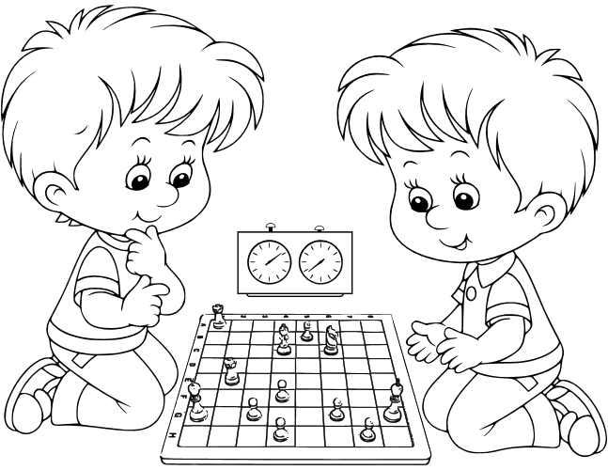

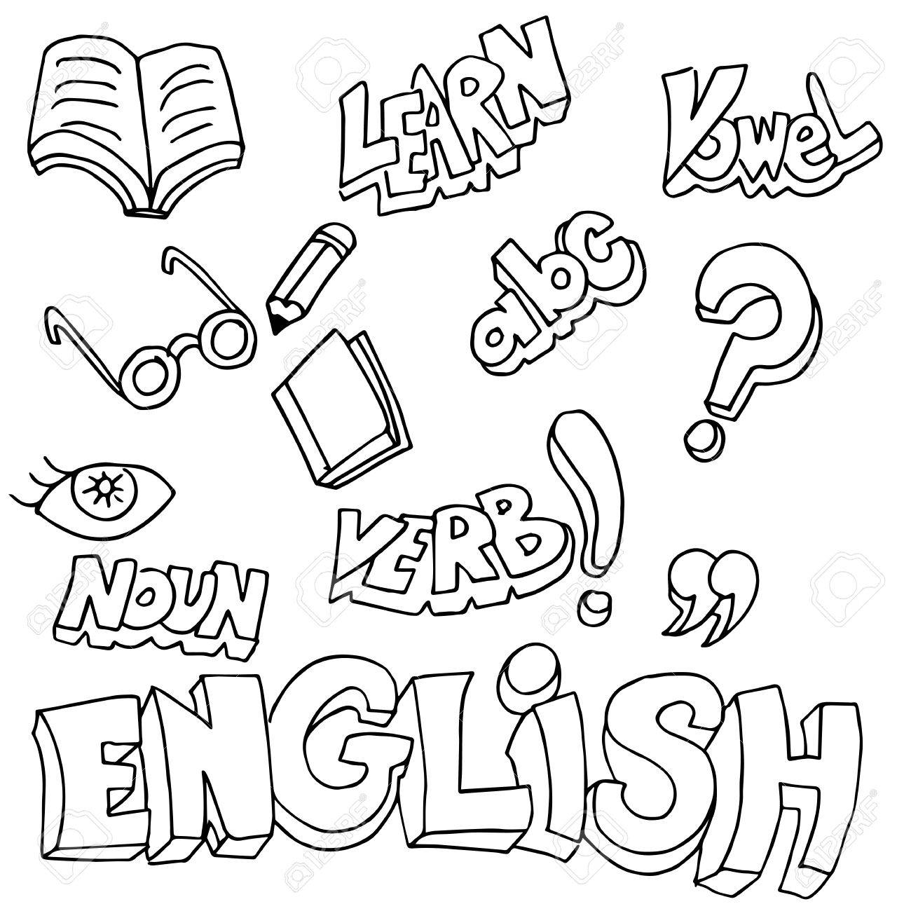

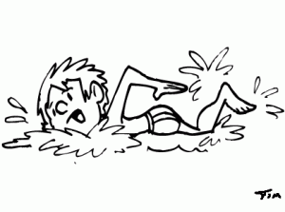

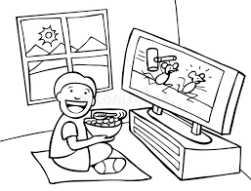

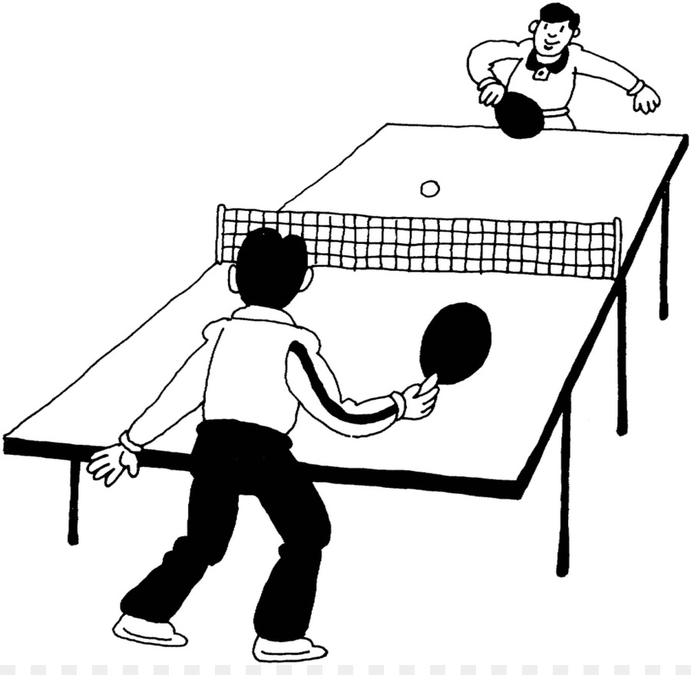

1. I …..…..………………………………………….….. playing table tennis.

2. I …..…..………………………………………….….. playing chess.

3. I …..…..………………………………………….….. learning English.

4. I …..…..………………………………………….….. swimming.

5. I …..…..………………………………………….….. watching cartoons.

C) Write the words under the pictures. (Resimlerin altına sözcükleri yazın.) (3x5=15 points)
3. ride a horse
4. do puzzles
5. climb a tree
2. speak English
1. take a picture

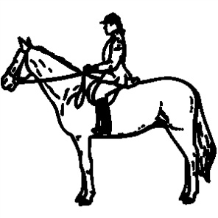
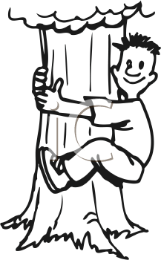

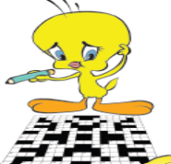
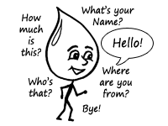

................... ................... .................. ................... ..................

D) Using pictures make sentences with “can” / “can’t”. (Resimleri kullanarak “can” ya da “can’t” ile cümleler yazın.) (5x3=15 points)

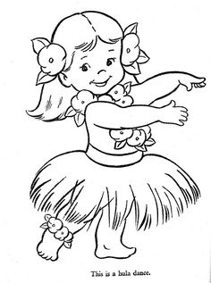
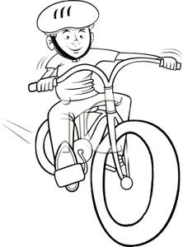
1. I ……………………………………………………………...

2. I ……………………………………………………………...

3. I ……………………………………………………………...

E) Choose the correct answer. (Doğru cevabı seçiniz.) (3x10=30 points)

1) Is she from Italian?

No, she isn’t. She is …………………….. 2) This is …………. ball.
A) his

Britain

A) French B) her
B) Russian C) my
C) German D) your
D) British

3) A) scissors 4) A) thirty – five

B) ruler B) twenty - eight
C) pencil C) forty – eight
D) eraser D) twenty - three

5) A) Be quiet. 6) Friday - ……… - Sunday


B) Open the door.
C) Turn off the lights. A) Monday B) Wednesday
D) Clean the board. C) Thursday D) Saturday

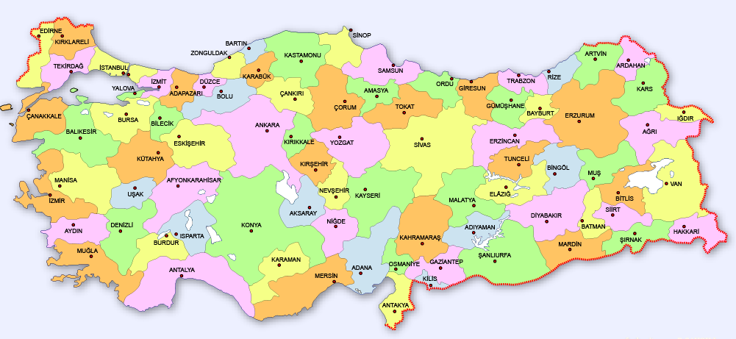

7) İzmir is in the ………….

A) east B) north
C) west D) south

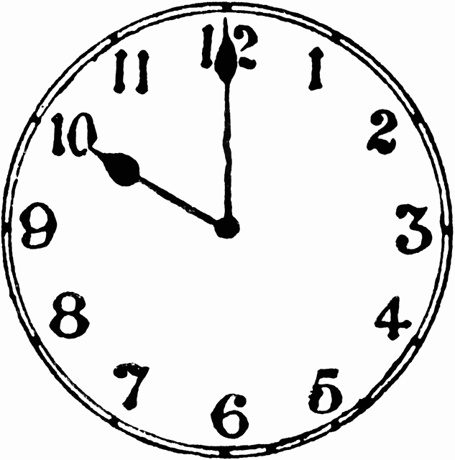
8) “Do you like playing computer games?” 9) “What time is it?”
sorusuna doğru cevap hangisi olabilir?
A) It is o’clock.
A) Yes, I do. B) Yes, I can. B) It is ten o’clock.
C) No, I can’t. D) No, I do. C) It is o’clock ten.
D) It is two o’clock.
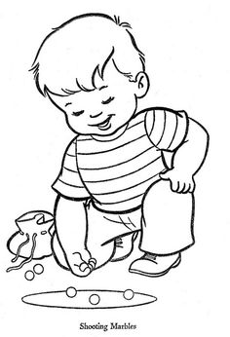

10) I like ………………


A) watching cartoons B) singing
GOOD LUCK!
Elif ARSLAN ÇELE
English Language Teacher

C) playing basketball D) playing with marbles

