**……………………… PRIMARY SCHOOL …………… EDUCATION YEAR 1st TERM 2nd**

**ENGLISH EXAMINATION FOR 4th GRADES**

**NAME-SURNAME: CLASS: 4/**

**NUMBER:**

**A-)Boşluklardaki sayıları tamamlayınız. (2x5=10 pts)**

10 - 20 - 30 - 40 - 50 - 60 - 70 - 80 - 90 - 100

**……….. – twenty - thirty - …………- fifty - ………… - …………. - eighty - …………– one hundred**

**B-)Cümleleri resimlere göre kutucuktaki kelimelerle eşleştiriniz. (2x5=10 pts)**

1.May I come in? 2.May I go to the toilet? 3.May I clean the board?

4.May I turn off the lights? 5.May I drink water?

|  |  |  |  |  |
| --- | --- | --- | --- | --- |
| [http://tse1.mm.bing.net/th?&id=OIP.M95a664b45be2e1e28ea104664833ddd8o0&w=300&h=300&c=0&pid=1.9&rs=0&p=0](http://www.bing.com/images/search?q=+go+to+the+toilet+clipart&view=detailv2&&id=5C66EA7F140230E86D7FCB291655F7EA759FBDB9&selectedIndex=61&ccid=laZktFvi&simid=608002486114848118&thid=OIP.M95a664b45be2e1e28ea104664833ddd8o0) | http://talkingback2restrainingorders.files.wordpress.com/2014/07/turn_on_the_light-e1406173313852.jpg |  | http://www.idiomconnection.com/1teacher23-med.jpg | http://watermarked.cutcaster.com/901534533-Thirsty.jpg |
|  |  |  |  |  |

**C-)Cümleleri kutucuktaki kelimelerle tamamlayınız. (2x5=10 pts)**

**Japanese - Spanish - Italian - Turkish - German**

|  |  |  |  |  |
| --- | --- | --- | --- | --- |
| http://thumb7.shutterstock.com/display_pic_with_logo/2241848/277968959/stock-vector-animation-east-princess-in-an-ancient-dress-full-growth-isolated-on-a-blue-background-277968959.jpg | C:\Users\Sefa_Yalçın\Desktop\ülkeler alıştırma\intl_spain_bullfight.gif | GERMAN.png | http://www.clipartguide.com/_small/1386-0803-0615-2747.jpg | ITALIAN 2.png |
| 1.I’m from Turkey  I’m ……………………….. | 2.I’m from Spain  I’m ……………………….. | 3.I’m from Germany  I’m ……………………….. | 4.I’m from Japan  I’m ……………………….. | 5.I’m from England  I’m ……………………….. |

**D-)Resimlerin altına uygun eylemleri yazınız. (3x5=15pts)**

|  |
| --- |
| **Climbing --- Riding a bike --- Fishing --- Playing football --- Reading comics** |

 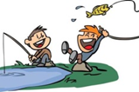  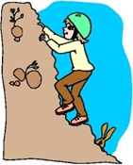 

1\_\_\_\_\_\_\_\_\_\_\_ 2\_\_\_\_\_\_\_\_\_\_\_\_\_ 3\_\_\_\_\_\_\_\_\_\_\_\_ 4\_\_\_\_\_\_\_\_\_\_\_\_ 5\_\_\_\_\_\_\_\_\_\_\_\_

**E-)Aşağıdaki resimlerdeki kişileri alttaki cümlelerle eşleştiriniz.** **(3x5=15pts)**

  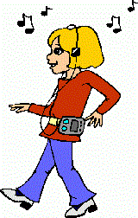  

Lisa Sue Jim Clara Sandra

I like dancing. (………………) I like swimming. (………………) I like singing.(.……………………)

I like drawing. ( ……………………) I like listening to music. (……………………)

**F-)Resimleri inceleyerek doğru seçeneği işaretleyiniz. (3x5=15pts)**

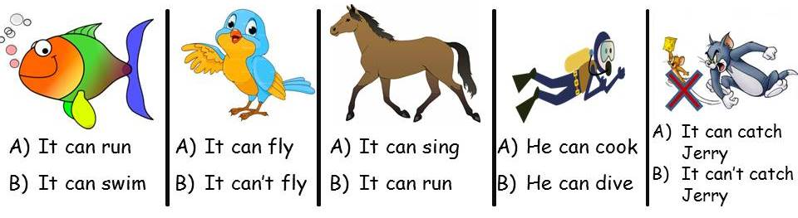 **G-)Aşağıda verilen resimlere bakarak ‘’CAN veya CAN’T’’ ile tamamlayınız. (3x5=15pts)**

**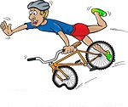**

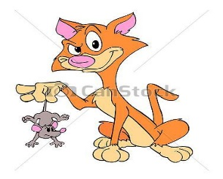**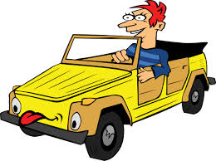**Superman…………………. fly He…………………ride a bike He………………..ride a horse

He…………………drive a car It………………..catch a mouse

**H-)Cümleleri verilen sahiplik sıfatları ile tamamlayınız. (2x5=10 pts)**

**his ---her**

**your --- its**

**my**

1. **I** have got a dog. It is **\_\_\_\_\_\_\_\_\_\_\_**dog.

1. **You** have got a cat. It is \_\_\_\_\_\_\_\_\_\_\_cat.

1. **He** has got a bike. It is **\_\_\_\_\_\_\_\_\_\_\_\_\_** bike.

1. **She** has got a doll. It is \_\_\_\_\_\_\_\_\_\_\_\_\_doll.

1. **It** has got a kennel. It is **\_\_\_\_\_\_\_\_\_**kennel.