…………………. ACADEMIC YEAR CUMHURİYET PRIMARY SCHOOL

1st TERM 4th GRADE 2nd WRITTEN EXAM

NAME : SURNAME: NUMBER: CLASS: 4 / …..

 | 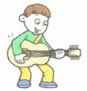 | 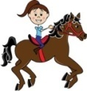 | 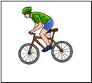
Mehmet | + | - | -
Ayşe | - | + | +
Tarık | - | - | +
- 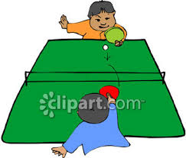
Tuba: Do you like ………………..?
Ahmet: …………………..

- Playing table tennis / Yes, I do.
- Playing football / No, I don’t.
- Playing football / Yes I can.
- Playing table tennis / Yes, I can.

2-- Efe : Where are you from?
Bob : ………………………………

- I’m Spanish.
- I’m ten years old.
- I’m from Brazil.
- I’m a student.

3- I like……………..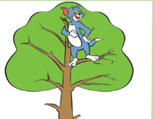
a)climb a tree b)climbing tree
c)cooking d)running

4- Paul: Can you ride a bike?
John : …………………………………

- No, I’m not.
- No,not now
- No I don’t.
- No I can’t.

5- Jack: …………………………………?
Tom : No, she isn’t. She is Japanese.

- Are you from France?
- Do you like fishing?
- Can she run fast?
- Is she Chinese?

6.
I like……………...
a) Dancing b) Swimming
c) Reading d) Flying

7. I can play basketball ….. I can’t play violin.

a). And b)But c)because d) not

8,9,10,11 soruları tabloya göre cevaplandırınız

8. Who can play the guitar?

A) Mehmet B) Ayşe C) Tarık D)No one

9. Can Ayşe ride a horse?
- No he can’t.
- Yes he can.
- No she can’t.
- Yes, she can.

10. Can Mehmet ride a bike ?
- No he can’t.
- Yes he can.
- No she can’t.
- Yes, she can.

11. Can Tarık ride a bike?
- No he can’t.
- Yes she can.
- No she can’t.
- Yes, he can.

12. ‘’ fiffty three’’ sayısı hangisidir?

A) 23 B) 33 C) 43 D) 53

13. What is this ?
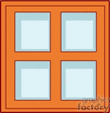
A) a table
B) a cat
C) a desk
D) a window

14. ) chess with marbles
Playing………

the guitar ………….?

A) running B) cartoons
C) the piano D) swimming

15. Aşağıda verilen aktivite isimlerinden hangisinin resmi verilmemiştir?
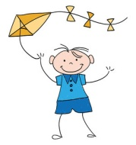

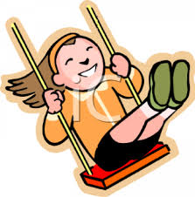

A) Reading a book B) Swinging
C) Rididng a bike D) Flying a kite

16 - David: ……………………………………?
Brad : Yes, she can.

- Are you from France?
- Can she run fast?
- Do you like fishing?
- Is she Chinese?

17. Hangisi farklıdır?
1 | ( a) | ( b ) | ( c ) | ( d )
2 | ( a) | ( b ) | ( c ) | ( d )
3 | ( a) | ( b ) | ( c ) | ( d )
4 | ( a) | ( b ) | ( c ) | ( d )
5 | ( a) | ( b ) | ( c ) | ( d )
6 | ( a) | ( b ) | ( c ) | ( d )
7 | ( a) | ( b ) | ( c ) | ( d )
8 | ( a) | ( b ) | ( c ) | ( d )
9 | ( a) | ( b ) | ( c ) | ( d )
10 | ( a) | ( b ) | ( c ) | ( d )
11 | ( a) | ( b ) | ( c ) | ( d )
12 | ( a) | ( b ) | ( c ) | ( d )
13 | ( a) | ( b ) | ( c ) | ( d )
14 | ( a) | ( b ) | ( c ) | ( d )
15 | ( a) | ( b ) | ( c ) | ( d )
16 | ( a) | ( b ) | ( c ) | ( d )
17 | ( a) | ( b ) | ( c ) | ( d )
18 | ( a) | ( b ) | ( c ) | ( d )
19 | ( a) | ( b ) | ( c ) | ( d )
20 | ( a) | ( b ) | ( c ) | ( d )
21 | ( a) | ( b ) | ( c ) | ( d )
22 | ( a) | ( b ) | ( c ) | ( d )
23 | ( a) | ( b ) | ( c ) | ( d )
24 | ( a) | ( b ) | ( c ) | ( d )
25 | ( a) | ( b ) | ( c ) | ( d )
A) Russian B) England
C) Italy D) Germany

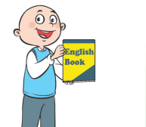
18. ………. can speak English.

a)It b)They b)She c)He

19. Farklı olanı bulunuz?
A) Africa B) Turkey
C) Europe D) Asia
her bir soru 4 puandır.

20. Where is Turkey?

- It is in North America
- It is in Europe and Asia
- It is in Australia
- It is in Africa

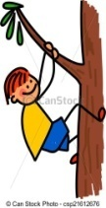
21. Yandaki resme uygun seçeneği bulun

- swim
- climb
- point
- run

22. Yandaki resme uygun seçeneği bulun
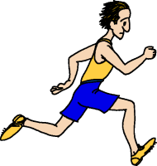
- swim
- climb
- point
- run

23. Yandaki resme uygun seçeneği bulun
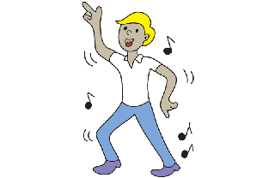
- write
- wash
- dance
- open

24. ‘’ nineteen’’ sayısı hangisidr?

A) 17 B) 18 C) 19 D) 20

25. Rafael : May I come in?
Martin : ……………………

- Yes,you are.
- Yes, you do.
- Yes, you can.
- Yes, you may.

