……………….. EDUCATION YEAR HURSUNLU SECONDARY SCHOOL 1ST TERM 2ND ENGLISH EXAM for Grade 4th
Name: Surname:
1. 23 t 44 = ? İşlemin sonucu hangisidir?
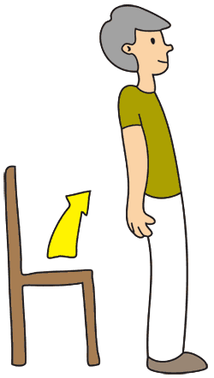
a) sixty seven
b) seventy
c) sixteen
d) forty four
2. Resimdeki kişiden ne yapması istenmiştir?
a) Stand up, please.
b) Open the door, please.
I’M GOOD
------------------------------------
c) Turn on the light, please.
d) Clean the board, please.
3. Konuşmayı tamamlayan seçenek hangisidir?

a) Please, turn around.
b) How are you?
c) Quiet, please.
d) May I come in?
4. Meriç’in yaşı kaçtır?
Kaan:How old are you?
Meriç: I’m 15.

a) ten
b) twelve
c) seventeen
d) fifteen
5.Aşağıdaki konuşmada kişi hangi millettendir?
I’m from Germany.
________________
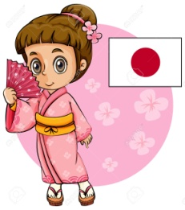
a) I’m French.
b) I’m Spanish
c) I’m Italian
d) I’m German
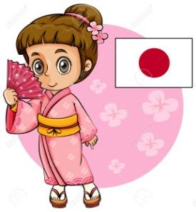
6. Seçeneklerden hangisi diğerlerinden farklıdır?
a) France c) Turkish
b) Germany d) Russia
7. - Is she Spanish?
- _______________She is Japanese.
Konuşmayı tamamlayan seçenek hangisidir?
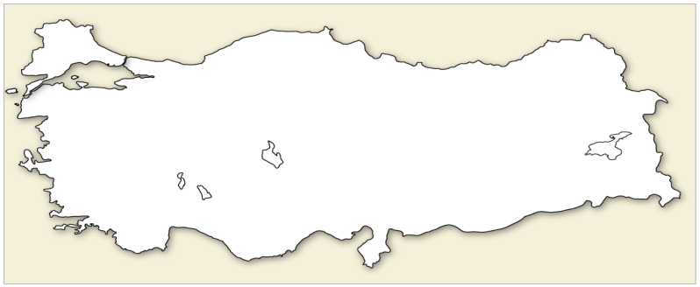
a) Maybe.
b) Yes, she is.
c) No,she isn’t.
d) Yes, I am.
8.

Which country is it?
a) It is Germany
b) It is Russia
c) It is Turkey
d) It is the USA
I am 18.
How old are you?
9.
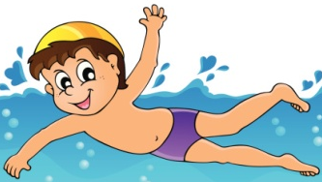
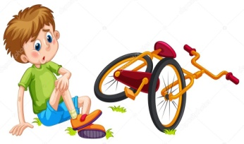
a)seventeen
b) nineteen
c) eighteen
d) twenty
10.
I ____ swim but I ____ ride a bike.

Cümleyi tamamlayan seçenek hangisidir?
a) can/can’t c) can’t/can
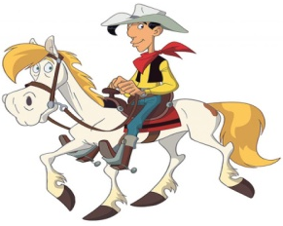
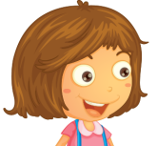
11.
Can Red-kit ride a horse?

a) No, he can’t.
b) Yes, he can.
12.
This is ___ guitar and I can play it.
a) his c) my
b) your d) her
This is my camera. I can ________.
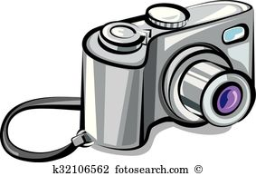
13.
a) ride it
b) take pictures
c) drive it
d) read it
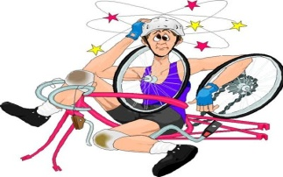
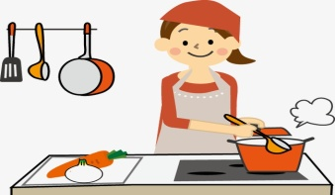
14.

a) She can swim but she can’t cook.
b) She can cook but she can’t ride a bike.
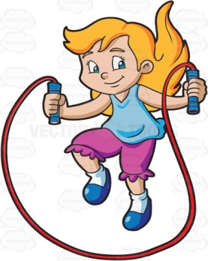
I like ______________.
15.
a) riding a horse
b) singing
c) playing chess
d) skipping a rope
Do you like playing with dolls?
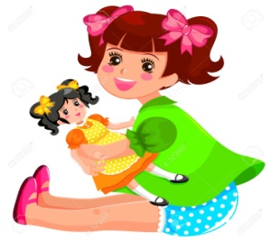
16.
a) Yes, I do.
b) No,I don’t

17. Aşağıdaki konuşmanın Türkçesini yazınız.
Do you like swimming?
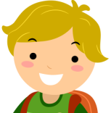
Yes, I do.

...................................................................................
18. Resimde ne yapıyor?
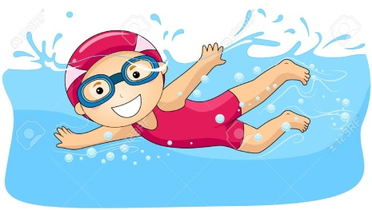
a) swimming c) running
b)flying d) jumping

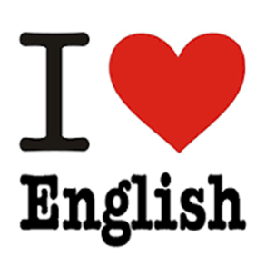
19.

a) I like learning English but I don’t like swimming.
b) I like reading but I don’t like dancing. .
What is your favourite activity?
20.
My favourite activity is _________.
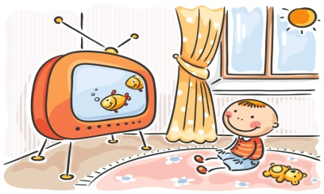
a) riding a bike
b) watching cartonns
c) playing the guitar
d) reading comics

GOOD LUCK
NESİBE NESLİHAN ONARAN

