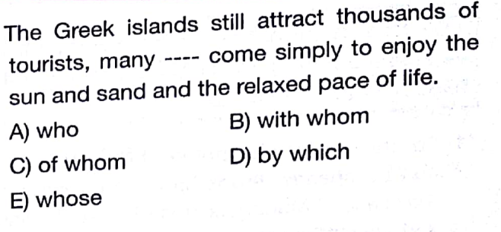
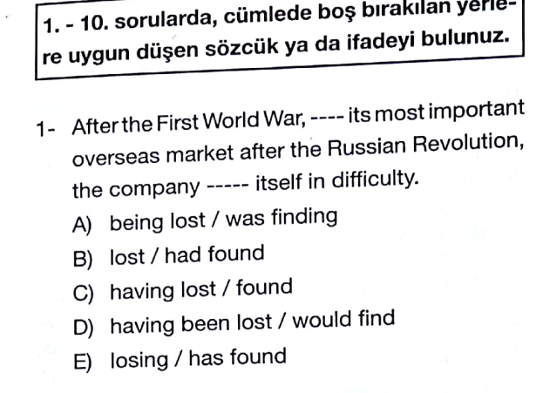
8-

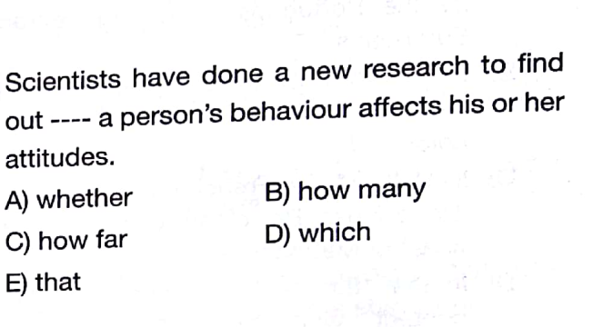

9-
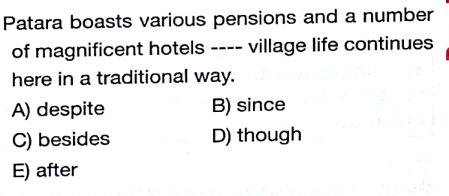
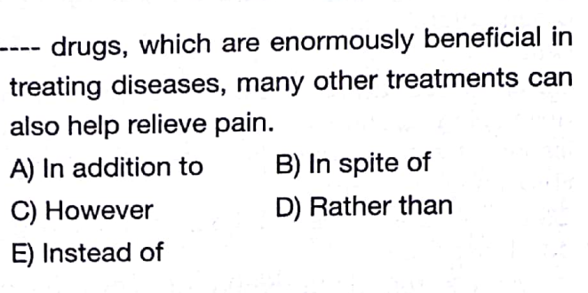
2-
10-
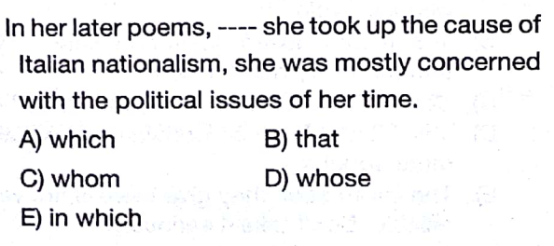
3-

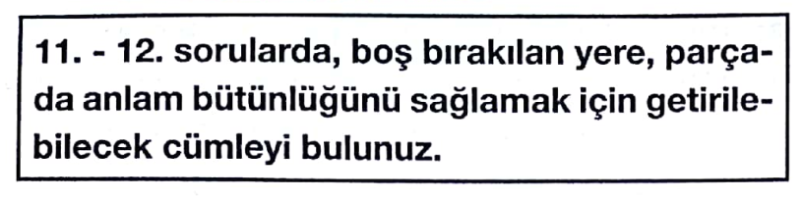
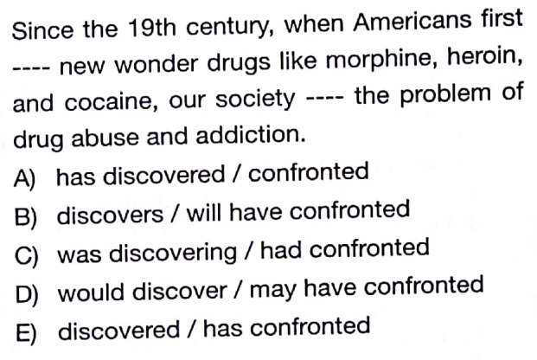
4-
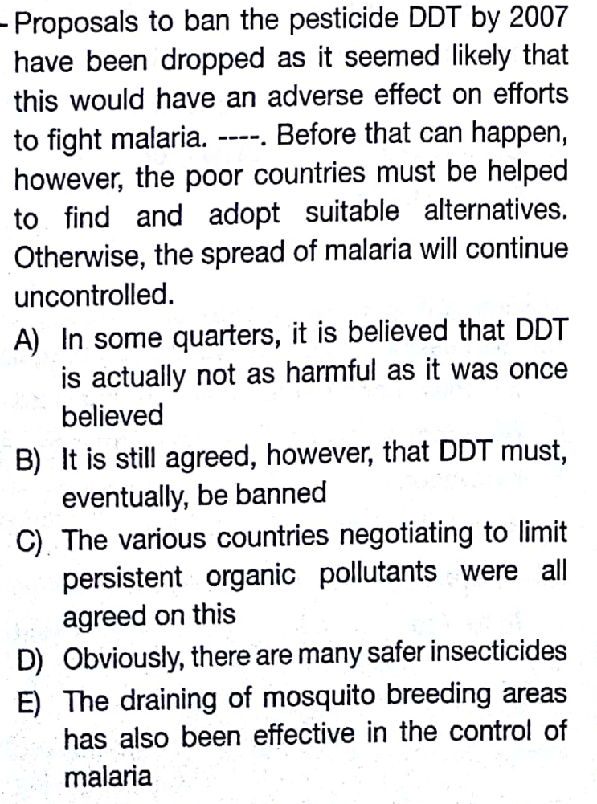
11-

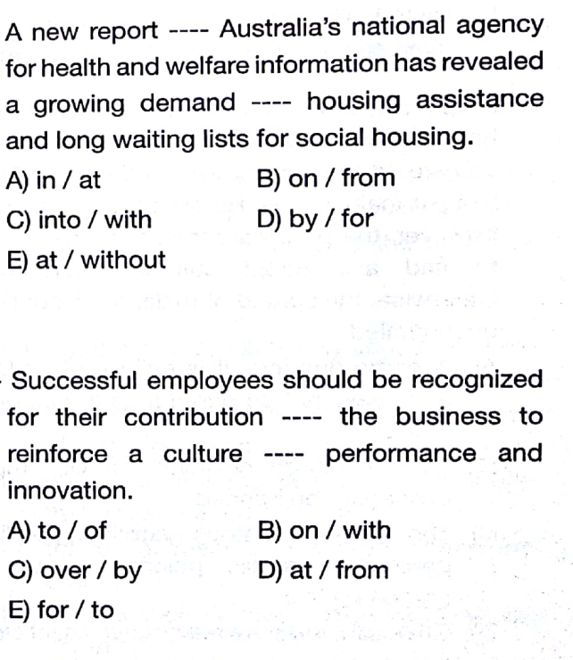
5-

6-

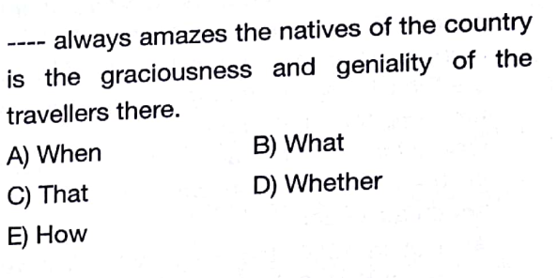
7-

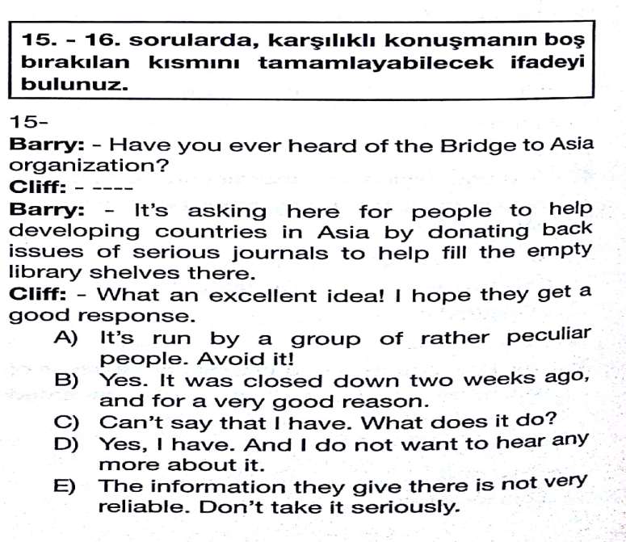
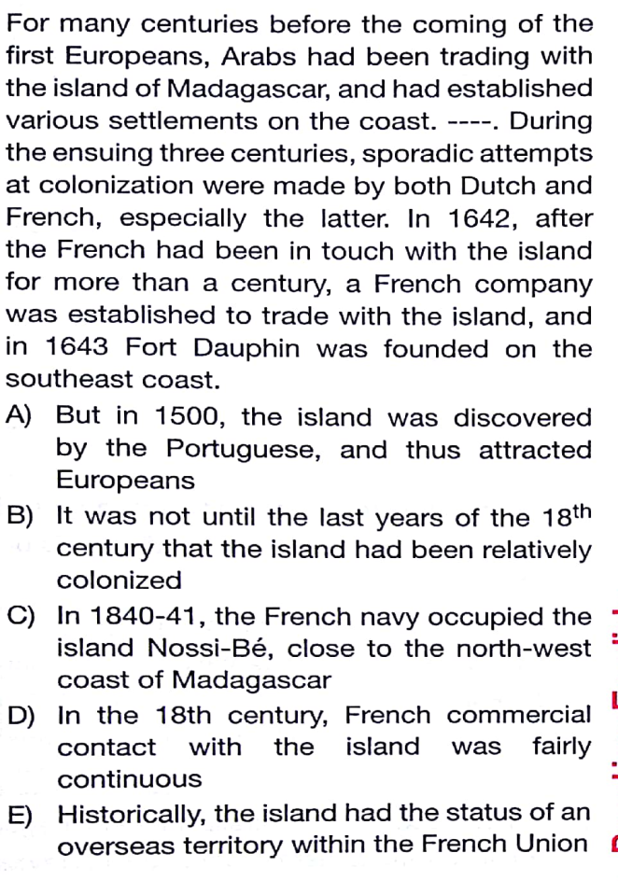
12-

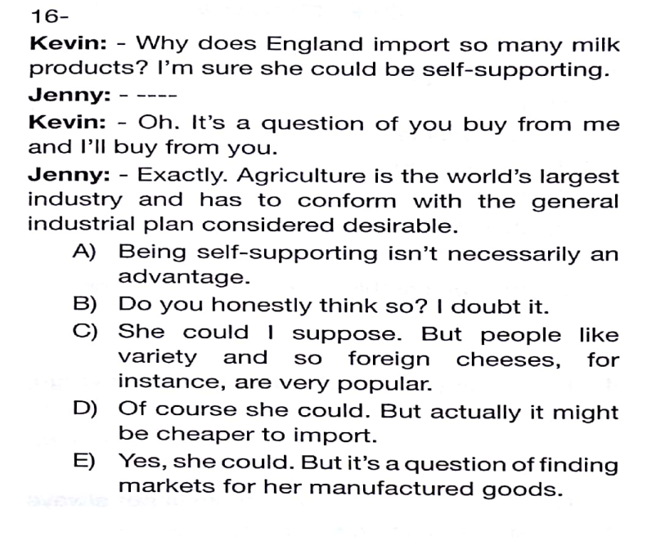

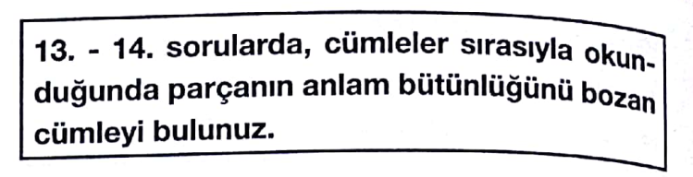

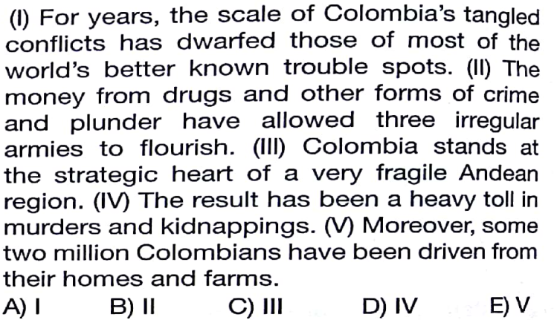
13-
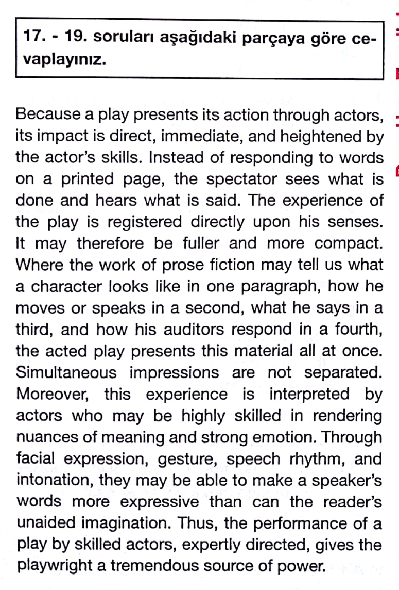

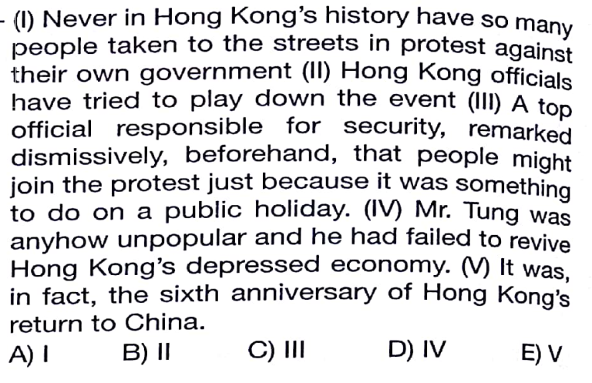
14-

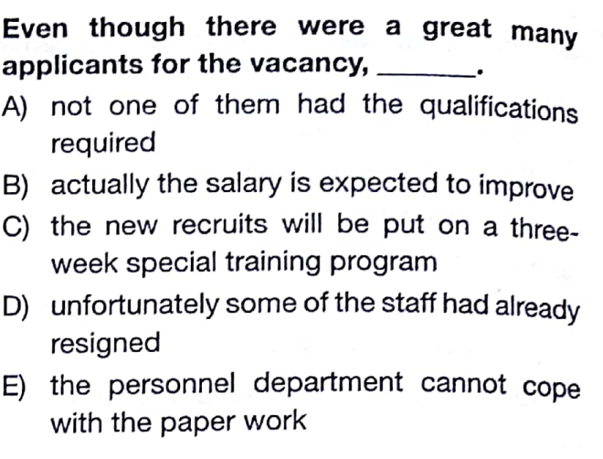
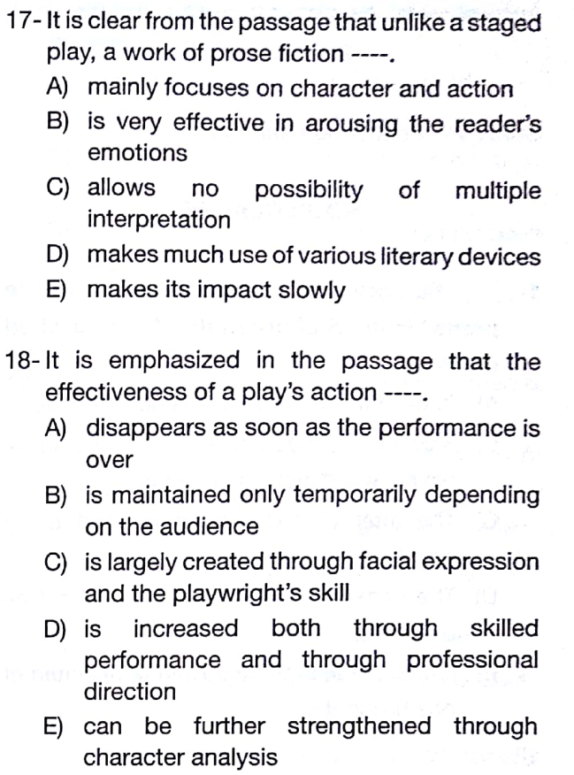
22-

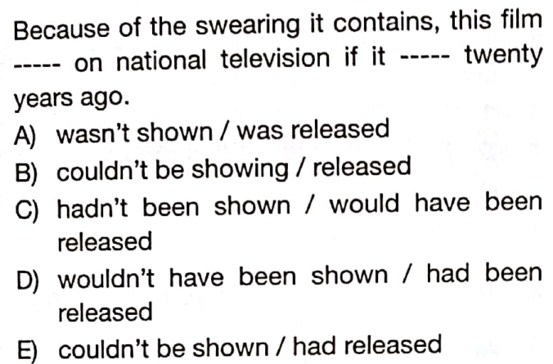
23-

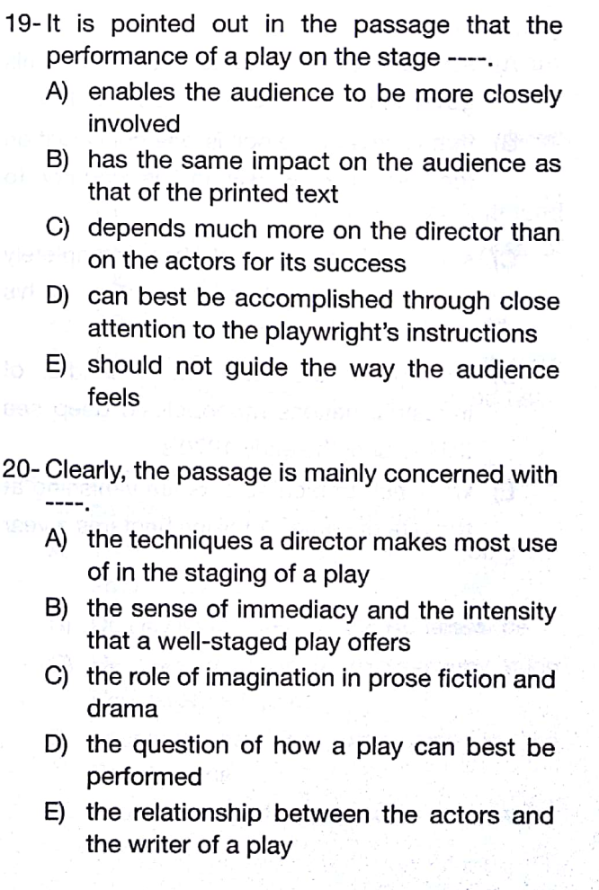

24-
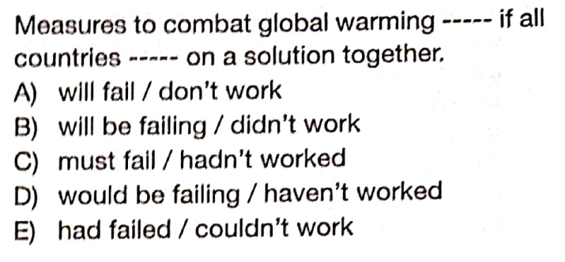

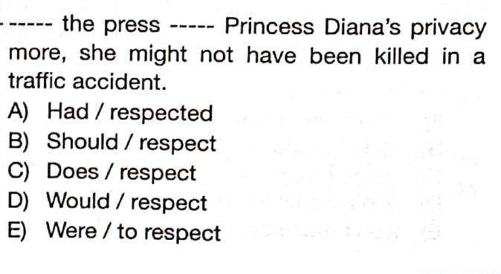
25-
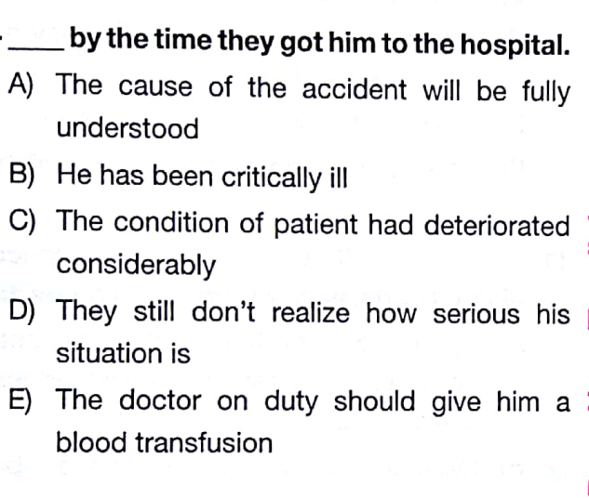
21-

GOOD LUCK
Aydın GÖZÜPEK (ELT INSTRUCTOR)

EMİR SULTAN ANATOLIAN HIGH SCHOOL12th LANGUAGE CLASS ELECTIVE ENGLISH
1st TERM ^{nd} EXAM
NAME&SURNAME:
NUMBER: MARK:
A-COMPLETE THE SENTENCES WITH THE CORRECT WORDS.(2*10=20pts)
inevitable | evokes | distraction | devote | ample
prevail | confined | revealed | deception | enthusiastic

1-He left government to _____________more time to his privacy.
2-I am sure that common sense will_____________in the end.
3-She_______________ her history to him because she thought it was important.
4-When you’re working such long hours,it’s _____________that your marriage will start to suffer.
5-He was found guilty of obtaining money by __________
6-That dreadful noise is driving me to___________I cannot concentrate at all.
8-The perfume ‘Exclamation’ always ______________memories of my university days.
9-This product is preferable to use for a patient who is____________to bed.
10-Well, you could try to look a little more _____________.
B-MATCH THE WORDS WITH THEIR SYNONYMS(1*5=5PTS)
1- Pave the way |  | error,mistake
2- distorted |  | Unite,join
3- merge |  | Counterfeit,fake
4- forgery |  | Warped,misshapen
5- fallacy |  | lead,precede

