………… ACADEMIC YEAR

SABANCI VOCATIONAL AND TECHNICAL ANATOLIAN HIGH SCHOOL

FIRST SECOND WRITTEN EXAM OF 11TH GRADES
NAME-SURNAME: MARK:
CLASS-NUMBER:

- READ THE PASSAGE BELOW AND WRITE “TRUE” OR “FALSE”.(4x5=20p)
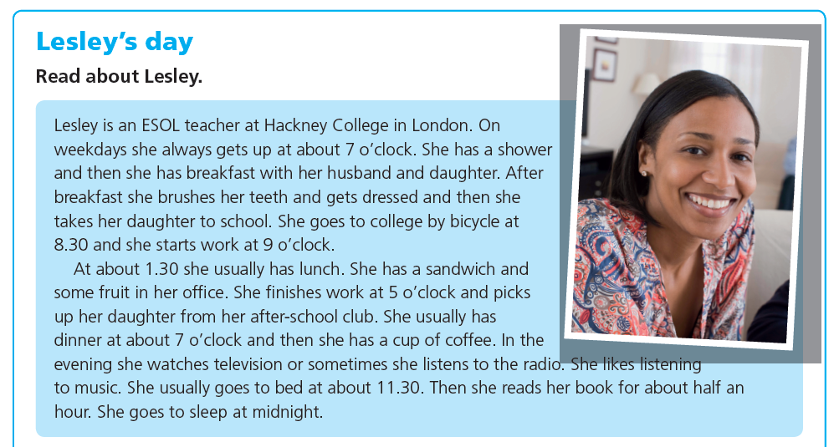
- Lesley gets up at 7 on weekends. ............
- Lesley is a married woman. ............
- Her daughter doesn’t go to school. ............
- Lesley reads book for two hours every night. ............
- She goes to work by bicycle. ............

- FILL IN THE BLANKS IN FORM OF SIMPLE PAST TENSE.(10x3=30p)
- I ________ (know) that someone came here today.
- Lydia ___________ (call) me yesterday after school.
- I don’t like Susan because she _____________(break) my arm last year.
- My cousin ______________(not write) anything when I was away.
- Where _________ Jack __________ (move) to?
- The weather _______(be) warm last week so we went to picnic.
- We _____________(buy) a new car and it is so fancy.
- ___________ you ___________ (eat) Lucy’s to birthday cake?
- I guess you came to me last night but I __________(not see) you.
- What ______ they _________(teach) you on the camp?

- MAKE SENTENCES IN THE CORRECT FORM OF WISH CLAUSES.(5x6=30p)
- Your father never comes to cinema with you.
- You didn’t study for Math exam and you failed.
- You don’t have enough money to buy a dress for graduation party.
- Your best friend didn’t call you for your birthday.
- Lucy is good at English but she doesn’t help you.

- WRITE THE TURKISH MEANINGS OF THE GIVEN WORDS.(10x2=20p)
consequence: hesitate:
genius: ashamed:
regret: purchase:
cheat: empire:
wish: conquer:

GOOD LUCK
ENGLISH LANGUAGE TEACHER
DUYGU ULAŞ

