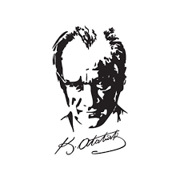 | …………. ACADEMIC YEAR ………………….ANATOLIAN HIGH SCHOOL  1ST TERM 2ND ENGLISH EXAM FOR  THE 11TH GRADES | 

Name Surname : __________________________ Date : ... .12.2019
Class – Number : __________________________ Point : _______

- PAST SIMPLE or PAST PERFECT? READ THE SENTENCES CAREFULLY AND CIRCLE THE CORRECT OPTIONS. (30 POINTS)

1. The robbers left / had left the bank when the policemen finally arrived / had arrived.
2. When the rain started / had started , the Rebecca finished / had finished planting trees.
3. By the time Rebecca went / had gone into the store , she got / had got soaked.
4. Darcey saw / had seen this castle before she came / had come again last Sunday.
5. Mr.Palmer didn't speak / hadn't spoken any Turkish before he moved / had moved to Turkey.
6. Sonny got / had got fainted by the time the ambulance reached / had reached the hospital.
7. When my mother brought / had brought me an apple , I finished / had finished my homework.
8. Mrs.Wilkinson refused / had refused to drive the car because she had / had had a terrible
accident on the highway about a year ago.
9. I didn't think / hadn't thought of having a new car before I saw / had seen that ad on TV.
10. My uncle didn't try / hadn't tried Mexican food before went / had gone to that restaurant.

- MATCH THE HOBBIES WITH THE NAMES AND ANSWER THE QUESTION. (25 POINTS)

JUGGLING | ICE-SKATING | KNITTING | MODEL MAKING | PARKOUR
POTTERY | TREKKING | COLLECTING STAMPS | TURKISH CALLIGRAPHY | MOUNTAIN-CLIMBING

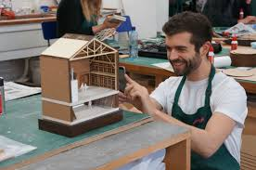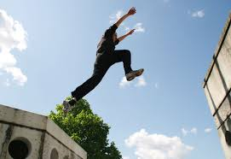

…………………………… …………………………….. ……………………………. ……………………………..

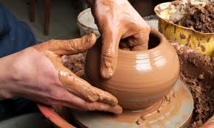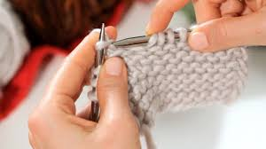

…………………………… ………………………… ……………………….. …………………………
Which hobby would you like to try? Why?
………………………………………………………………………………………………………………………………………………………………………………………..



…………………………… ……………………….

- READ THE SENTENCES CAREFULLY AND CHOOSE THE CLOSEST TRANSLATION. (9 POINTS)

- Jessica called me while I was parking the car.
- Jessica’yı aradığımda, o arabasını park ediyordu.
- Jessica aradığında, arabamı park etmiştim.
- Ben arabamı park ediyorken, Jessica beni aradı.

- I was sleeping when she knocked on the door.
- O kapıyı çaldığında, ben uyuyordum.
- O kapıyı çaldığında, ben uyudum.
- O kapıyı çaldığında, ben uyumuştum.

- My mum was preparing the lunch while my brother and I were doing the homework.
- Erkek kardeşim ve ben ev işi yapıyorken, annem öğle yemeğini hazırlıyordu.
- Annem öğle yemeğini hazırladığında, erkek kardeşim ve ben ödev yapıyorduk.
- Erkek kardeşim ve ben ödev yapıyorken, annem öğle yemeğini hazırlıyordu.

- READ THE PASSAGE AND ANSWER THE QUESTIONS. WRITE TRUE (T) or FALSE (F). (16 POINTS)

WHAT LIFE USED TO BE

‘’My name’s Alex and I’m 16 years old. Two years ago I had a car accident and since then I’ve been in this wheelchair. I had a truly hard time trying to accept the situation. I used to spend many hours feeling sorry for myself thinking it was the end of my life. I used to watch my friends from my bedroom window doing all the things I used to do with them.
I used to walk to school. I used to play football. I used to skateboard. Can I do all these things now? No, I can’t. now I have to get used to a different lifestyle. I have to believe in myself and try to make the best I can. Life is hard and I know it is going to be harder for me but I won’t give up.’’



- Alex had a car accident when he was 14 years old. ………………………
- Alex didn’t use to be an active boy. …………………….
- Alex used to be pessimistic about his situation. ………………………..
- Alex will try harder than other people for his life. ………………………..

- COMPLETE THE SENTENCES ACCORDING TO YOURSELF. (20 POINTS)

- I prefer ……………………………………………… because…………………………………………..
- When the teacher came in, ……………………………………………………………………………….
- I am gifted in ………………………………………………………………………………………………
- My dream job is ……………………………………………………………………………………………
- After I had finished primary school, ……………………………………………………………………….

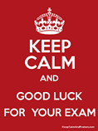

………………………….. / ELT
……………………….. / ELT

