…………………………………… MIDDLE SCHOOL FIRST TERM FIRST ENGLISH EXAM GRADE 7
NAME SURNAME: CLASS NUMBER:
A-) CATEGORIZE WORDS AS PHYSICAL APPEARANCE OR PERSONALITY ( 8X2=16 P)
SLIM / HELPFUL / OUTGOING / OVERWEIGHT /PUNCTUAL / HANDSOME / TALL / EASYGOING
PERSONALITY | PHYSICAL APPEARANCE
helpful | slim
outgoing | overweight
punctual | handsome
easygoing | tall
B-) COMPLETE THE SENTENCES WITH THE WORDS BELOW (5 X 3 = 15 )
STUBBORN / PUNCTUAL / HONEST /SELFISH /GENEROUS

1. Mike doesn’t care about other people. He only thinks of himself. He is ..selfish.............
2. Tom always tells the truth. He never lies. He is ....honest.....................................
3. Tony never changes his mind. He is ....stubborn...........................
4. Sue has got a lot of money and she helps poor people. She is ....generous.................... .
5. My teacher is never late. She is very .....punctual.........................
C-) FILL IN THE BLANKS WITH COMPARATIVE FORMS ( 5 x 2 = 10 )
1. Lucy is ......slimmer .................................. (slim) than Sarah.
2. Today the weather is .......worse................................. (bad) than the weather yesterday.
3. My mother is ....more generous................................... (generous) than my father.
4. The living room is ........larger................................ (large) than the bedroom.
5. My sister is ...more hardworking..................................... (hardworking) than me.
ARCHERY / CYCLING/WRESTLING/VOLLEYBALL / SKIING
D-) WRITE THE SPORTS( 5x2=10)
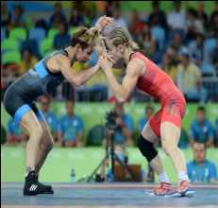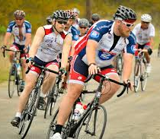 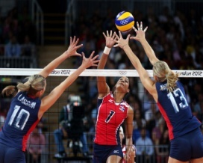 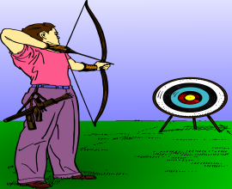……wrestling……. ……skiing…………… ……cycling…………. ………volleyball…….. ……archery…………..
E-) READ THE TEXT AND ANSWER THE QUESTİONS. (5×4=20 PTS.)
Betty and Lucy are sisters, but they are very different. Betty has long wavy blonde hair and brown eyes. Lucy is short with straight dark hair and blue eyes. Their personalities are also different. Betty is more hardworking than Lucy. She always does her homework and studies hard. She is also more outgoing than Lucy. She has a lot of friends and she enjoys spending time with them. They usually go to the cinema or play basketball at weekends. Lucy is shy and quiet. She loves being alone and playing computer games in her room. She is sometimes stubborn. She never changes her mind. Betty and Lucy don’t have similar personalities, but they get on well with each other. They have some hobbies in common. Their favourite activity is swimming and they go to the pool to swim three times a week.

1. What does Lucy look like? ..... Lucy is short with straight dark hair and blue eyes..........
2. What is Betty like? .....Betty is hardworking and outgoing............................................
3. Who is more successful at school? .......Betty is more successful.than Lucy....................
4. What do Lucy and Betty like doing together? .. Their favourite activity is swimming and they go to the pool to swim
5. How often do they go swimming? .... Three times a week..............................................
F-) MATCH THE QUESTİONS WİTH THE ANSWERS. (5×3= 15 PTS.)
(…E………)1. What is your mother like? A-) She likes going shopping
(…D………)2. How often does your sister go jogging? B-) I enjoy skating and rugby
(…A………)3. What does Emma like? C-) She is tall with curly Brownhair
(…B………)4. What sports are you interested in? D-) Twice a week
(…C………)5. What does your sister look like? E-) She is kind and helpful.

G-) WRITE THE SPORT EQUIPMENTS UNDER THE PICTURE ( 5 X 2 = 10 )
BALL / HELMET / RACKET / GOOGLES / GLOVES /

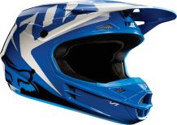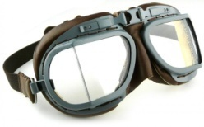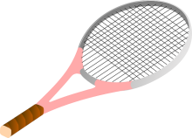
…helmet……….. …googles…… …racket…… …ball………….. …gloves…
H-) WRITE TWO INDIVIDUAL AND TWO TEAM SPORTS ( 4 X 1 = 4 )
INDIVIDUAL SPORTS: 1-)……swimming………….. .. 2-) …climbing………………….
TEAM SPORTS 1-) ……football…………. 2-) ……………baseball…………………
GOOD LUCK MR. İZGİ / ENGLISH TEACHER

