……………………………. EDUCATION YEAR ………………………………. SECONDARY SCHOOL
1st TERM 1st ELECTIVE ENGLISH WRITTEN EXAM
Name - Surname: Number:

- Find the words and complete the gaps. (3px8:24 pts)
stheon
goungtio
tthuogflhu
luffgroet
resogneu
ualpnctu
bbsturno
mclusy
  - My dad is ………………… honest……………………………………………………………
  - Her parents are ………… outgoing………………………………..
  - My neighbour is ………… thoughtful………………………………………………….
  - Our grandma is ………… forgetful……………………………………..
  - Their teacher is ……………generous………………………………………………….….
  - My classmates are ………punctual………………………………………...
  - My son is …………………… stubborn…………………………………………............
  - My wife is ……………………clumsy…………………………………………………………..

- Complete the sentences with the adjectives below. (3px8:24 pts)
Hardworking – selfish – jealous – lazy – polite – shy – rude – calm

  - This girl is very ………calm………………........... she never gets angry.
  - Ann is a ………………… jealous ………………. She feels sad when her friend gets high marks.
  - My brother is a ………lazy………………………… student. He always gets low marks.
  - Edmond is a ………… rude …………………….. person. He usually shouts at people.
  - My little sister is very …………shy……………………………… she can’t speak in front of people.
  - Eddie is a …………hardworking…………………………………… student. He always does his homework.
  - My friend is ………polite……………………………………. He always gives his seat to old people on public buses.

- Circle the odd one (2px8:16 pts)
  - İndividual team free
  - Swimming climbing scuba diving
  - Racket skate medal
  - Boxing football handball
  - Dangerous easy risky
  - An ankle pad a ball a wrist guard
  - Winter outdoor indoor
  - Rarely always seldom
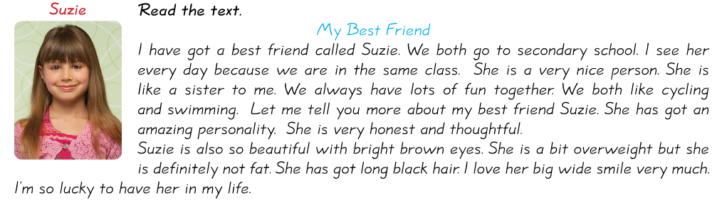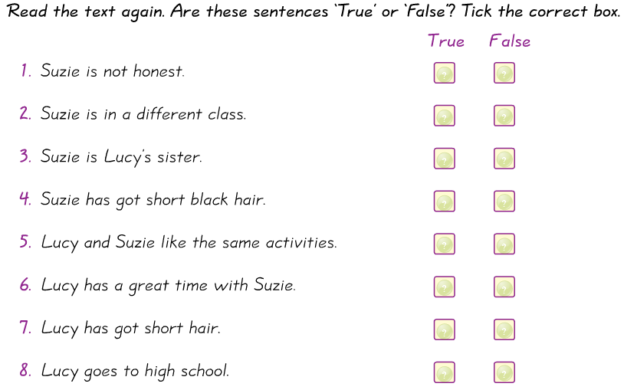
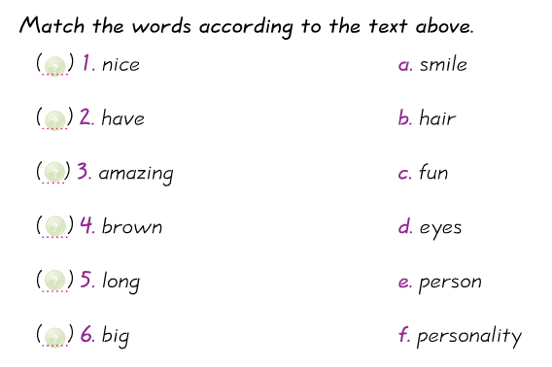

GOOD LUCK
Zeynep Kübra ÖZDEMİR

