…………………………………….. EDUCATIONAL YEAR ……………………………………………… SECONDARY SCHOOL 7TH GRADE 1ST TERM 1ST WRITTEN EXAM
Name-Surname: Number: Class:
A) Write the words to the correct boxes. (Verilen kelimeleri gruplayınız.) (24 points)
* beautiful * hardworking * quiet * tall * stubborn * selfish
* overweight * generous * short * slim * punctual * young
PERSONALITY
- ……hardworking….
- ……quiet………………….
- ……stubborn………………….
- ……selfish………………….
- ……generous……….
- ……punctual………………….

PHYSICAL APPEARANCE
- …beautiful…………………….
- …tall…………………….
- …overweight…………………….
- …short…………………….
- …slim………………….
- …young…………………….

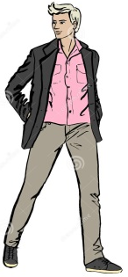


B) Write the names under the pictures. (Resimlerin altına anlatılan kişilerin isimlerini yazınız.) (18 points)




Ali Özlem Fatma Ayşe Ahmet Dursun

1) Ahmet: He is a handsome boy. He is tall and slim. 4) Özlem: She has got long wavy hair. She is very beautiful.
2) Fatma : She has got grey hair. She is old. 5) Dursun : He has got short curly hair and a big nose.
3) Ali: He has got short brown hair. He is overweight. 6) Ayşe: She has got glasses. She is ugly with wavy blonde hair.

C)Write the equipments under the pictures.(Spor malzemelerini uygun resmin altına yazınız.) (10 points )
Ball / Helmet / Racket / Goggles / Swimming Cap /
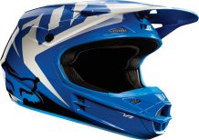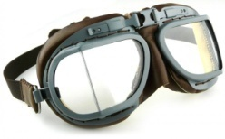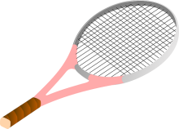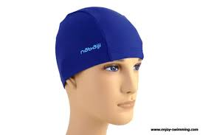
…helmet……… ……goggles……….… ……racket………… ……ball….…….. …swimming cap……
D) Fill in the blanks using the comparative forms of the adjectives. (Boşlukları sıfatların karşılaştırma halleriyle yazınız.) (10 points )
1) Math is .....more difficult................. than geography. (difficult)
2) Tayfun is ………slimmer………………………………….than Ahmet. (slim)
3) Winter is ………colder…………………………….than summer. (cold)
4) My English is ………better ……………………..than my Maths. (good)
5) Cem Yılmaz is …… funnier………………………………..than Ata Demirer. (funny)

E) Complete the sentences according to Simple Present Tense. (Cümleleri Geniş Zaman’a gore tamamlayınız. (20 points)

- Serap ..........lives........................ (live) in İzmir.
- They .....don’t have.................... (not have) breakfast at 7 o’clock.
- He ....doesn’t drink.................... (not drink) coffee in the mornings.
- We......love............................ (love) camping.
- She ....finishes.............................. (finish) the work in the evening.
- I ....don’t sleep.............................. (not sleep) 10 hours a day.
- My brothers .......come........................... (come) to Batman in summers.
- Eyüp .....doesn’t study............................. (not study) Maths.
- .Does......................... he work in the bank?
- .Are........................ they speak English

F) Choose the correct adjective.(Uygun sıfatı yuvarlak içine alınız.) (10 points)
- Roy always help people. He’s a helpful / stubborn boy.
- Linda and Sam are clumsy / outgoing girls. They have got a lot of friends.
- Tom always buys presents for his friends. He’s very rude / generous.
- Susan is very forgetful / kind. She always forgets her plans.
- Jane always come to class on time. She’s a shy / puctual girl.

G) Choose the correct option. (Doğru seçeneği işaretleyiniz.) (8 points)
1)Cem:............................?
Ali: I go running twice a week.

A) Do you go running?
B) How often do you go running?
C) Does he go running?
D) Where do you do?

2)Tim:_____________________?
Lora : Because I want to win medals.

A) Do you always train hard? B) Who do you train with? C) Why do you train so hard? D) Where do you train?

3) Selena : _____________________?
James : He is very honest and generous.

A) How is Harry
B) What is Harry like
C) Is Harry an honest person
D) What does Harry look like
4)Aşağıda verilen kelimelerle düzgün bir cümle oluştuurnuz
eat / always / I / food / healthy
A)eat I always food healthy.
B) I always eat healthy food.
C) I food eat healthy always.
D) I eat always healthy food.

