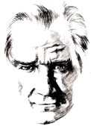 |  | ………………. SECONDARY SCHOOL  7TH GRADERS’ 1ST TERM 1ST WRITTEN EXAM |  |  |  | A
 | Name-Surname: |  | Class-Number: | P: |  | A
A) Fill in the chart (15x1= 15 Points)

big blue eyes
blonde hair
cheerful
green eyes
hardworking
helpful
listening to music
medium weight
riding a bike
selfish
surfing on the Net
talkative
tall
thin
watching movies

Personality | Appearance | Hobbies
Cheerful  Hardworking  Helpful  Selfish  Talkative | Big blue eyes  Blonde hair  Green eyes  Medium weight  Tall  Thin | Listening to music  Riding a bike  Surfing on the net  Watching movies
B) Match. (4x3= 12 Points)
1. | What does Mehmet look like?
2. | What is Murat like?
3. | What is Ayşe like?
4. | What does Zeynep look like?
2 |  | He is a generous and punctual person.
4 |  | She is a beautiful girl with curly hair and hazel eyes.
1 |  | He is tall and slim. He has got blonde hair.
3 |  | She is very clever and social.

C) Choose the correct option. (4x2= 8 Points)

1) An elephant is …… a cat.
a) big
b) more big than
c) more bigger than
d) bigger than
2) Kars is …… İzmir in winter.
a) cold
b) colder than
c) more colder than
d) more cold than

3) My father is …… me.
a) old than
b) more older than
c) older than
d) old
4) Toyota is…… Mercedes.
a) cheaper than
b) cheap
c) cheap than
d) more cheap than

D) Write the sports in the correct places. (10x1= 10 Points)

archery
baseball
basketball
football
handball
ice skating
roller-skating
skiing
swimming
volleyball

Team Sports | Individual Sports
Baseball  Basketball  Football  Handball  Volleyball | Archery  Ice skating  Roller-skating  Swimming  Skiing
E) Write “indoor” or “outdoor”. (5x2= 10 Points)
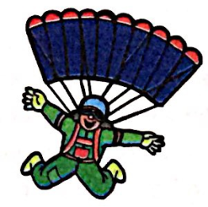 | 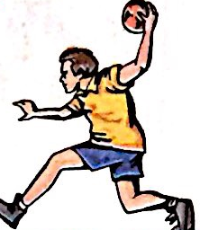 | 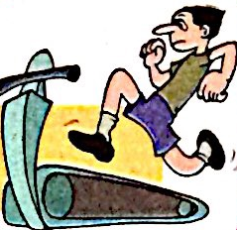 | 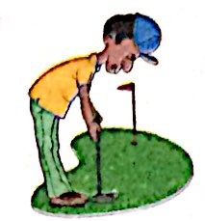 | 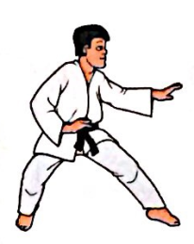
outdoor | indoor | indoor | outdoor | indoor
F) Match the words. (5x3= 15 Points)
- racket
- helmet
- goggles
- football
- cleats

 | 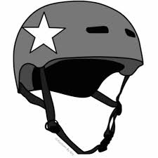 | 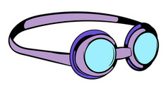 | 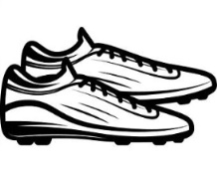 | 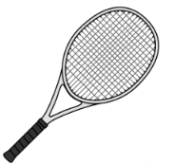
football | helmet | goggles | cleats | racket

G) Fill in the blanks with “was” or “were”. (14x1= 14 Points)

1. You ....were............ very noisy in class yesterday.
2. Thomas ..was........... at home the whole weekend.
3. Lucy...was........... at the shopping mall last night.
4. Mary ..was........... ill last week.
5. She ..was.............. at the school yesterday.
6. The cat ..was.............. in the garden.
7. They .were............ very sleepy last night.
8. David ....was......... at the bank yesterday.
9. My mother ...was......... born in August.
10. I...was........... at the station last night.
11. You ..were........... at the hospital yesterday.
12. They ..were........... at school yesterday.
13. I .was........... in Madrid on holidays last summer.
14. He..was............ a good student.

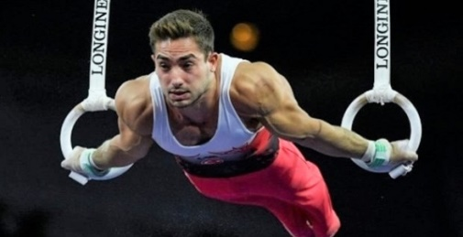
H) Read the text and answer the questions. (8x2= 16 Points)
İbrahim Çolak is a Turkish artistic gymnast. He was born in Konak on 7th January in 1995. He is from İzmir. He is 165 cm tall and 58 kg weight. He likes gymnastics. He trains six days a week. He enjoys outdoor sports such as football and jogging. He won the first gold in 2019 in Germany. It was also the first gold medal for Turkey in world championship.

1- What is his name?
……His name is İbrahim…………………………………

2- Where was he born?
…He was born in Konak……………………

3- When was he born?
…He was born on 7th January in 1995………………………
4- Where is he from?
… He is from İzmir ………………………………………………………
5- How old is he?
…He is 26 years old……………………………………………………

6- When did he win his first gold medal?
… He won the first gold in 2019…………………………………
7- How often does he train?
… He trains six days a week.…………………………………
8- Which outdoor sports does he enjoy?
… He enjoys outdoor sports such as football and jogging.....

 |  | YENIBOSNA SECONDARY SCHOOL  7TH GRADERS’ 1ST TERM 1ST WRITTEN EXAM |  |  |  | B
 | Name-Surname: |  | Class-Number: | P: |  | B

A) Fill in the chart (15x1= 15 Points)

watching movies
thin
tall
talkative
surfing on the Net
selfish
riding a bike
medium weight
listening to music
helpful
hardworking
green eyes
cheerful
blonde hair
big blue eyes

Appearance | Hobbies | Personality
B) Match. (4x3= 12 Points)
1. | What does Zeynep look like?
2. | What is Ayşe like?
3. | What is Murat like?
4. | What does Mehmet look like?
 |  | He is a generous and punctual person.
 |  | She is a beautiful girl with curly hair and hazel eyes.
 |  | He is tall and slim. He has got blonde hair.
 |  | She is very clever and social.

C) Choose the correct option. (4x2= 8 Points)

1) Fiat is…… Mercedes.
a) cheaper than
b) cheap
c) cheap than
d) more cheap than
2) My mother is …… me.
a) old than
b) more older than
c) older than
d) old

3) Ağrı is …… İstanbul in winter.
a) cold
b) colder than
c) more colder than
d) more cold than
4) A lion is …… a cat.
a) big
b) more big than
c) more bigger than
d) bigger than

D) Write the sports in the correct places. (10x1= 10 Points)

volleyball
swimming
skiing
roller-skating
ice skating
handball
football
basketball
baseball
archery

Individual Sports | Team Sports
E) Write “indoor” or “outdoor”. (5x2= 10 Points)
F) Match the words. (5x3= 15 Points)
- cleats
- football
- goggles
- helmet
- racket

G) Fill in the blanks with “was” or “were”. (14x1= 14 Points)

1. He.............. a good student.
2. David ............. at the bank yesterday.
3. They ............. very sleepy last night.
4. The cat ................ in the garden.
5. She ................ at the school yesterday.
6. Mary ............. ill last week.
7. Lucy.............. at the shopping mall last night.
8. Thomas ................ at home the whole weekend.
9. You ................ very noisy in class yesterday.
10. I ............. in Madrid on holidays last summer.
11. They ............. at school yesterday.
12. You ............. at the hospital yesterday.
13. I.............. at the station last night.
14. My mother ............ born in August.

H) Read the text and answer the questions. (8x2= 16 Points)
İbrahim Çolak is a Turkish artistic gymnast. He was born in Konak on 7th January in 1995. He is from İzmir. He is 165 cm tall and 58 kg weight. He likes gymnastics. He trains six days a week. He enjoys outdoor sports such as football and jogging. He won the first gold in 2019 in Germany. It was also the first gold medal for Turkey in world championship.

1- What is his name?
………………………………………………………………………………………
2- How old is he?
………………………………………………………………………………………
3- When was he born?
………………………………………………………………………………………
4- Where was he born?
………………………………………………………………………………………
5- Where is he from?
………………………………………………………………………………………
6- How often does he train?
………………………………………………………………………………………
7- Which outdoor sports does he enjoy?
………………………………………………………………………………………
8- When did he win his first gold medal?
………………………………………………………………………………………

