……………………. EDUCATION YEAR ………………………… SECONDARY SCHOOL
7th GRADES 1st TERM 1st OPTIONAL ENGLISH COURSE EXAM
(GROUP A)
Name & Surname : No:
1. Categorize the words.(Kelimeleri doğru kategorilere ayırın.) (20 pts)
handsome - punctual - stubborn - slim - outgoing
honest - overweight - pretty - blonde - stingy

Appearance

Personality
punctual stubborn outgoing honest pretty stingy
handsome slim overweight blonde

2.Match the adjectives with their opposites.(Sıfatları zıt anlamlarıyla eşleştirin.) (10 pts)
1. old X ………young…………………
young ugly short
hardworking rude
2. tall X …… short………………
3. polite X …… rude……………
4. lazy X ……hardworking…………………
5. beautiful X …… ugly……………

3.Write the comparatives of the adjectives.(Sıfatların karşılaştırmalı hallerini yazın.) (14 points)
1. Beren Saat is ...........beautiful than...................................... Bergüzar Korel. (beautiful)
2. Messi is .............better than.................................... Ronaldo. (good)
3. I am ........generous than....................................... my friend. (generous)
4. My grandmother is .........younger than........................................ my grandfather. (young)
5. Her sisters are ...............more hardworking than...................... her brothers. (hardworking)
6. Lions are ................faster than................................. Zebras. (fast)
7. İstanbul is ....................bigger than............................. Ankara. (big)

3.Match the equipments with the pictures. (Ekipmanları resimlerle eşleştirin.) (10 points)
a. trainers b. helmet c. googles d. shuttlecock e. arrow f. racket g.backpack

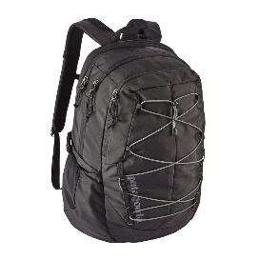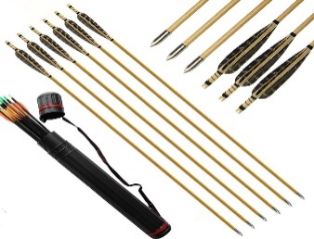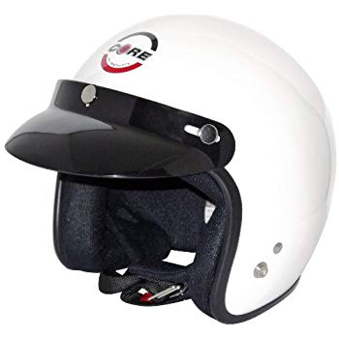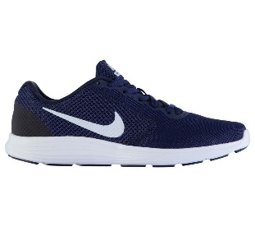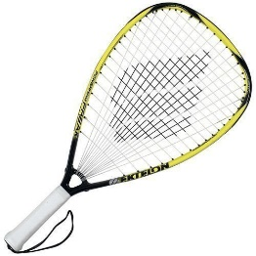
___backpack_____ __arrow_________ _____helmet____ __trainers______ __racket____

4.Circle the correct answer. (Doğru seçeneği yuvarlak içine alın.) (12 points)
1. Boxing/Climbing/Trekking is an indoor sport.
2.Would you like to play/do/go rafting?
3. Our school team won a score/medal/spectator.
4. Swimming/Skiing/Baseball is a team sport.
5. The score was 2-1. Turkey lost/draw/train the match.
6. I and my friends always play/do/go boxing.

5.Write the correct frequency adverb in the sentences.(Cümlelere doğru sıklık zarfını yazın.)(12 pts)
 | do gymnastics | play basketball | meet friends | ride a bike | go hiking | read a book
Jessica | X | **** | * | *** | ** | *****
( never / rarely / often / sometimes / usually / always )
1) Jessica …………never………………… does gymnastics.
2) Jessica ……… usually………………… plays basketball.
3) Jessica …………rarely………………… meets friends.
4) Jessica ……………often……………… rides a bike.
5) Jessica …………sometimes………………… goes hiking.
6) Jessica ………always…………………... reads a book.

6.Complete the paragraph according to Simple Present Tense. (Geniş Zaman’a göre paragrafı tamamlayın.) (22 points)

Hello, my name is Enes. I ………work……………………… (work) at a restaurant but I …don’t get up early………… (not get up) early. I really ………love……………………… (love) my job here. I have two good friends; Mehmet and Ayşe.
Mehmet …(usually) opens…………………………… (open) the restaurant every morning and he ………tidies…… (tidy) the tables. He ……doesn’t like………………………… (not like) his job. Ayşe always ……washes………………………… (wash) the dishes and ……cleans………………………… (clean) the kitchen. She ……doesn’t go………… (not go) home early. I usually …………finish……… (finish) my work at 3 o’clock and ………meet……………………… (meet) my friends at a café.

GOOD LUCK!
ERKAN TOY – TEACHER of ENGLISH

2018-2019 EDUCATION YEAR CENGİZ TOPEL SECONDARY SCHOOL
7th GRADES 1st TERM 1st OPTIONAL ENGLISH COURSE EXAM
(GROUP B)
Name & Surname : No:
1. Categorize the words.(Kelimeleri doğru kategorilere ayırın.) (20 pts)
blonde - stubborn - stingy - overweight thoughtful
slim - outgoing - handsome - punctual - pretty

Appearance
Personality

2.Write the comparatives of the adjectives.(Sıfatların karşılaştırmalı hallerini yazınız.) (14 points)
1. İzmir is ................................................. Batman. (big)
2. My sisters are ................................................. my brothers. (hardworking)
3. Melek is ................................................. Sevim. (generous)
4. My grandmother is ................................................. my grandfather. (young)
5. Beren Saat is ................................................. Bergüzar Korel. (beautiful)
6. Ronaldo is ................................................. Messi. (good)
7.Lions are ................................................. Zebras. (fast)

3.Match the adjectives with their opposites.(Sıfatları zıt anlamlarıyla eşleştiriniz) (10 points)
1. ___ X young
A – polite B – old C – beautiful
D – tall E – lazy
2. ___ X rude
3. ___ X ugly
4. ___ X hardworking
5. ___ X short

3.Match the equipments with the pictures. (Ekipmanları resimlerle eşleştirin.) (10 points)
a. backpack b. helmet c. arrow d. shuttlecock e. trainers f. racket g.googles

_______________ _______________ _______________ _______________ ______________

4.Circle the correct answer. (Doğru seçeneği yuvarlak içine alın.) (12 points)
1. Boxing/Climbing/Trekking is an indoor sport.
2.Would you like to play/do/go rafting?
3. Our school team won a score/medal/spectator.
4. Swimming/Skiing/Baseball is a team sport.
5. The score was 2-1. Turkey lost/draw/train the match.
6. I and my friends always play/do/go boxing.

5.Write the correct frequency adverb in the sentences.(Cümlelere doğru sıklık zarfını yazın.)(12 pts)
 | do gymnastics | play basketball | meet friends | ride a bike | go hiking | read a book
Jessica | X | **** | * | *** | ** | *****
( never / rarely / often / sometimes / usually / always )
1) Jessica …………………………… reads a book.
2) Jessica …………………………… goes hiking.
3) Jessica …………………………… plays basketball.
4) Jessica …………………………… rides a bike.
5) Jessica …………………………… meets friends.
6) Jessica …………………………... does gymnastics.

6.Complete the paragraph according to Simple Present Tense. (Geniş Zaman’a göre paragrafı tamamlayın.) (22 points)

Hello, my name is Enes. I ……………………………… (work) at a restaurant but I ……………………………… (not get up) early. I really ……………………………… (love) my job here. I have two good friends; Mehmet and Ayşe.
Mehmet ……………………………… (open) the restaurant every morning and he ……………………………… (tidy) the tables. He ……………………………… (not like) his job. Ayşe always ……………………………… (wash) the dishes and ……………………………… (clean) the kitchen. She ……………………………… (not go) home early. I usually ……………………………… (finish) my work at 3 o’clock and ……………………………… (meet) my friends at a café.

GOOD LUCK!
ERKAN TOY – TEACHER of ENGLISH

