……………………. GÖZPINAR İMKB BOARDING SECONDARY SCHOOL 1st TERM 1st WRITTEN EXAM FOR 6th GRADES
Name& Surname: Class: Number:

1.Aşağıdaki kelimelerin Türkçe anlamlarını yazınız. (3x8=24p.)

a.)Breakfast:…kahvaltı…………………. e.) Study:…ders çalışmak…………………..

b.)Healthy:……sağlık…………….. f.) Sell:……satmak…………………….

c.) Nutritious:…besleyici…………………… g.) Crowded:…kalabalık……………………….
d.) Cheap:…ucuz………………. h.) Wait:…beklemek…………………..

2.Verilen kelimeleri uygun resmin altına yerleştirin.(10X2=20 p.)
sausages – bread – milk – junk food – fruits – cheese – pancakes – muffin – toast – apple juice
 | 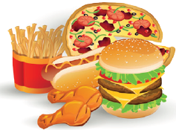 |   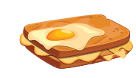 |  | 
apple juice | junk food | toast | fruits | pancakes
 | 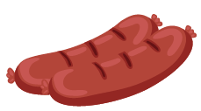 | 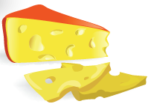 | 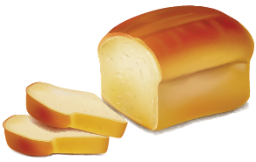 | 
muffin | sausages | cheese | bread | milk
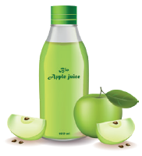
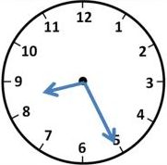
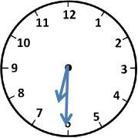
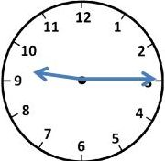
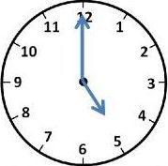
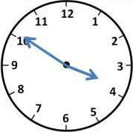
3. Aşağıdaki yazılı saatlerin yanına resimlerin altındaki harfleri uygun olacak şekilde yazınız. (10 p)
a-It is half past six _D__
b-It is ten to four _A__
c-It is five o’clock _C__
d-It is twenty-five past eight _B__
e-It is quarter past nine _E__ A B C D E
- Write the meanings words under the correct pictures. (12 points)
Farm - Skyscraper - Village - Feed The Animal - Traffic Jam - City
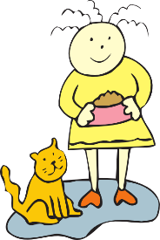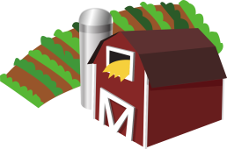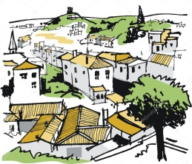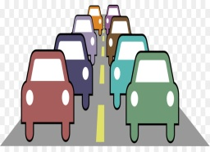

1 feed the animal 2…city…………… 3…farm………… 4 …village…. 5…skyscraper… 6 traffic jam
4. Resimlerin altına etkinliklerin isimlerini yazınız. (20p.)
a. run errands b. take care of pet c. visit grandmother d. wake up e. play football f. have breakfast g. take folk dance courses h. rest i. do homework j. go to bed
  1…have breakfast | 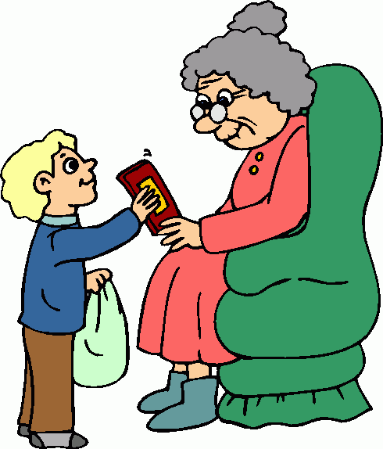  2…visit grandmother… |   3……rest……… |   4…take care of pet |   5 take folk dance courses
  6…play football… |   7…go to bed…….. | 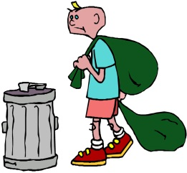  8…run errands… |   9…do homework… |   10…wake up.…..

5. Verilen metne göre resimlerin altına tik veya çarpı koyun. (15 points)
 | 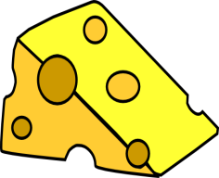 |  |  |  | 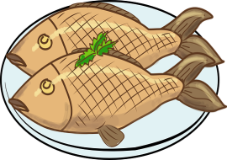 | 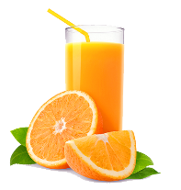
Aslıhan
Elif
Furkan
Hasan
Ayşe

- Aslıhan likes jam, omelette and fish but she doesn’t like cheese, muffin and orange juice.
- Elif likes cheese, muffin and orange juice but she doesn’t like jam, omelette and fish.
- Furkan likes omelette, muffind and fish but he doesn’t like cheese, jam and orange juice.
- Hasan likes jam, muffin and orange juice but he doesn’t like cheese, omelette and fish.
- Ayşe likes cheese, omelette and fish but she doesn’t like jam, muffin and orange juice.

Orhan DAĞ
English Teacher

