2020-2021 EĞİTİM ÖĞRETİM YILI ………………………. ORTAOKULU 1. DÖNEM 6. SINIFLAR 1. YABANCI DİL SINAVI
Name Surname: No: Class:
A Aşağıdaki kelimeleri resimlerin altına uygun düşecek şekilde yazınız. (20 p)
have breakfast – take care of dog – help father – have a rest – visit grandmother
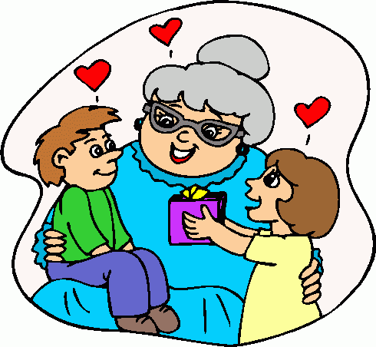 | 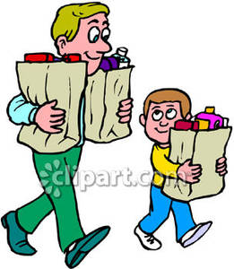 | 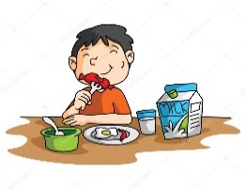 | 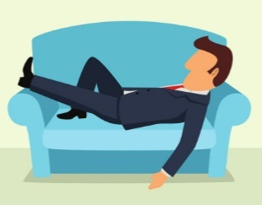 | 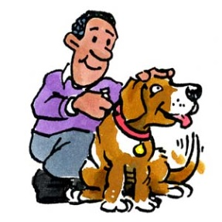
.visit grandmother. | …help father... | …have breakfast… | …have a rest... | …take care of dog…

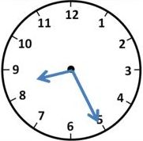
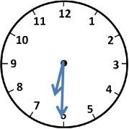
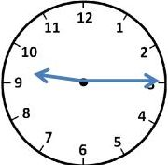
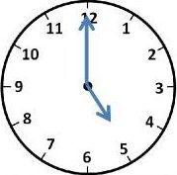
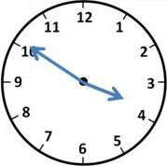
B- Aşağıdaki yazılı saatlerin yanına resimlerin altındaki harfleri uygun olacak şekilde yazınız. (10 p)
1-It is half past six _D__
2-It is ten to four _A__
3-It is five o’clock _C__
4-It is twenty-five past eight _B__
5-It is quarter past nine _E__ A B C D E

C- Aşağıdaki kelimeleri resimler ile eşleştiriniz. (24 p)
bagel – olives – sausages – jam – cheese – cucumber – cereal – butter

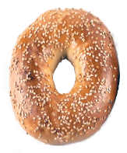 | 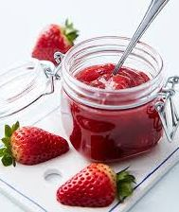 | 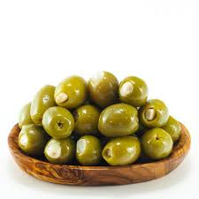 | 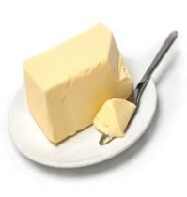 | 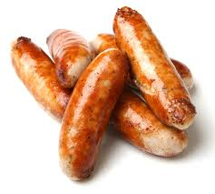 | 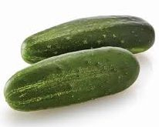 | 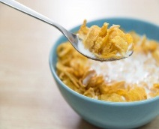 | 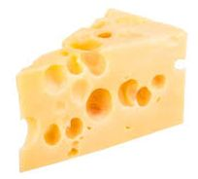
…bagel…… | ……jam….. | ……olives…. | ……butter… | …sausages. | cucumber | …cereal… | …cheese…

D- Aşağıda boş bırakılan haftanın günlerini tamamlayınız. (12 p)

1-SUNDAY 2-MONDAY…… 3-TUESDAY……… 4-WEDNESDAY……… 5-THURSDAY…… 6-FRİDAY………………
7-SATURDAY………………
https://www.sorubak.com

E- Aşağıdaki sorular ile cevaplarını uygun olacak şekilde eşleştiriniz. (10 p)
- What time does your school start? _C___ A- It is Wednesday.
- Do you do homework in the afternoon? _E___ B- He plays computer games.
- What does Hakan do after school? _B___ C- It starts at 7:30.
- What is the day today? _A___ D- Yes, she does.
- Does your sister drink milk? _D___ E- No, I don’t. I hate homework.
F- Aşağıdaki boşlukları “in, on veya at” ile doldurunuz. (12 p)
- I get up _at___7:00 o’clock.
- Salih attends folk dance course _on__ Thursdays.
- We have breakfast _in___ the morning.
- I go to bed _at___ 22:30 .

G- Aşağıdaki paragrafı okuyarak ifadelerin karşısına True (T) ya da False (F) yazınız.( 12 p)
My name is Selin. I get up at 6:45 on weekdays and I have a good breakfast. I love eating egg and cheese. I drink milk at breakfast because it is nutritious. I go to school by bus. My school starts at 7:30 and finishes at 13:10. My favourite school subjects is science. I love science and science teacher. I come home at 13:30 and have lunch. After lunch I have a rest. I do my homework between 15:30 and 17:30 Then I take care of pet. I take the dog for a walk at 18:00. I have dinner with my family at 19:30. After dinner I usually read a book. I go to bed at 22:00
- Selin has breakfast at home. __T_____
- She drinks tea at breakfast. __F_____
- She goes to school by bicycle. __F_____
- She has lunch after school at 13:30. __T_____
- She loves P.E. at school __F_____
- She reads a book after dinner. __T_____

