………………………. SECONDARY SCHOOL ………………….. EDUCATION YEAR 1ST TERM 1ST EXAM OF 6TH CLASSES

Name / Surname:
Number / Class:

- Read the text and write “True” or “False” (15 pts.)
1. Julia is thirteen year-old Italian boy. __F____
2. Paul likes playing football. ___T_____
3. Paul goes online every day. ___F_____
4. Paul doesn’t meet his friends at the
weekend. ___F_____
5. Julia and Paul like eating olive, cheese, eggs and sausages at breakfast. ___F_____
Hello! My name’s Paul. I’m from Italy. I’m thirteen years old. I like playing soccer in my free time. I sometimes go online. I attend guitar course at the weekend. After guitar course, I meet my friends.
I’ve got a sister, Julia. She likes eating olives and cheese at breakfast but I don’t like them. I love eggs and sausages.

- Fill in the blanks with the given words (10 pts.)
twice a day - every day - Never - at 8.15 - always

- I don’t like pop music, so I _____never___________ listen to it.
- I brush my teeth after breakfast and dinner. I brush my teeth __twice a day_____________.
- John takes folk dance course at 8.30 at school on Saturdays. He arrives at school ____at 8.15____________ on Saturdays.
- Mary’s favorite drink is lemonade. She drinks lemonade at breakfast __ everyday____________.
- I ___always_____________ take my books with me, because I love reading.

- Fill in the blanks with “Some” or “Any”. (10 pts.)

- Do you want ____some____________ milk?
- We haven’t got ___any_____________ cookies. Can you go to supermarket?
- You need ____some____________ flour to make a cake.
- We have ____some____________ cheese and three eggs to make an omelette.
- There are a few oranges but there aren’t ___any_____________apples on the table.

- Match the clocks. (10 pts.)
* 6.00
* 11.45
* 4.30
* 7.50
* 5.15
- Susy wakes up at ten to eight. ___7.50___________
- Amy takes a nap at half past four in the afternoon. ___4.30___________
- Micheal finishes his homework at quarter past five. ___5.15___________
- Maria plays chess with her friends at six o’clock at the weekends. __6.00____________
- I go to step dance class at quarter to twelve on Sundays. ___11.45___________

- Write the names of food. (10 pts)
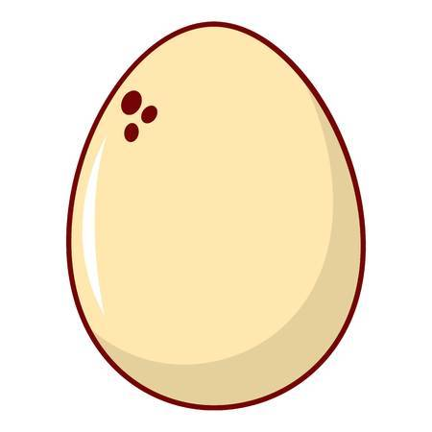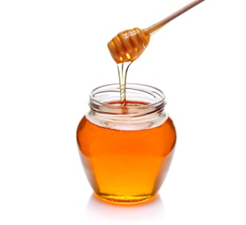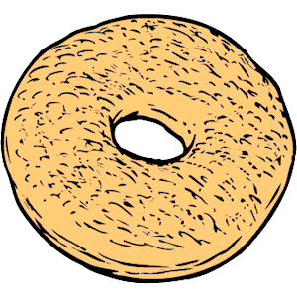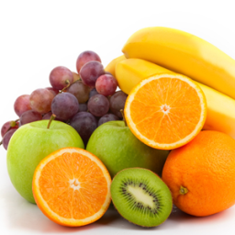

_____olive_______ _____egg_________ ___honey_______ _____bagel______ ___fruits_________

- Fill in the blanks with the given sentences. (15 pts)
* Yes, please. * It’s all gone. *Enjoy your breakfast.
*No, thanks. * There are olives, cheese and honey.

Alex : I am very hungry. What do we have for breakfast ?
Claire : _ There are olives, cheese and honey.______.
Alex : Is there any butter ?
Claire: Sorry, we haven’t got any . _ It’s all gone.______________________________. Do you want tomatoes?
Alex: _Yes, please. ________________________________. They are yummy!
Claire: Do you want to drink orange juice?
Alex: _ No, thanks._________________________________. I want to drink tea.
Claire: Enjoy your breakfast ________________________________.
https://www.sorubak.com
- Fill in the blanks with “like – likes – don’t like – doesn’t like” (20 pts.)

 | EVA | JOE | TOM | NINA
Riding bike | + | x | x | x
Watching film | + | + | + | x
Playing chess | X | x | x | x
Going shopping | + | + | x | +
Doing homework | X | x | + | +

- Eva ___likes___________________ riding a bike and going shopping.
- Joe ___doesn’t like___________________ playing chess.
- Tom and Nina __like____________________ doing homework but they ____don’t like______ riding bike.
- Tom and Joe ___like___________________ watching film but Nina ___doesn’t like___________________ it.
- Joe ____likes__________________ going shopping. Nina ____likes__________________ it, too.
- Tom and Nina__don’t like____________________ playing chess.
- Joe __doesn’t like__________________ riding bike or doing homework.

- Match the words. (10 pts)

1. TAKE CARE OF ___b____ a. MUSIC CLASS
2. RUN ___c____ b. THE PET
3. HELP ___e____ c. ERRANDS
4. WRITE ___d____ d. DIARY
5. ATTEND ___a____ e. DAD

