…………………. Academic Year ……………Secondary School 1st Term 1st English
Exam for the 6th Grades
Name&Surname: Class / Number:
A) Match the activities with the photos.(10x2=20)
tidy (my) room / run errands / do homework / go to school / do sports / take care of the pet / rest / visit relatives / take a nap / have breakfast


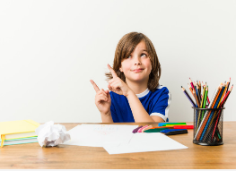
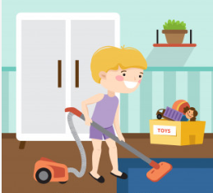
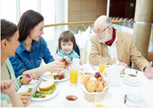
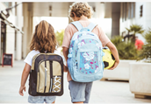



do sports do homework go to school tidy my room have breakfast

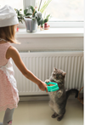
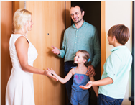
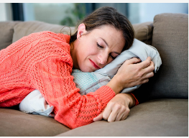
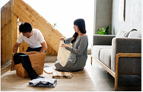

run errands rest take care of the pet visit relatives take a nap


B) Underline the correct Word (10x20)
Kate gets / get up early on weekdays. She has / have a shower.Afterwards ,she feeds /eats her cat and then she has/ have breakfast.She eats / eat olives, cheese, honey and butter at breakfast . She also drinks / drink tea. She sometimes eats / feeds salami. It is so yummy! At weekends, She gets up at 10 a.m. She loves having a big and long family breakfast. There are croissants, pancakes, bagels and toasts on the breakfast table. There is also butter, honey and jam but she doesn’t like eating them.After breakfast,She goes / takes out with her friends. They go /goes to cinema.They buy /buys popcorn and coke.


C) Write TRUE or FALSE acording to the passage.(5x2=10)
She gets up at 10 a.m. (T)
fromf from
New York.
She doesn’t get up early on weekdays. (T)

She doesn’t like eating butter,honey and jam. (F)

She loves having a big and long family breakfast. (T)

She doesn't have a shower. (F)
D) What time is it? Write the time. (5x2=10)
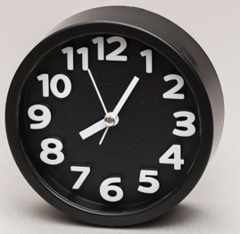


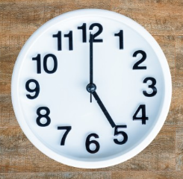
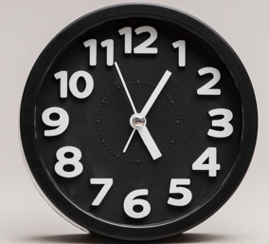

It’s five past five It’s five o’clock It’s five past eight It’s half past twelve It’s seventeen
past eight.

E) Complete the text with the words below. (10x2=20 )
have / eat / works / stay / go/ invite /reads /goes/play/prepares
fromf from
New York.

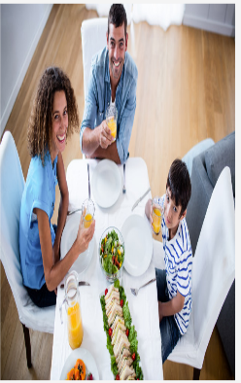
My favourite day of the week is Sunday. Nobody …works………… on Sunday morning.I usually …stay………….in bed until 10:30.My mother prepares…… a big breakfast. We …eat……….. breakfast. After breakfast we …play………. cards or read.My mother sometimes …goes……………… for a walk.My father …reads……………… newspaper. We have………. lunch outside on Sunday. In the evening we often invite…….. friends for dinner. It is very enjoyable for me. We never …go………… to bed before 1:00.

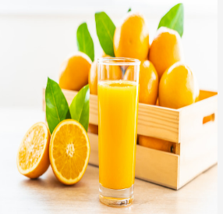

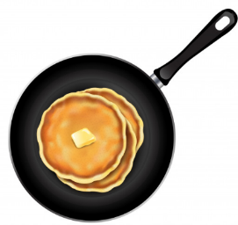
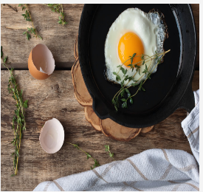
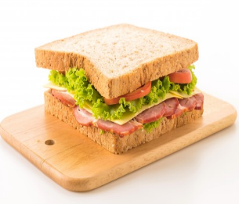
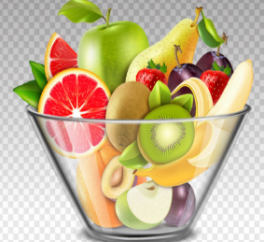

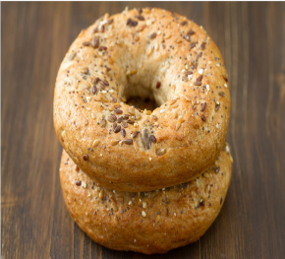
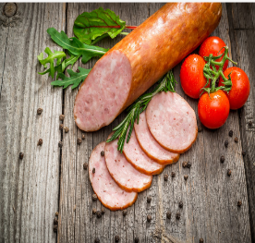
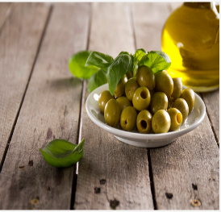
F) Label the pictures. Use the words given. (10x2=20 )
bagels
butter
eggs/ fruit juice/bagels/ butter/olives /junk food/sausages/toast/ fruit salad/pancake
fromf from
New York.
sausages
fruit juice
olives
toast
eggs
fruit salad
junk food
pancake

