|  |  |  |  |  |
| --- | --- | --- | --- | --- |
| **KARATAY BELEDİYESİ İHO 2018–2019ACADEMIC YEAR**  **7th GRADE 2nd TERM 1st ENGLISH WRITTEN EXAM** | | | | |
| **Name &Surname** |  | **No:** | **Class:** | **Mark** |

1. **Match the WORDS with pictures. (8p)**

**present – beverages – decorations – guests – music – invitation card –cake – traditional costume**

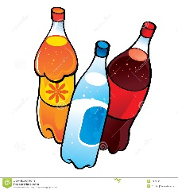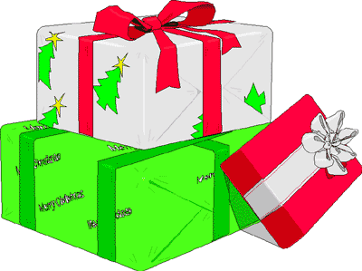



1. **CHOOSE THE CORRECT CHOICE. (18 pts.)**

**1.** She has got …………….. apple in his bag. **a)** an  **b)** some **c)** a lot of

**2.** We haven’t got ……………… balloons at home. **a)** some  **b)** any  **c)** a little

**3.** He has ………………. cheese. **a)** a  **b)** a few **c)** some

**4.** There are …………………. eggs in the fridge. **a)** a few **b)** much **c**) a little

**5.** ……………………… sisters have you got? **a)** How much  **b)** How many **c)** what

**6.** We haven’t got ………………. money. **a)** a fe **b)** many **c)** any

**7.** Kamil has got ………………….. books in his bag. **a)** little  **b)** a lot of **c)** an

**8.** Would you like ……………… coffee? **a)** some **b)** a **c)** a lot of

**9.** There are ………………….. oranges in the trees. **a)** any  **b)**a little  **c)** a lot of

1. **MAKE PREDICTIONS USING “WILL/WON’T” about your future dreams.12**

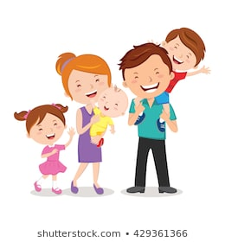 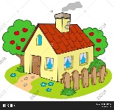 

**1.** I………………………………………..……….in my 20s.

**2.** I………………………………………………….in my 30s.

**3.** I………………………………………………….in my 40s.

**4.** I………………………………………….……….in my 50s.

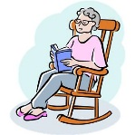 

1. Match the sentences **(Cümleleri eşleştiriniz.)(** 10)

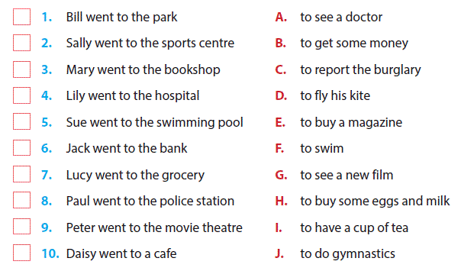

1. **Match the sentences.(Cümleleri eşleştiriniz.)(5x2=10p.)**

**1.** The weather is very hot and I need a beverage ………. **a.**Why don’t we study tonight?

**2.** We will have English exam tomorrow. ………. **b.** How about eating hamburger?

**3.** There aren’t any eggs in the fridge. ………. **c.** Let’s go to the grocery and buy some.

**4.** The weather is terrible. It is raining. ………. **d.** Shall we go to a cafe and drink coke?

**5.** I am very hungry.I need to eat something ………. **e.** Why don’t you take your umbrella?

1. **Match the pictures and sentences. (12p)**

a. People will have food pills instead of meals.

 b. The Internet will be more popular.

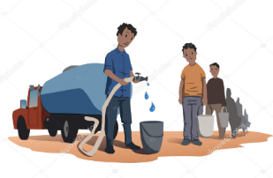c. Robots will teach children at home.

d. People will wear oxygen masks in streets.

e. People will travel into space.

f. There will be water shortage.

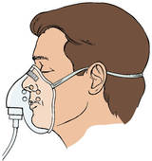

|  |  |  |
| --- | --- | --- |
| 1. ***Fill in the blanks (7x2=14points)***   **wrap - decorate - wear - invite**  **- send - have - celebrate**  1. We will …………..….. my father’s 40th birthday.  2. We will…………..….. a lot of guests.  3. I will …………..….. birthday presents.  4. My sister will …………..….. invitation cards.  5. My brother will …………..….. our house with balloons.  6. Guests will …………..….. party hats.  7. I’m sure we will …………..….. fun.   1. **ANSWER THE QUESTIONS.16 points** 2. Alex went to \_\_\_\_\_. Because he lost his wallet in the street yesterday.  |  | | --- | | Image result for LOST WALLET CARTOON |  1. Police station 2. Post Office 3. Chemist’s 4. Boutique | 1. 27-03-2019_19-40-58.jpg    **believe in yourself ile ilgili görsel sonucu**  **Şahin Taş**☺ **Good luck** |