Mehmet Soysaraç Ortaokulu ……………….. Eğitim-Öğretim Yılı 7.Sınıf İngilizce Dersi
2.Dönem 1.Yazılı Sınavı

Adı - Soyadı: Sınıfı / No: NOTU:

A. Match the names of the TV programmes with the pictures. ( 2 x 8 = 16 )
1 . News 2. Documentary 3. Quiz Show 4. Soap opera 5. Sports programme
6. Cookery programme 7. Reality Show 8. Cartoon

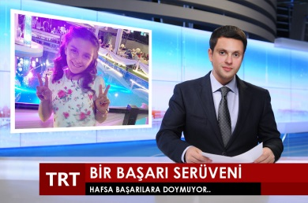

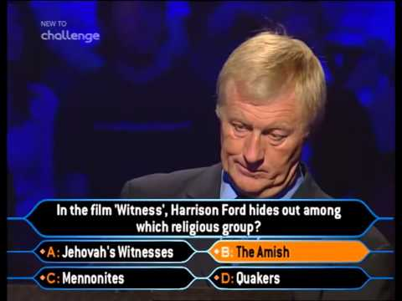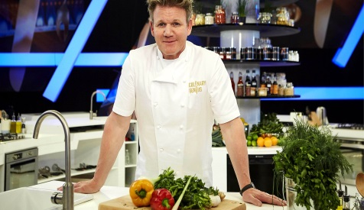

B. Complete the sentences with “ Simple Past Tense, Simple Present Tense, Future Tense ”. ( 4 x 5 = 20 )
1 . Robert …………………. a football match last night. (watch)
2 . It …………………. probably …………….. tomorrow. (rain)
3 . Tiffany …………………. the house yesterday. (decorate)
4. I usually …………………. a quiz show once a week. (watch)
5 . In the future, I …………………. in a big city. I want to live in a small city. (live)

C. Match the phrases. ( 2 x 7 = 14 )
eat / organise / wear / light / invite / send / visit
1 . …………………… funny clothes 2 . …………………… invitation card

3. …………………… candles 4 . …………………… relatives
5 . …………………… a traditional meal 6 . …………………… a birthday party
7 . …………………… guests
D. Fill in the boxes with phrases. ( 2 x 15 = 30 )

Would you like some coffee? / No, thanks. / That sounds good. / What about a sandwich? Let’s have a party tonigh. / I’d love to. / I’d rather not. / Shall we go together?
Do you fancy watching a documentary? / I don’t really like it. / Why don’t you join us? Yes, please. / Sure, why not? / Great idea. / Not really, thanks.

Offering / Suggesting

Accepting Refusing

E. Look at the invitation card and answer the questions. ( 4 x 5 = 20 )

1.What type of a party is it?
……………………………………….
2.Who is organising it?
……………………………………….
3.Where is it?
……………………………………….
4.What is the date of the party?
……………………………………….
5. What time does it start?
……………………………………….
Peter

