A. MATCH THE THE DATES TO THE SAYINGS. (15P)
- Twothousandandeight
- Nineteenthirtysix
- Nineteenoh two
- Eighteenhundred
- Twentytwentythree

A. 1902 ____
B. 2008 ____
C. 2023 ____
D. 1800 ____
E. 1936 ____

B. FILL IN THE BLANKS WITH ‘’ WAS – WERE – WASN’T – WEREN’T ‘’. (15P)
1. My sister ________ in Rome lastsummer. Shevisitedmuseums. (+)
2. I ________ at schoolyesterdaybecause I wasill. (-)
3. Where ______ he born?
4. Children ________ in theplaygroundtwohoursago. Theyplayedbasketball. (+)
5. We _________ at homebecausewewere in theshoppingmall. (-)

C) MATCH THE PLACES WITH THE PICTURES. (15P)
*roller coaster *Carousel *bumpercars *ghosttrain *ferriswheel

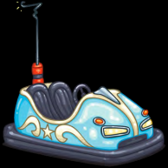 | 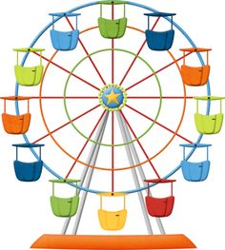 | 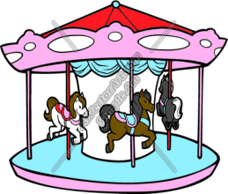 | 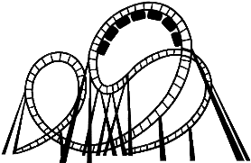 | 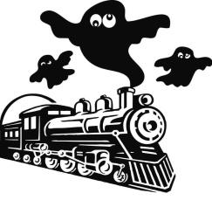

*in *on *at
D) FILL IN THE BLANKS WITH THE APPROPRIATE WORDS. (10P)
1. My grandfatherwasborn ___ 1948.
2. I do myhomework ___ 5 p.m.
3. Ourteacherdidn’tcometoschool ___ Tuesday , becauseshewasill.
4. My birthday is ___ 15th of September.
5. School finishes ___ Juneeveryyear.

E. WRITE THE MEANINGS OF WORDS AND EXPRESSIONS. (15P)
I agree: |  | Sewfabric:
Boring: |  | Repair car:
Amazing: |  | Pulloutteeth:
Fun: |  | Yesterday:
Frightening: |  | Mechanic:
I think: |  | Lastsummer:
Drive car: |  | Tailor:
Retired: |  | Engineer:

F. CIRCLE THE CORRECT CHOICE. (15P)
1. Wedidn’tinvite/invitedhimtotheparty but he came.
2. John come/cametotheschoolyesterday.
3. Didyougo/wenttothecinemalastweek?
4. Gamze didn’tplay/playedchesswith her sister.
5. Sultan drink/dranka glass of milklastnight.

G. MATCH THE JOBS WITH THE PICTURES (15P)
1. singer 2. nurse 3. Hairdresser 4. cook 5. teacher
