NAME/SURNAME CLASS: A)Write thenames of theactivitiesunderthecorrectpicture.(10 p )
Beachvolley / sunbathing / iceskating / climbingmountains /sightseeing / trekking /
having a picnic / diving / skiing / Sailing
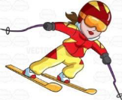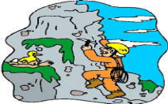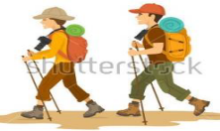
…………………………..…………………………..…………………………..…………………………..
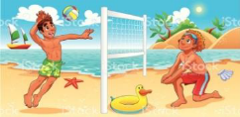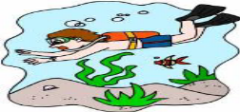
…………………………..…………………………..…………………………..…………………………..
B)Fill in thegapswith “ yesterday”, “ last”, “ago”(10 p.)
a. Murat was in İzmir ……………………month.
b. Güneş visited her grandparentsthreedays…………………………….. .
c. Wewere at home……………………………..night. Wewatched TV withmysister.
d. I was in a scoutcamp a month…………………………………….. .
e. Itwasrainy……………………………….but it is sunnytoday.

C)Fill in the blanks with the past form of the verbs (V2). (2x8= 16 Pts)
1.My dad……………(work ) last weekend.
2.Pelin ………………………… (not swim) in the pool yesterday.
3.Students _______ lessons last night. (study)

4.He……………………….(not listen) to music yesterday.
5.We……………(go) to İzmir two days ago.
6.Selim………………(get) up late yesterday.
7.We................( climb) trees and picked fruits.
8……..you…….(play) football yesterday
D) Matchthequestionswiththeanswers. (8p)
___ Whatis yourjob? A- Samet
___ Whendidyougotoschool? B- Murat Boz
___ How didyougotoschool? C- to Antalya.
___ What time do youhavebreakfast? D- Because it is funny.
___ Whydo youlike English? E- at 6:30 a.m
___ Wheredidyouflylastsummer? F- bybus
___ Whichsinger do youlove? G- in themorning
___ Whois your English teacher at school? H- I am a teacher.
E)Matchthedates. (5p)
1. 18 Nisan 2011 : ____ a.Thetwentieth of December , eighteen- eightysix
2. 30 Ağustos 1922 :____ b.Thefirst of July , nineteen- eightyfive
3. 1 Temmuz 1985 : ______ c.Thethirtieth of August , nineteen- twentytwo
4. 20 Aralık 1886 :_____ d.Theeighteenth of April , twothousandandeleven.
F)Complete thetextwith “in, at, on” (5p)
My father’s name is Jack. He is a mathsteacher. He usuallygetsup ______ 6.30.______ TuesdaysandThursdays he has lunch in theschool ______ 12.30, because he has lessons. ______ theweekend he getsuplater. My father has his summerholiday______ August. He has a difficultjob, but he loves it!
G)Complete thesentenceswiththecomparatives(5X2=10)
- Thecity is …………………...............…………………………. (crowded) thevillage.
- I thingcarousel is …………………...............…………………………. (boring)theswingingchairs.
- Mehmet thinksfairsare…………………...............…………………………. (big)playgrounds.
- Antalya is …………………...............…………………………. (hot) Erzurum in winter.
5.I agreewithyou. I thingtheGhosttrain is…………………...............……….(terrifying) thetrainride
H) Matchthedefinitionswiththejobs.(10P)
1. Teacher___ a)Helpsdoctorsandworks in ahospital
2. Secretary___ b) Works in a Office andanswersthephone
3. Nurse_____ c) Teacheslessonfort he student
4. Dentist____ d)Drives a taxi
5. Tailor_______ e) Works in an airport
6. Actor______ f)Writesnews on newspaper
7. Journalist____ g)Actsformovieortheatre
8. Driver______ h)Sellsthemeat
9. Pilot_______ i)Cutsandsewsthedresses
10. Butcher_____ j)Pullsouttheteeth

I)Fill in theblankswith “was – were – wasn’t – weren’t” ile doldurunuz.(8P)
1- Atatürk ...............born in Salonika in 1881.
2- I ...................atschoolyesterday, because I wasill.
3-Where......................youlastnight?
4- Pelin and Osman .................attheparty on Saturdaynight.
5-You.....................attheoffice an hourago! Youwere at thecinema.Isawyouthere!
6-Today it is sunny, but it ..............sunnyyesterday, it wasrainy.
7- I thinkthe film ...................veryfunny. I liked it!
8- I ………………..verygood at swimminglastsummer. I wonalot of medals

J) Circlethecorrectanswer of thequestions.(4X2:8P)
I.Jane:……………………………………………………………..  Tom:Lastweek.Itwasamazing.Iwouldliketogotherethissummeragain.  A)Wheredidyoustay in France?  B)How yourholiday in Paris?  C)Whendidyoucomebackfrom France?  D)Whatdidyou do in France? | III.Ali: I was on holidaybytheseaside.  Salih:………………………………………  Ali: I wasalone.  A)How was it?  B)Whenwereyouthere?  C)Whowaswithyou?  D)Wheredidyoustay?
- K: I was on a camp in themountainslastsummer.  M:………………………………. .I didn’tunderstand.  K: I wentcampimg in themountains.  A) Itwasn’tinterestingorfun.  B)I reallywantto do it.  C) Say thatagain , please.  D)You can goalso. | IV.Ayse: Ghosttrainsareamazing.  Can:……………………………… .Theyareboring.  A)I disagreewithyou.  B)Yes, I thinkso.  C)Sorry, I agreewithyou.  D)I don’tunderstand.
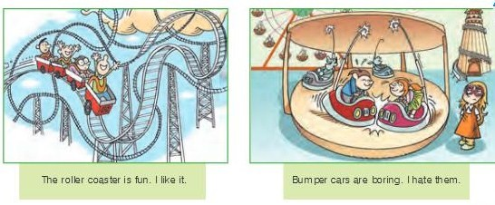
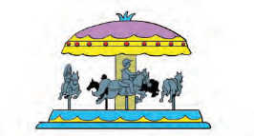
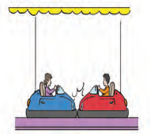
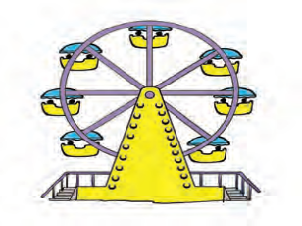
B)Matchpictureswithwords. Kelimelerle resimleri eşleştiriniz.(6P)a-BumperCars b- Chairoplane c- Ferris Wheel d- Carousel e-Roller coaster f -Ghosttrain
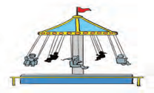
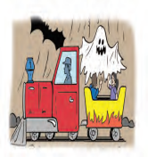

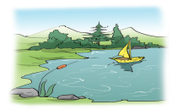
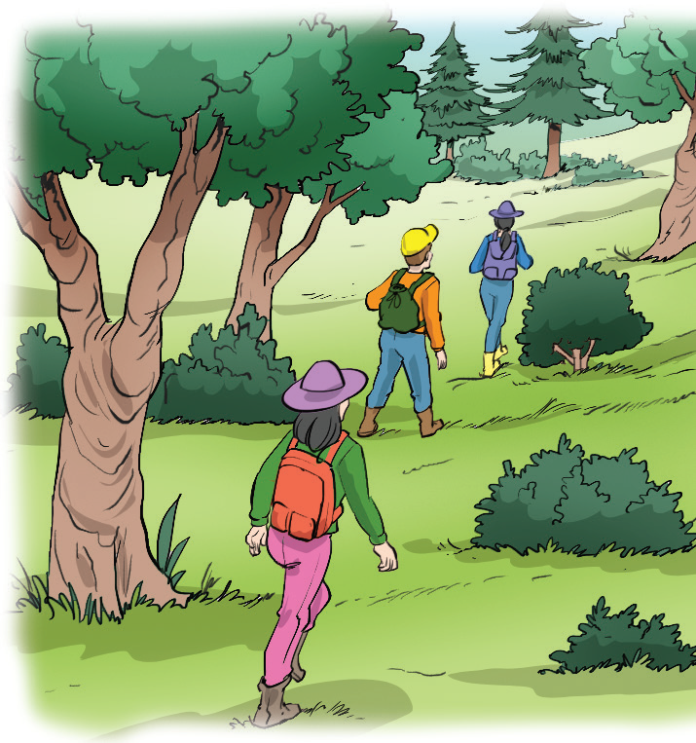
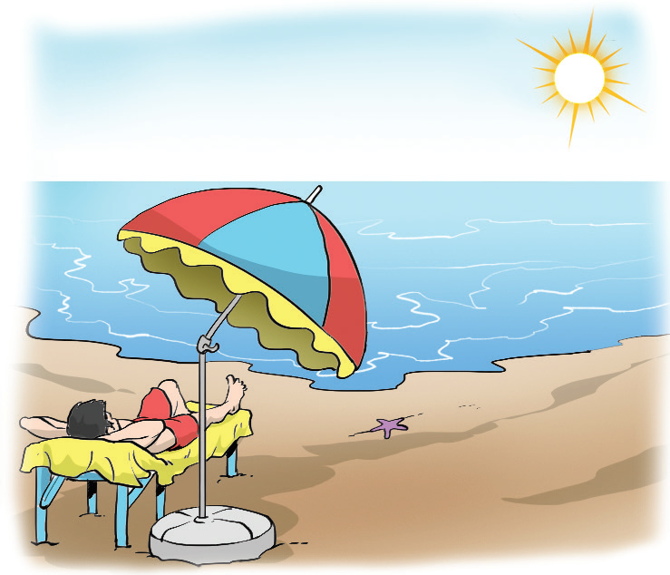
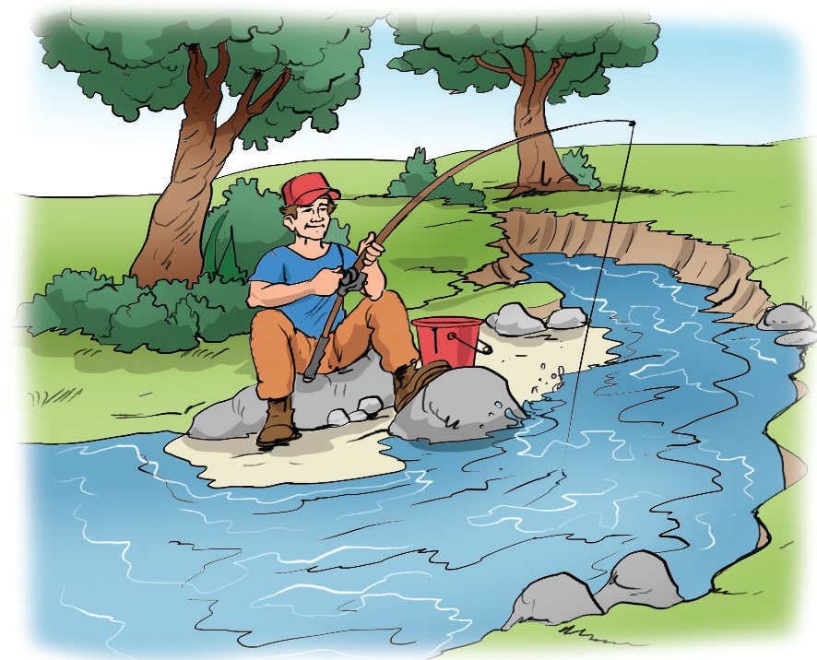
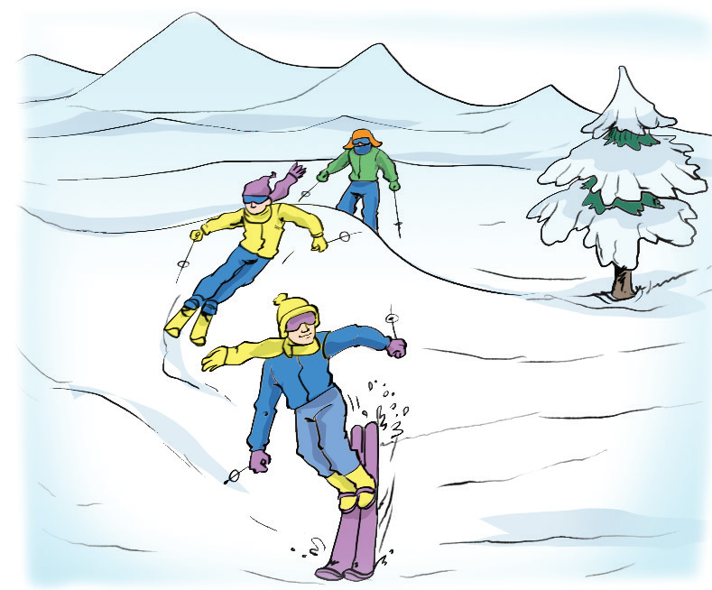
A) Matchtheplaceswiththepictures.(5P) (Resimlerle yerleri eşleştiriniz)lake – seaside – mountain – forest – river

