**A. MATCH THE THE DATES TO THE SAYINGS. (10P)**

1. Twothousandandeighteen
2. Nineteenthirtysix
3. Nineteenninetytwo
4. Eighteeneightyone
5. Nineteentwentythree

**A. 1992 __**

**B. 2018 __**

**C. 1923 __**

**D. 1881 __**

**E. 1936 __**

**B. FILL IN THE BLANKS WITH ‘’ WAS – WERE – WASN’T – WEREN’T ‘’. (10P)**

1**.** My sister ________ in Rome lastsummer. Shevisitedmuseums. (+)

2. I ________ at schoolyesterdaybecause I wasill. (-)

3. Where ______ he born?

4. Children ________ in theplaygroundtwohoursago. Theyplayedbasketball. (+)

5. We _________ at homebecausewewere in theshoppingmall. (-)

|  |
| --- |
| **C) MATCH THE PLACES WITH THE PICTURES. (10P)lake – seaside – mountain – forest – river** |

………………….…………………….……………………….……………………………….........

**D) FILL IN THE BLANKS WITH THE APPROPRIATE WORDS. (10P)**

**in – on – under – near – nextto – between – behind – in front of –over -**

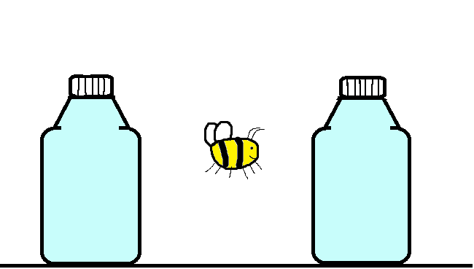

Thesheep is …………………………thebox. Thebee is …………………………thebottles.



Theapple is …………………………thebox. Thebird is …………………………the board.

**E. MATCH THE WORDS WITH THE PICTURES. (10P)**

**1. magazine 2. dictionary 3.newspaper 4. e-book 5. library**



**F. CIRCLE THE CORRECT CHOICE. (20P)**

1**.** Wedidn’t**invite/invited**himtotheparty but he came.

2**.** John **come/came**totheschoolyesterday.

3**.** Didyou**go/went**tothecinemalastweek?

4**.** Gamze didn’t**study/studied**totheexam.

5**.** Sultan **sing/sang**a perfectsong.

**G. WRITE THE PAST FORM OF THE VERBS. (20P)**

a. become………………………… f. buy …………………………

b. make………………………… g. break …………………………

c. do ………………………… h. take…………………………

d. put ………………………… i. begin…………………………

e. bring………………………… j. cut…………………………

**H. MATCH THE JOBS WITH THE PICTURES (10P)**

**1. singer 2. nurse 3. fireman 4. cook 5. teacher**

