**NAME/SURNAME CLASS: A)Write the names of the activities under the correct picture.(10 p )**

Beach volley / sunbathing / ice skating / climbing mountains /sightseeing / trekking /

having a picnic / diving / skiing / Sailing



**………………………….. ………………………….. ………………………….. …………………………..**



**………………………….. ………………… ……….. ……… ………………….. …………………………..**

**B)Fill in the gaps with “ yesterday”, “ last”, “ago”(10 p.)**

a. Murat was in İzmir ……………………month.

b. Güneş visited her grandparents three days …………………………….. .

c. We were at home……………………………..night. We watched TV with my sister.

d. I was in a scout camp a month…………………………………….. .

e. It was rainy………………………………. but it is sunny today.

**C)Fill in the blanks with the past form of the verbs (V2). (2x8= 16 Pts)** 1.My dad…………… **(work )** last weekend.

2.Pelin ………………………… **(not swim)** in the pool yesterday.

3. Students _______ lessons last night. **(study)**

4.He ……………………….**(not listen)** to music yesterday.

5.We…………… **(go)** to İzmir two days ago.

6.Selim ………………**(get)** up late yesterday.

7.We................**( climb)** trees and picked fruits.

8……..you…….(**play)** football yesterday

**D) Match the questions with the answers. (8p)**

___ **What** is your job? A- Samet

___ **When** did you go to school? B- Murat Boz

___ **How** did you go to school? C- to Antalya.

___ **What time** do you have breakfast? D- Because it is funny.

___ **Why** do you like English? E- at 6:30 a.m

___ **Where** did you fly last summer? F- by bus

___ **Which** singer do you love? G- in the morning

___ **Who** is your English teacher at school? H- I am a teacher.

**E)Match the dates. (5p)**

1. 18 Nisan 2011 : ____ a.The twentieth of December , eighteen- eighty six

2. 30 Ağustos 1922 :____ b.The first of July , nineteen- eighty five

3. 1 Temmuz 1985 : ______ c.The thirtieth of August , nineteen- twenty two

4. 20 Aralık 1886 :_____ d.The eighteenth of April , two thousand and eleven.

**F)Complete the text with “in, at, on” (5p)**

My father’s name is Jack. He is a maths teacher. He usually gets up ______ 6.30.______ Tuesdays and Thursdays he has lunch in the school ______ 12.30, because he has lessons. ______ the weekend he gets up later. My father has his summer holiday______ August. He has a difficult job, but he loves it!

**G) Put the words in the correct order.(10P)**

1-can /Atechnician / electrical devices / repair

…………………………………………………………………………………

2- to different places / A driver / drive people / can

…………………………………………………………………

3-write /A secretary / can / letters and e-mails

…………………………………………………………………………………

4-cars / can /A mechanic / mend

……………………………………………………………………………………

5-teach new things / at school /A teacher / can / to students

……………………………………………………………………………………

**H) Match the definitions with the jobs.(10P)**

1. Teacher___ a) Helps doctors and works in ahospital

2. Secretary___ b) Works in a Office and answers the phone

3. Nurse_____ c) Teaches lesson fort he student

4. Dentist____ d) Drives a taxi

5. Tailor_______ e) Works in an airport

6. Actor______ f) Writes news on newspaper

7. Journalist____ g) Acts for movie or theatre

8. Driver______ h) Sells the meat

9. Pilot_______ i) Cuts and sews the dresses

10. Butcher_____ j) Pulls out the teeth

**I)Fill in the blanks with “was – were – wasn’t – weren’t” ile doldurunuz.(8P)**

**1-** Atatürk ............... born in Salonika in 1881.

**2-** I ................... at school yesterday, because I was ill.

**3-** Where ...................... you last night?

**4-** Pelin and Osman ................. at the party on Saturday night.

**5-** You ..................... at the office an hour ago! You were at the cinema.I saw you there!

**6-** Today it is sunny, but it .............. sunny yesterday, it was rainy.

**7-** I think the film ................... very funny. I liked it!

**8-** I ……………….. very good at swimming last summer. I won alot of medals

**J) Circle the correct answer of the questions.(4X2:8P)**

|  |  |
| --- | --- |
| **I.Jane:……………………………………………………………..**  **Tom:Last week.It was amazing.I would like to go there this summer again.**  A)Where did you stay in France?  B)How your holiday in Paris?  C)When did you come back from France?  D)What did you do in France? | **III.Ali: I was on holiday by the seaside.**  **Salih:………………………………………**  **Ali: I was alone.**  A)How was it?  B)When were you there?  C)Who was with you?  D)Where did you stay? |
| 1. **K: I was on a camp in the mountains last summer.**   **M:………………………………. .I didn’t understand.**  **K: I went campimg in the mountains.**  A) It wasn’t interesting or fun.  B)I really want to do it.  C) Say that again , please.  D)You can go also. | **IV.Ayse: Ghost trains are amazing.**  **Can:……………………………… .They are boring.** A)I disagree with you.  B)Yes, I think so.  C)Sorry, I agree with you.  D)I don’t understand. |

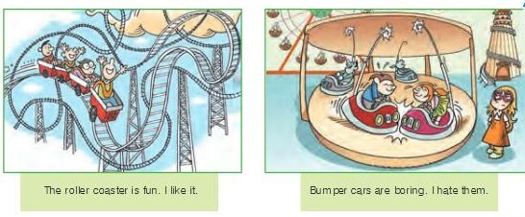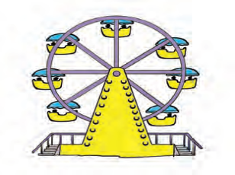**B)Match pictures with words. Kelimelerle resimleri eşleştiriniz.(6P) a-Bumper Cars b- Chairoplane c- Ferris Wheel d- Carousel e-Roller coaster f -Ghost train**

 

|  |
| --- |
| **A) Match the places with the pictures.(5P) (Resimlerle yerleri eşleştiriniz)** **lake – seaside – mountain – forest – river** |