………………. EDUCATIONAL YEAR
.............................................. SECONDARY SCHOOL 6 TH GRADE 2ND TERM 1ST ENGLISH EXAM
1)Write the names of the activities under the correct picture.(10 p )
Beach volley / sunbathing / ice skating / climbing mountains /sightseeing / trekking /
having a picnic / diving / skiing / Sailing
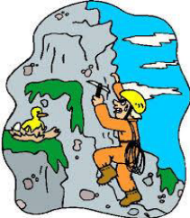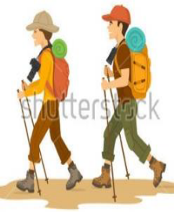
………………………….. ………………………….. ………………………….. …………………………..
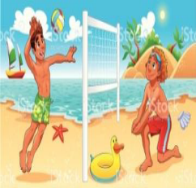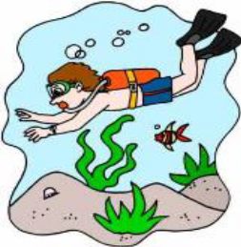
………………………….. ………………… ……….. ……… ………………….. …………………………..

2)Fill in the gaps with “ yesterday”, “ last”, “ago”(10 p.)
a. Murat was in İzmir ……………………month.
b. Güneş visited her grandparents three days …………………………….. .
c. We were at home……………………………..night. We watched TV with my sister.
d. I was in a scout camp a month…………………………………….. .
e. It was rainy………………………………. but it is sunny today.
3) Read the text and fill in the blanks with past form of the words.(20 p.)
Last week, my family and I ………………………(be)at a winter sports centre. We………………………(stay) at a nice hotel. We did a lot of interesting activities. I………………………..(learn) ice-skating. My parents ………………………(play) ice-hockey.We………………………..(walk)in the forest and ………………………..(have) a picnic there. The weather…………………………..(be)cold and snowy. We……………………….(make) a big snowman. Then, my sister ……………………………(go) snowboarding.We all ………………………(enjoy) our holiday!
4) Match the questions with the answers. (8p)
___ What is your job? A- Samet
___ When did you go to school? B- Murat Boz
___ How did you go to school? C- to Antalya.
___ What time do you have breakfast? D- Because it is funny.
___ Why do you like English? E- at 6:30 a.m
___ Where did you fly last summer? F- by bus
___ Which singer do you love? G- in the morning
___ Who is your English teacher at school? H- I am a teacher.
5)Match the dates. (5p)
1- Eighteen eighty-one (……)19th May
2- The twenty-ninth of October (……)1st May
3- Nineteen twenty-three (……)1881
4- The nineteenth of May (……)1923
5- The first of May (……)29th October
6)Complete the text with “in, at, on” (5p)
My father’s name is Jack. He is a maths teacher. He usually gets up ______ 6.30.______ Tuesdays and Thursdays he has lunch in the school ______ 12.30, because he has lessons. ______ the weekend he gets up later. My father has his summer holiday______ August. He has a difficult job, but he loves it!

7) Put the words in the correct order.
1-can /Atechnician / electrical devices / repair
…………………………………………………………………………………………………..................................
2- to different places / A driver / drive people / can
…………………………………………………………………………………………………..................................
3-write /A secretary / can / letters and e-mails
………………………………………………………………………………………………….................................
4-cars / can /A mechanic / mend
………………………………………………………………………………………………….................................
5-teach new things / at school /A teacher / can / to students
………………………………………………………………………………………………...................................
8) Match the definitions with the jobs.
1. Teacher___ a) Helps doctors and works in ahospital
2. Secretary___ b) Works in a Office and answers the phone
3. Nurse_____ c) Teaches lesson fort he student
4. Dentist____ d) Drives a taxi
5. Tailor_______ e) Works in an airport
6. Actor______ f) Writes news on newspaper
7. Journalist____ g) Acts for movie or theatre
8. Driver______ h) Sells the meat
9. Pilot_______ i) Cuts and sews the dresses
10. Butcher_____ j) Pulls out the teeth
9)Fill in the blanks with “was – were – wasn’t – weren’t” ile doldurunuz.
1- Atatürk ............... born in Salonika in 1881.
2- I ................... at school yesterday, because I was ill.
3- Where ...................... you last night?
4- Pelin and Osman ................. at the party on Saturday night.
5- You ..................... at the office an hour ago! You were at the cinema.I saw you there!
6- Today it is sunny, but it .............. sunny yesterday, it was rainy.
7- I think the film ................... very funny. I liked it!
8- I ……………….. very good at swimming last summer. I won alot of medals
10) Circle the correct answer of the questions.
Jane:……………………………………………………………..  Tom:Last week.It was amazing.I would like to go there this summer again.  A)Where did you stay in France?  B)How your holiday in Paris?  C)When did you come back from France?  D)What did you do in France? | - Ali: I was on holiday by the seaside.  Salih:………………………………………  Ali: I was alone.  A)How was it?  B)When were you there?  C)Who was with you?  D)Where did you stay?
- K: I was on a camp in the mountains last summer.  M:………………………………. .I didn’t understand.  K: I went campimg in the mountains.  A) It wasn’t interesting or fun.  B)I really want to do it.  C) Say that again , please.  D)You can go also. | IV.Ayse: Ghost trains are amazing.  Can:……………………………… .They are boring.  A)I disagree with you.  B)Yes, I think so.  C)Sorry, I agree with you.  D)I don’t understand.
NURFER TAVŞANKORU GOOD LUCK

