…… EDUCATION YEAR ENGLISH LESSON 6th CLASS THE SECOND TERM FIRST EXAM QUESTIONS

A)Write the names of the activities under the correct picture.(6 p)

**carrousel -chairoplane - bumper car - ferris wheel - roller coaster - ghost train**

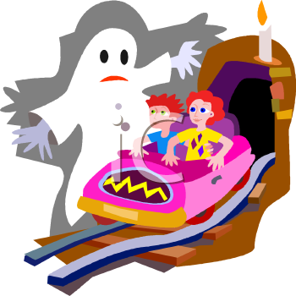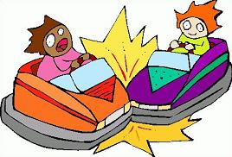

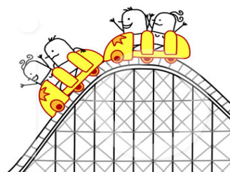

___________________ ______________________ ______________________

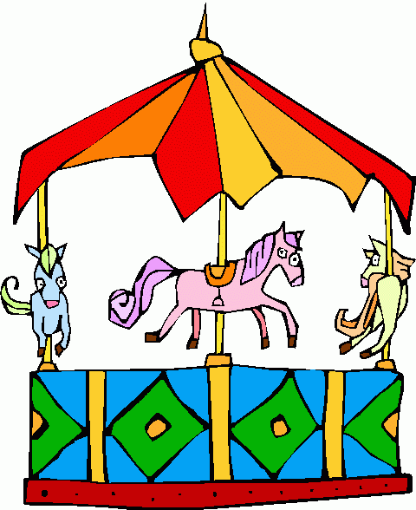

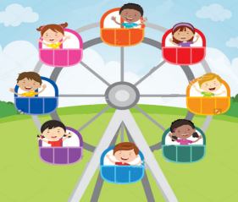

B) Fill in the blanks (4x2=8 pts.)



**dangerous**



**terrifying**

**boring**

## Rollercoaster is than Ferriswheel.

**faster**

* 1. Bumper carsaremore than Ferriswheel.
  2. Ghost trainismore thancarrousel.
  3. Ferris wheelis more than bumpercars.



**enjoyable**

* 1. Roller coasteris more thancarrouse



**C) .Fill in the blanks with (10X2=20**

**nurse**

**engineer hairdresser**

**salesman**

**waitress**

**chef**

**tailer**

**dendist**

**dentist**

**farmer**

**fireman**

1..I’man I can build roads, bridges andbuildings.

2.I’m a I can cut and sewfabric.

3.I’ma I can pull outteeth.

4.I’ma I can sell goods at ashop.

5.I’ma I can look after illpeople.

6.I’ma I can cut, dye and designhair.

7.I’ma I can grow fruits andvegetables.

8.I’ma I can serve food and drinks at arestaurant.

9.I’ma I can cook deliciousmeals.

10I’ma I can put outfires.

D ) Read and answer the questions.( 5x5 = 25)

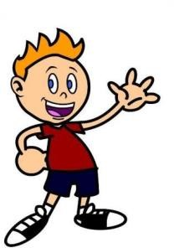

**Hi everybody! My name is Gezgin. Last summer I went to Antalya. I tried sailing and swimming there. It was very exciting. I went camping with my friends and we stayed in a tent in the forest but I think it was boring. I like water sports more. Also, I learned rafting. It was dangerous but it was very enjoyable. I went to Erzurum two months ago. It was very cold. I tried skiing there with my uncle. I think it is difficult but amusing. You should tryit.**

# Where was Gezgin lastsummer?

1. What did he try inAntalya?
2. Where did he stay with hisfriends?
3. What did he think aboutrafting?
4. Where did he go two monthsago?

E) Metnitekrarokuyunuzveaşağıdakicümlelerdoğruise TRUE, yanlışise FALSE yazınız.( 5x2 = 10

He thinks camping was very exciting.

He prefers water sports to camping.

**TRUE**

**FALSE**

**TRUE**

**FALSE**

It was very cold in Erzurum.

He went skiing with his friends.

**TRUE**

**FALSE**

**TRUE**

**FALSE**

He thinks skiing was challenging and amusing.

**TRUE**

**FALSE**

**F)Complete thetextwith “in, at, on” (5p)**

My father’s name is Jack. He is a mathsteacher. He usuallygetsup ______ 6.30

.______ TuesdaysandThursdays he has lunch in theschool ______ 12.30, because he has lessons. ______ theweekend he getsuplater. My father has his summerholiday

______ August. He has a difficultjob, but he loves i

**G)Sorularındoğrucevabınıişaretleyiniz.(14p)**

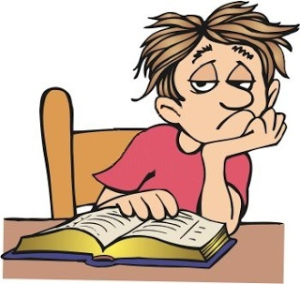

**.** 1.A:How do youfeel?

B:I fell ________.

a)suprised b)bored

c)scared d)happy

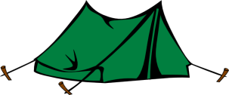

**2.**I stayed in a _____________on my

vacationlastsummer.

a)hotel b)house

c)tent d)museum

**3. A**:__________ is thefunfair?

**B:**It is in May

a)When b)What

c)What time d)Where

**4.Sude :** Ithinkghosttrainsarefrightening.

**Alice :** - - - - . Theyarefun.

A) I didn'tunderstand

B) That’sright

C)I agreewithyou

D) I don’tagreewithyou

**5. .**I feel ________ when it is stormy.



A) anxious

B) cheerful

C) sleepy

D) happy

**6. Boşluğahangisigetirilemez?**

**Dilan:** Where were you last summer?

**Nevin:** I was in Fethiye.

**Dilan:** …………………………. I didn’t understand.

**Nevin:**  I was in Fethiye.

A) Excuse me ?

B) Oh, really?

C) Say that again,please.

D) Pardon me?

**7. Jim:** ______________________?

**Linda:** It was great and funny.

A) Who were with you

B) How was your holiday

C) Where were you on holiday

D) When did you go on holiday

CEVAPANAHTARI:YOUTUBE NURFER TAVŞANKORU