…. EDUCATION YEAR ENGLISH LESSON 6th CLASS THE SECOND TERM FIRST EXAM
NAME: SURNAME: CLASS:
A) Match the places with the pictures. (Resimlerle yerleri eşleştiriniz)
lake – seaside – mountain – forest – river
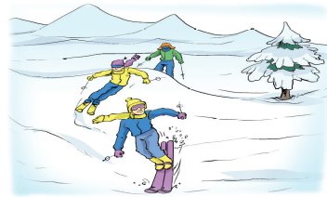 | 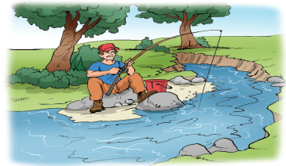 | 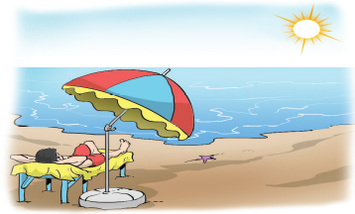 | 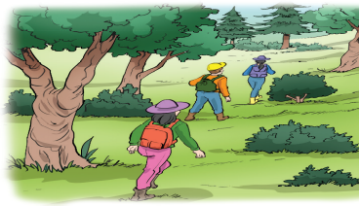 | 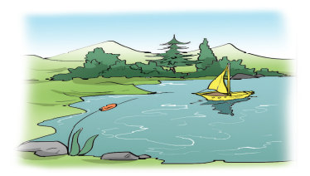
1. | 2. | 3. | 4. | 5.
B)Match pictures with words. Kelimelerle resimleri eşleştiriniz.
a-Bumper Cars b- Chairoplane c- Ferris Wheel d- Carousel e-Roller coaster f -Ghost train

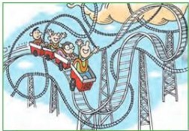
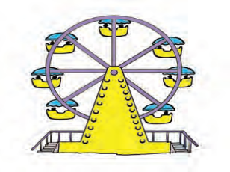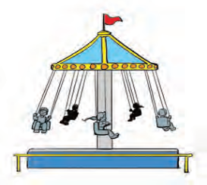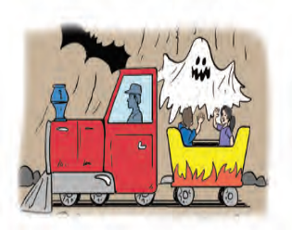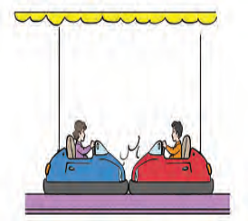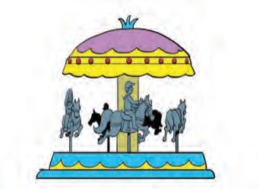
1……………………… 2……………………. 3………………………… 4…………………… 5…………………… 6…………………………

C) Answerthequestıons. (soruları cevaplayınız.)






1.What is he doing? 2.What aretheydoing? 3.What is he doing? 4.What is he doing? 5.What is he doing?
………………………………………………………………………………..…………………………………..…………………………………..…………………………………..

D)Fill in the blanks with suitable words. (Uygun kelimelerle cümleleri tamamlayınız.)
Tailor- School – doctor – mechanic - postman – soldier – dentist – architect – pilot -hairdresser
1. I liketeachingnewthingstostudents.Iwork at a …………………….……..
2. I am a ……………………………..... I can cut, dyeanddesignhair.
3. I am a ………………….…………. I can flytheplane .
4. I am an………………………………. I can designanddrawbuildingplans
5. He works in a clinic. He caresforpeople’steeth. ………………………………
6. Theyprotectthecountryfromtheenemies. ………………….……………….
7. I deliver letters. I’m a ……………………………………………
8. I am a …………………………………....I can repairthecars.
9. I am a…………………………………….I examine,operate on illpeople.
10. I can cutandsewfabric. I sewclothes. ……………………..……………………..

E ) UNDERLINE THE TRUE WORD (Doğru olanı yuvarlak içine alın)
1. Be quiet ! The baby sleeps / is sleeping
2.He visits / is visiting her uncle everyweek.
3.We often go / are going to the sports centre
4.Look. Tom is playing / play volleyball
5.I am going / go swimming after school every Thursday

F)Matchthequestionswiththeiranswers. (Soruları uygun cevaplarla eşleştiriniz.)
- What is the weather like today? ----Yes,I do
- Is İstanbul snowytoday? ----No,It is not
- Areyougoingtovisit me? ----No,she is not
4. Do yougetupearly? ----It is sunnytoday
5. Is shesleeping? ----Yes,I am
6. Can Ali swim? ----I wasborn in İzmir
7. Aretheygoingtohome? ----No,he can not
8. What is yoursisterdoingnow? ----Yes ,shedoes
9. Does Ayşe drive car? ----She is studingnow
10.Where wereyouborn? ----Yes ,theyare

G) Fill in theblankswith“was” veya “were”.
1. I ___________ in Londonlastmonth. 2. She _____________ a lawyer.
3.They _____________ in İstanbul lastweek. 4. ________________ you a teacher?
5.Ali _____________ a hardworkingstudent.
AMAZING WEEKEND

EZINE
(April 1st)
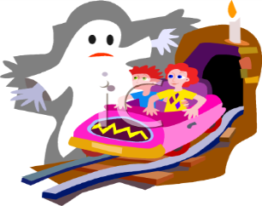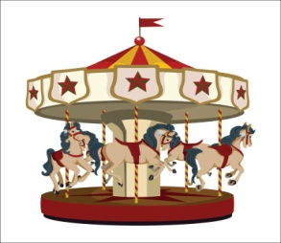
1 token=1TL
All rides only one token
EXCITING ACTIVITIES

H) Matchthedates.
1. 18 Nisan 2011 : ____ a.Thetwentieth of December , eighteen- eightysix
2. 30 Ağustos 1922 :____ b.Thefirst of July , nineteen- eightyfive
3. 1 Temmuz 1985 : ______ c.Thethirtieth of August , nineteen- twentytwo
4. 20 Aralık 1886 :_____ d.Theeighteenth of April , twothousandandeleven.
CEVAP ANAHTARI ;YOUTUBE NURFER TAVŞANKORU

