……………………….. ACADEMIC YEAR AKINCILAR IMAM HATIP SECONDARY SCHOOL
5th GRADES 2nd TERM 1st WRITTEN ENGLISH EXAM
Name: Surname: Class: Number:

- MATCH THE ILLNESSES WITH THE PICTURES. (15P)
toothache headache stomachache broken leg the measles

 |  | 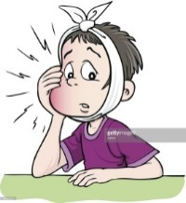 |  | 

- WRITE “SHOULD” OR “SHOULDN’T”. (15P)
- We ___________________ drinkcoke.
- They ____________________ do theirhomework.
- Ali has a runnynose, he _______________________ take a tissue.
- Ayşe has themeasles, she ___________________ gotoschool.
- Theclass __________________ standupwhentheirteachercomes in.

- MATCH THE WORDS WITH THE PICTURES. (12P)
*Romantic *cartoon *horror *science fiction *comedy *animation

 |  |  |  |  | 

- Matchquestionsandanswers.(15p)
______1. Whatkind of movies do youlike?  ______ 2. What is themovieabout?  ______ 3. What is yourfavoritemovie?  ______ 4. What time is themovie?  ______ 5. Do youlikehorrorfilms? | - It is at 2.30.  - It is aboutwar.  - I likecomedymovies.  - It is Hababam Sınıfı.  - No, I don’t .
- Look at the poster andanswerthequestions.(16p)
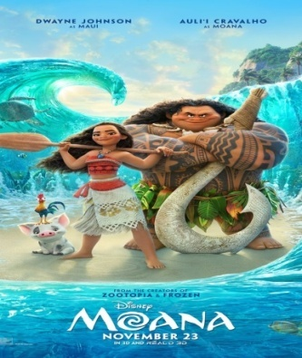 | 1.What’s the name of the film?  2.What type of film is it?  3. What time does itstart?  4.When is the film on?
Moana
23rd November
Time: 10:30p.m.

- Match the party items with the pictures.(12p)
* invitation card * party hats * gift *balloons *birthday cake *candles

 |  |  |  |  | 

- Match adjectives with the pictures.(15p)
Evil - beautiful - funny - strong - honest

 |  |  |  | 

FATMA ÖZHAN
ENGLISH LANGUAGE TEACHER

