Name:
2020-2021 Academic Year …………………..Secondary School
5th Grades English 2stTerm 1st Written Exam

Number:
A)Look at the poster and complete the table.(Postere bakıp tabloyu doldurunuz.) (5x3=15)
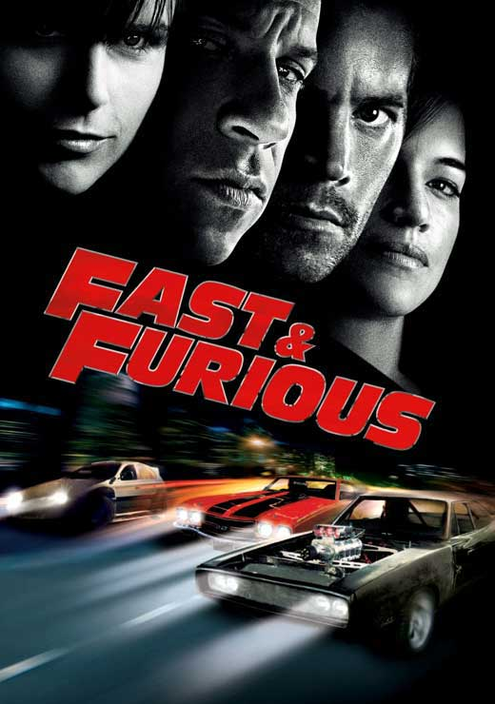
action
06.00pm

Name of the movie
Type of the movie
Time
Place
It’s about

cars
17 Burda Movie Theatre

B)Match the words with the pictures.(Kelimeleri resimlerle eşleştiriniz.)(5x2=10)
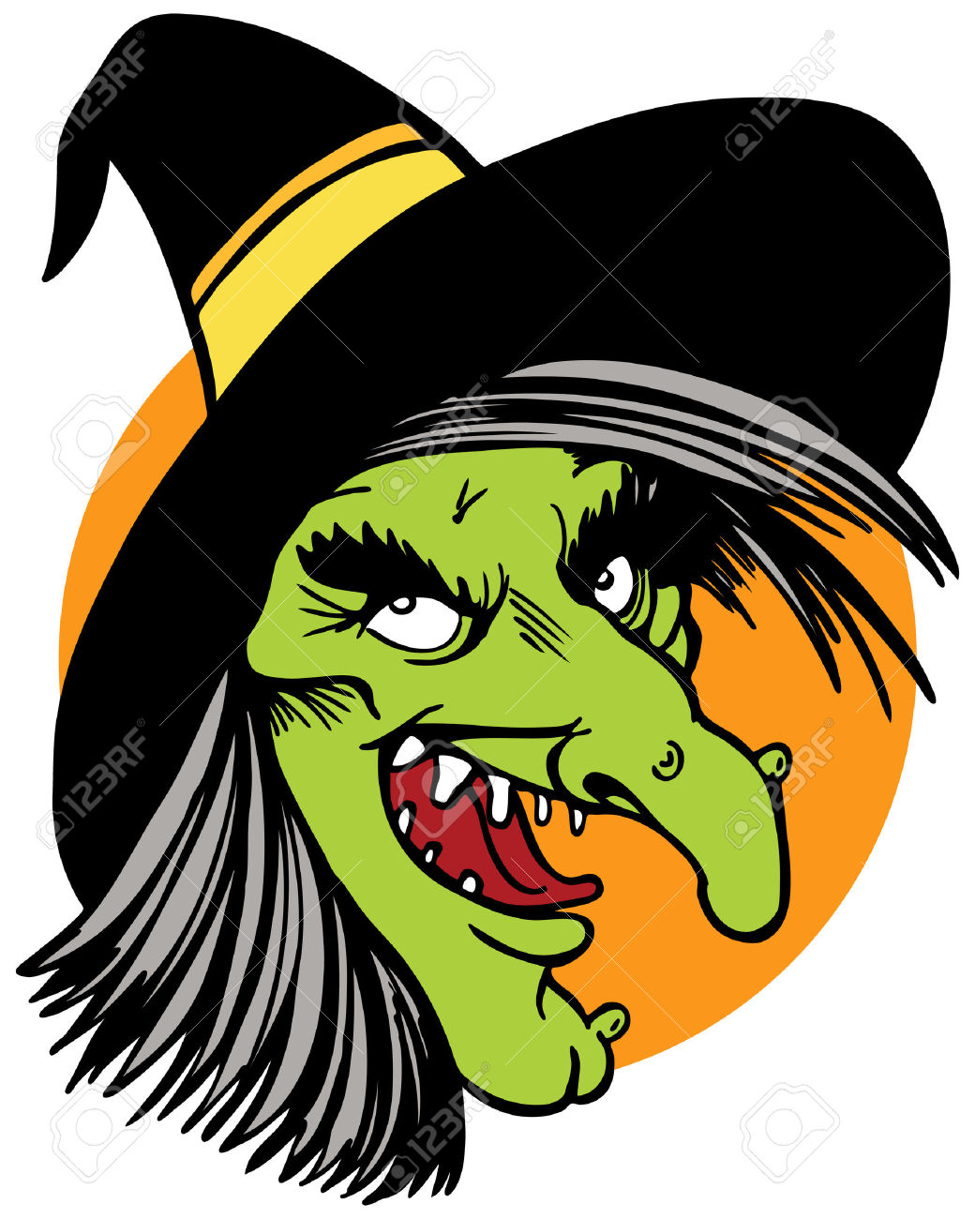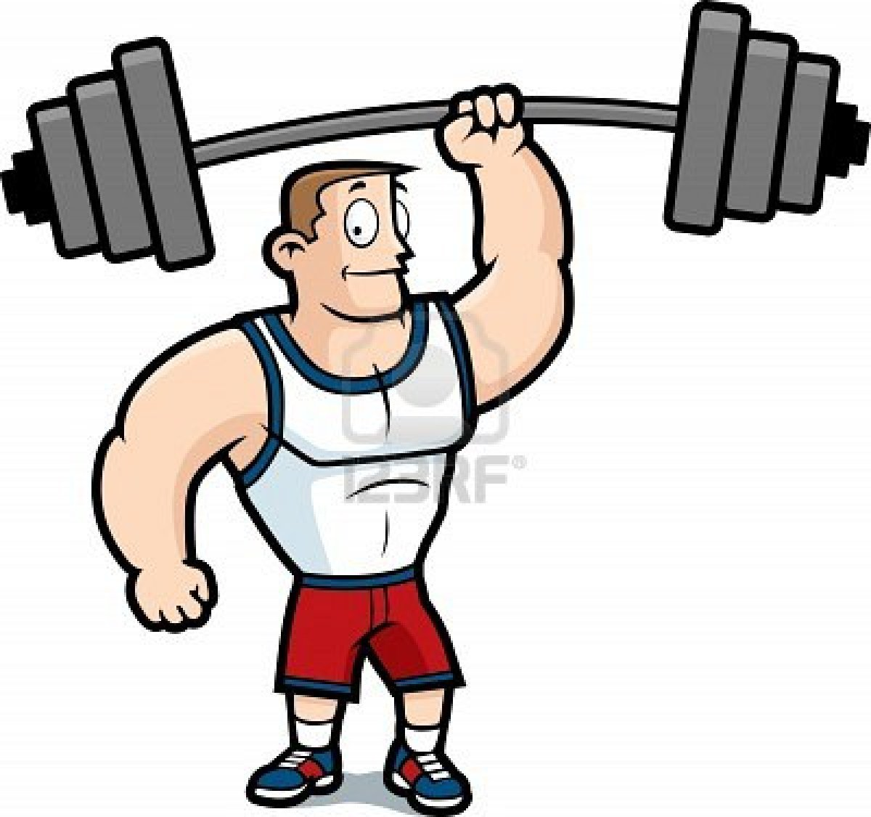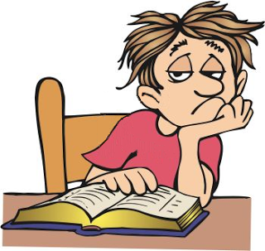
_______________ _______________ _______________ _______________ ________________
strong - boring - funny - ugly - beautiful

*cars *action
*animals *boring
*animation *drama
*funny *exciting
* comedy *a professor and a dog

C)Group the words.(Kelimeleri gruplandırınız.)(10x2=20)
Types of movies | The movie is about … | I think it is …..
D)Match the part items.(Parti ile ilgili kelimeleri eşleştiriniz.) (5x2=10 pts)





invitation card - birthday cake - candles - balloons - gift

E) Circle. (Koyu renkle yazılan kelimelerden doğru olanı daire içine alınız.) (6x3=18pts)
1.I don’t like Garfield because he is lazy / friendly. 2. I like Keloğlan because he is friendly / evil
3.Pinocchio isn’thonest / brave. 4. I hate Gargamel because he is funny / evil
5.Superman is a lazy / strong character. 6. Balkız is helpful / boring.

F)Choose the correct answer.(15x2=30)
1.A:…………………………………………….?
B:I have a stomachache.
a)What is the matter with you? c)Where are you from?
b)How old are you?d)What should I do?
2.Jack has a toothache. What should he do?
a)He should get a blanket c)He should drink cough syrup
b)He should see a dentist d)He should go to school
3.Resme uygun şıkkı işaretleyiniz.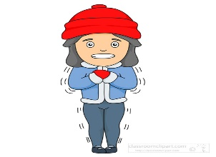
a)I have a runny nose c)I feel cold
b)I have a toothached)I have a terrible pain in my back
4.A:I have the measles.I shouldn’t go to school.
B:Oh! I ‘m really sorry to hear that. ______________.
a)Happy birthday to you. c)What’s the problem?
b)Get well soond)Sounds great!
5.I have a ____________.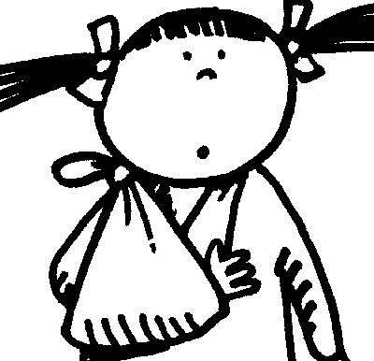
a)headache b)fever c)backache d)broken arm 6.These are my ___________.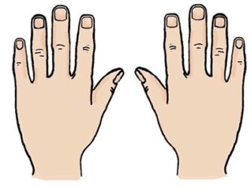
a)hands b)eyes c)legs d)ears
7.A:What kind of movie is it?
B:It is a ____________.
a)comedy b)cartoon c)horror d)love story

8.I think comedy films are ________.
a)funny b)boring c)frightening d)exciting

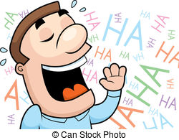

9.A:____9.A>:_______is the movie?
B:It is at B: at7 o’clock.
a)What c)How many b)How d)What time
10.It is an ________movie.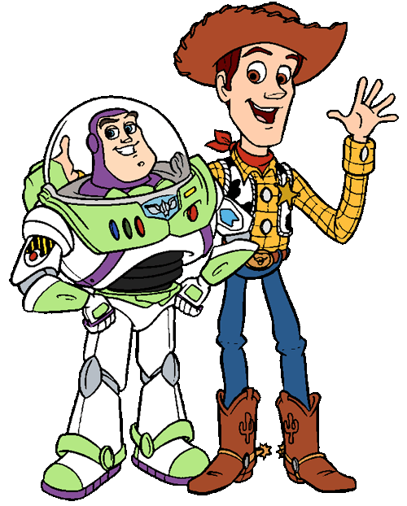
a)animation c)drama
b)science fictiond)horror
11.I don’t like dramas.I think they are_______.
a)exciting c)boring
b)funny d)interesting
12.She is __________.
a)ugly c)beautiful
b)brave d)honest
13.They are __________.
a) birthday cake c) balloons
b)candles d)invitation cards
14.A:__________ is your birthday?
B:It is in November.
a)What b)When c)What time d)Where
15.It is a /an _______.
a)party hat c)clown
b)present d)invitation card
 GOOD LUCK!
CEVAP ANAHTARI
YOUTUBE NURFER TAVŞANKORU

