……………….. EDUCATION YEAR
MAKBULE SÜLEYMAN ALKAN SECONDARY SCHOOL
2nd TERM 1st ENGLISH EXAM
5th GRADES – Elective Classes


A) Read the text and complete the sentences.( 30 pts.)
Hello! I’m Alan.I’m 13 years old. My birthday is in December.

I like reading books and riding bike. I can play basketball,
but I can’t swim. I have a sister. Her name is Jennie.
She is 5 years old. Her birthday is in August.
She likes watching cartoon, but she doesn’t
like playing computer games. She can dance.

1) Alan is ............. years old.
2) He likes .................................................. and riding bike.
3) Alan can ........................................................., but he can’t swim.
4) His sister is ............... years old.
5) Her birthday is ............ August.
6)Jennie likes .............................. cartoon.

B) Write the names of the games or activities.(24 pts.)
play the piano –draw pictures-play hopscotch–swing–play tennis– scubadive–go bowling– do origami



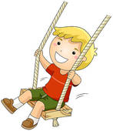


.......................... ................................... ................................ ...............................


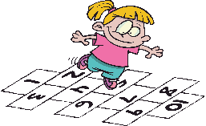

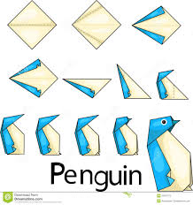

C) Answer the questions about the movie.( 20 pts. )
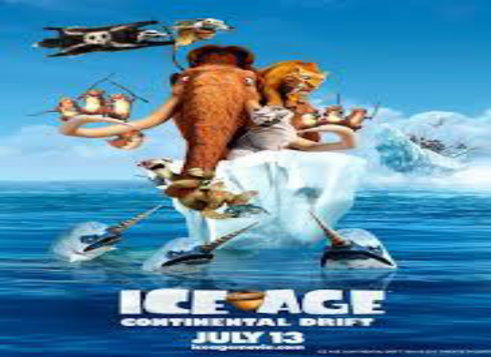
ICE AGE
CHARACTERS: Ray Ramano,Dennis Leary
TYPE : Animation ,Adventure
Time: 15.30

1) What‘s on at cinema? …………………………………...........
2)Who are the main characters?............................................
3) What kind of movie is it? .....................................................
4) What time is the film? ...........................................




D) Answer.( 10 pts.)cartoon
1) What type of movie do you like ? western
I like ..............................

2) What is your favourite party activity ?
My favourite activity is .................... taking photos


dancing

eating cookies opening gifts

E) Write the names of the party materials.( 16 pts.)


cakehats

balloons
candles
gifts
clown
.....................
.........................




........................... ...................

ELTeachers
F) Choose the best answer.( 14 pts.)



1)A : What is your hobby? a)b) c)
B : I like skipping rope.

2) Backgammon,chess and checkers are ........................... games.
a) indoor b) board c) outdoor


3) Jane hates ............... swimming.
a) doing b)playing c) going




4) Mary : What’s the matter with her ? a) b) c)
Sandy : Oh ! She has runny nose ?


5) John : I have got a cold.
Doctor : You should .....................................

a) drinkmint and lemon tea b) use a plaster c) not carry heavy things.


6) Tom and Jerry is a .................. movie.
a) horror b) animation c) cartoon

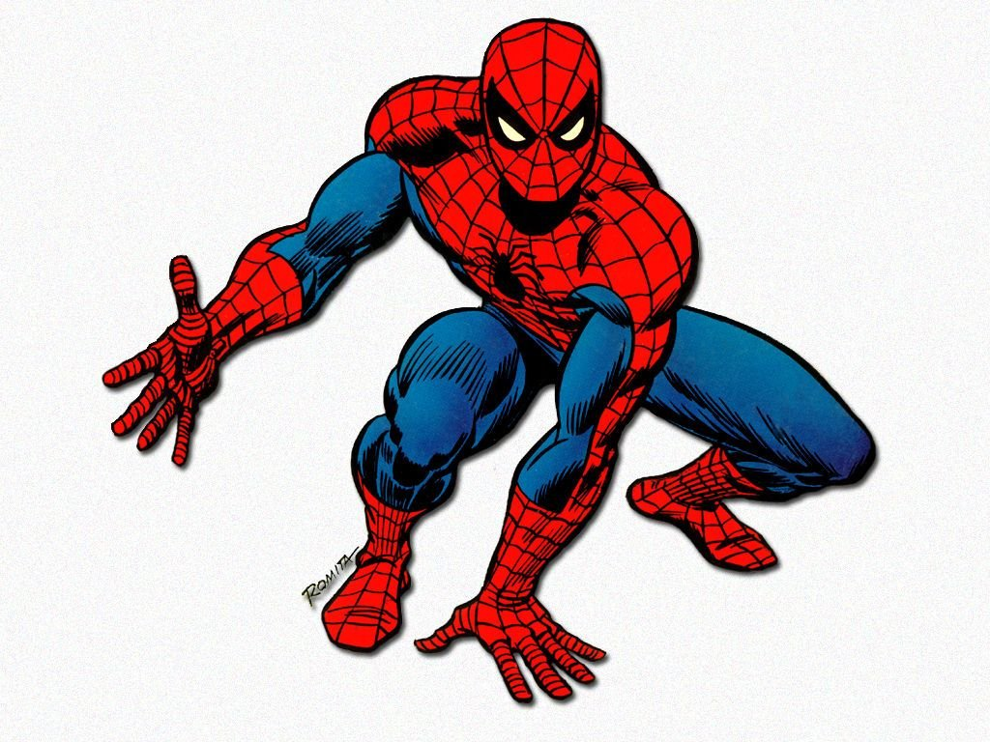
Good luck !

7) Mike : What is Spiderman like ?
Gary : I think he is............................ELTeacher
Özlem Münire NARDALI
a) brave b) liar c) cruel

