…………………….. EDUCATION YEAR ATATÜRK SECONDARY SCHOOL
5th GRADE 1st ENGLISH EXAMINATION
NAME-SURNAME: ……………………………………….. NUMBER: ………………… CLASS: ………………..

A. MATCH THE QUESTIONS WITH THE ANSWERS. (10P)
1. What time does it start? (………) a. It’s a horrormovie.
2. What is themovieabout? (………) b. I have a fever.
3. What’sthematterwithyou? (……….) c. He needsmedicine.
4. Whattype of movie is it? (……….) d. Itstarts at sixo’clock.
5. Whatdoes he need? (……….) e. It’sabout a beautifulgirland a brave boy.
B. WRITE ‘’SHOULD / SHOULDN’T’’. (10P)
1. Asude: I have a fever.Oğuzhan: You ______________ see a doctor.
2. Asime: I have a backache Mahmut: You ______________ carry heavy things.
3. Güner: I feel cold. Ali Kaan: You ______________stay in bed.
4. Neslihan: I have a sore throat.Elif:You _______________drink cold water.
5. Hilal: I have a toothache. Necati: You ________________go toa dentist.
C.WRITE THE MISSINGS WORDS.(Findouttheopposites of theadjectives)
CHOOSE FROM THE LIST. (10P)
1. __________xugly
Good– hardworking – beautiful -Strong- rude
2. __________xbad
3. __________xweak
4. __________ xlazy
5. __________ x kind
D. MATCH THE WORDS WITH THE PICTURES. (10P)
a.Romanticb.cartoonc.horrord.science fiction e.comedy f. animation
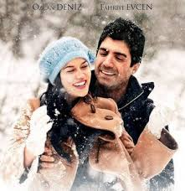
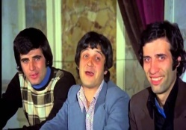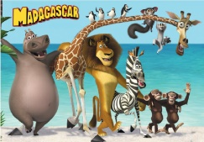

E.MATCH THE ILLNESSES WITH THE PICTURES. (10P)
a.toothache b.headachec.stomachached.broken leg e.backachef.the measles

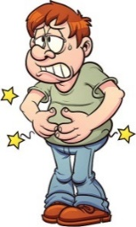
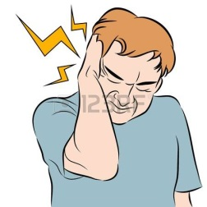


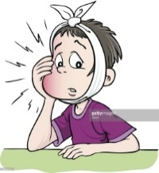
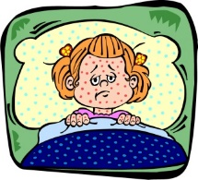

F. MATCH THE ILLNESSES WITH THE SUGGESTIONS. (10P)
a. You should take an aspirin. (……………)
b. You shouldn’t eat chocolate. (……………)
c. You shouldn’t carry heavy things.(……………)
d. You shouldn’t drink cold water. (……………)
e. You should get a blanket. (……………)
1. I have a toothache.
2. I have a sore throat.
3. I feel cold.
4. I have a headache.
5. I have a backache.

G. MATCH THE WORDS WITH THE PICTURES. (10P)
Evil-beautiful- weak - brave - honest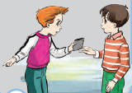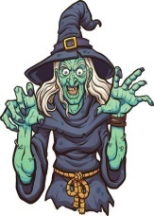
……………….………………………….…………………………..…………………………………
H.Match the party items with the pictures.
(Parti malzemelerini resimlerle eşleştirin.)(7x2=14pts)
invitation card party hats gift balloons
birthday cake candles clown


1.__________ 2.______ 3. _______ 4._______ 5. ______ 6_______ 7_____

I-Matchthewordsfromthephrases. (5x2=10)

- Arrange a. thebeverages
- Throw b. Thepartyroom
- Buy c. Theclown
- Decorate d. a party
- Call e.themusic

J-Choosethecorrectoption (2x3=6points)

1) Adam:…………………………………..?
Bill: It’s on the 13th of November.
A. What is yourname C. What is thedatetoday
B. How oldareyou D. When is yourbirthday

2. A: What is the fourth month of the year?
B: It is ………………..
- September c)November
- April d)December

