**………SECONDARY SCHOOL**

**4thGRADES2ndTERM 1stENGLISHEXAMINATION**

**A).Görseller ile bulundukları yerleri eşleştiriniz.(12P)**

**in -in front of - on - behind - under - near**

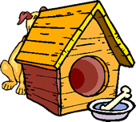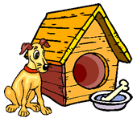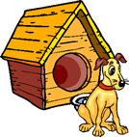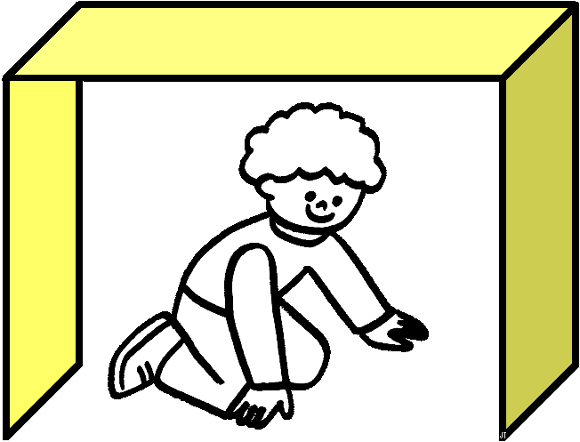



jar —beans —goggles—soil —pebbles

**B). Yönergeleri resmin altına yazınız. (16P)**

**\*mix red and yellow *cut the paper *shake the bottle *plant beans**

**\*do an experiment *wear your goggles *fold the paper *water the plant**

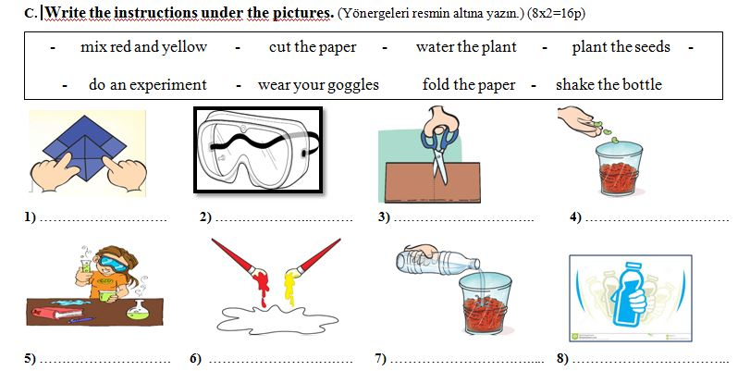**C). Uygun kelimeleri altlarına yazınız. (5P)**

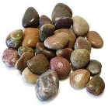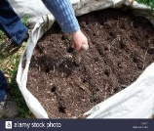

**D).What time is it? Saatin kaç olduğunu yaz. ( 8P)**

|  |  |  |  |  |
| --- | --- | --- | --- | --- |
| What time is it? | What time is it? | What time is it? | What time is it? | |
| 3 |  | http://t1.ftcdn.net/jpg/00/42/60/38/400_F_42603858_cbdfZUiYngNELfeNNnzh0ONmqORQp1MH.jpg | | Time0100 |
| It’s………..o’clock. | ……………………….. | ……………………….. | | ……………………….. |

**E). Cümlelerindevamını tablodan bularak yanlarına yazınız.( 10P)**

I work at a post office.

I work on a farm.

I work at a hospital.

I work at a police station.

I work at a fire station.

**I’m a fireman.______________________**

**I’m a postman._____________________**

**I’m a policeman.___________________**

**I’m a farmer._______________________**

**I’m a nurse.________________________**

**F). Günlük işleri anlatan cümlelerin rakamlarını ilgili resimlerin kutusuna yazarak sıralayınız. ( 6P)**

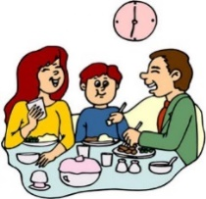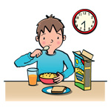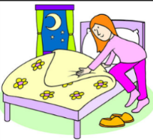

**1**

1. I read a book. **4.**I have dinner with my family.
2. I have breakfast in the morning. **5.**I go to bed atnight.
3. I wake up in the morning. **6.**I do my homework.

**H) Fill in the blanks with words**

**-primary – nice –doctor – meet– what – name – hospital –teacher –job-my-**

A: Hi, my name is Uğur. What’s your …………….………?

B: ……………..….. name is Lily,……….…… to meet you Uğur. ……………..….. do you do ?

A: I’m a ………….………….. I work at İstiklal ………..………. School.What is your ………………..?

B: I’m a ………………..…….. I work at Atatürk ……………..……..

A: Nice to …………..………. you.

**I) KELİMELERİ SIRAYA KOYARAK ANLAMLI CÜMLELER YAZINIZ.**

**1. cut / the /don’t / paper/ : …………………………………………………………..**

**2. day / water /every / plant / the / : ………………………………………………..................**

**3. the bag / where / is / ? : ……………………………………………………………**

**4. teacher / is / my / a / sister / : ……………………………………………………………**

**5. does / like / what / he / ? : ……………………………………………………………**

**J). Answerthe test.(6x2=12P)**

|  |  |  |  |  |  |
| --- | --- | --- | --- | --- | --- |
| http://static.arttoday.com/thm/thm11/CL/5433_2005010014/000803_1056_53/000803_1056_5376_v__v.thm.jpg**1) What is yourjob?**   |  |  | | --- | --- | | **A)** My name is Ali. | **B)** Hello! | | **C)** I am policeman. | **D)** Goodmorning. | | Açıklama: 7478a6163aca457d8c37bd09cd2d5d6d**2) Verilen görselin aşağıdaki mesleklerden hangisi ile ilgisi yoktur? (5P)**  **A**) Doctor **B**) Writer  **C**) Vet **D**) Nurse |
| **3)** “I wakeupearly......................”  **Resme göre boş bırakılan yere aşağıdakilerden hangisi getirilmelidir?**  **A) at nightB) in themorning**  **C) in theafternoonD) in theevening** | **4)Resimde gördüğümüz çiftçinin çalıştığı yer aşağıdaki seçeneklerin hangisinde verilmiştir?**  **A) Farm B)Hospital**  **C)Theatre D) School** |
| **5)“I can ………..thepaper.”**  **Görsele göre boşluğa hangisi gelmelidir?**  **A)cutB)mix**  **C)foldD)glue** | **6)** A………….. does experiments.  **A)**doctor **B)** vet  **C)** scientist**D)** pilot |

**CEVAP ANAHTARI :YOUTUBE NURFER TAVŞANKORU**