………… PRIMARYSCHOOL ……………… ACADEMIC YEAR 2ND TERM 1ST WRITTEN EXAM FOR 4TH CLASSES

NAME & SURNAME: | CLASS & NUMBER: | Points: .................
pA) Match . (Günleri Türkçeleriyle eşleştirip harflerini kutucuklara yazın. Saatin altına doğru harfi yazın!) 10 P
- 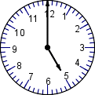Tuesday Pazartesi3 POINTS !
What time is it ?
A.It’s five a.m
B.It’s five p.m
D. It’s a six o’clock.

b. Thursday Cuma

c. Friday Cumartesi

d Monday Salı

e. Saturday Perşembe
B) Write the verbs under the pictures. (Resimlerin altına fiilleri yazınız.) 20 P
GO SHOPPING - WAKE UP - DO HOMEWORK - BRUSH TEETH - WASH FACE – GO TO BED–
HAVE LUNCH – GO TO SCHOOL – WATCH TV – HAVE BREAKFAST

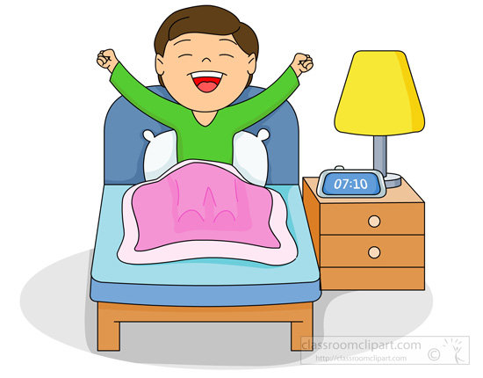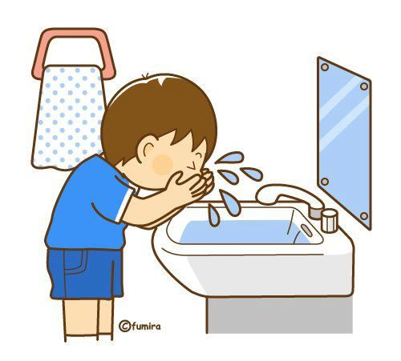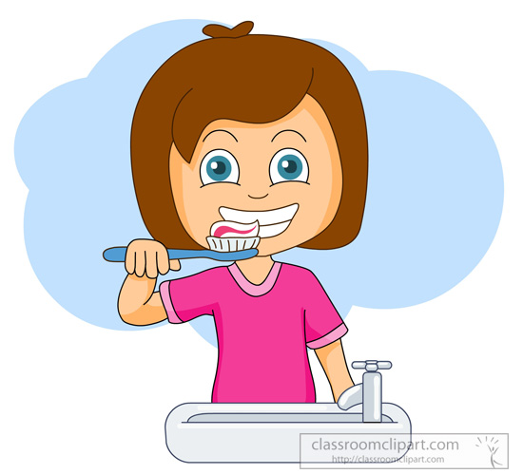
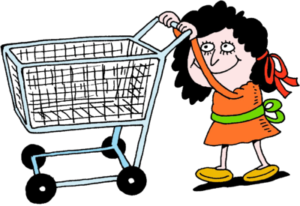

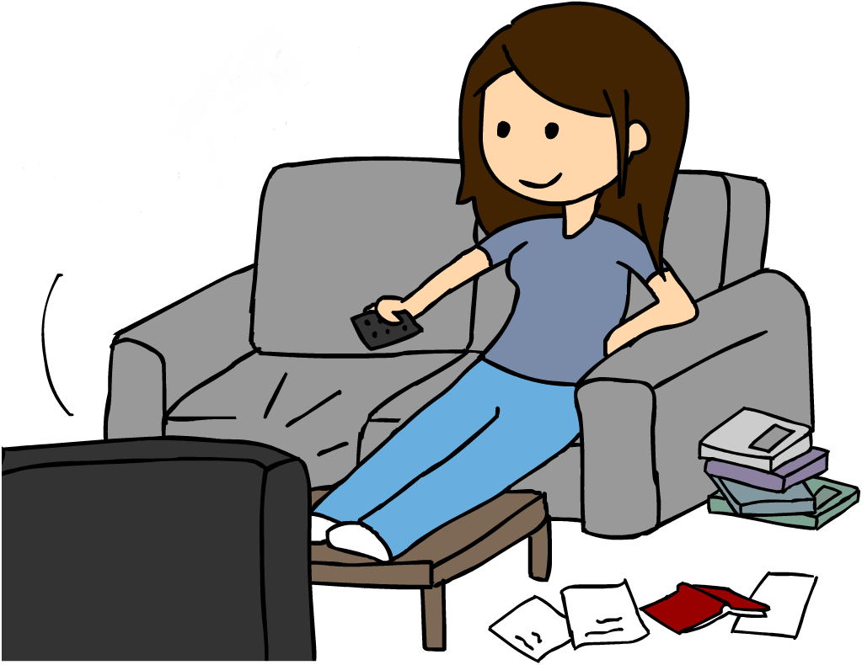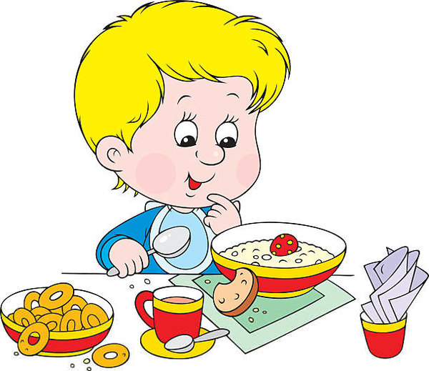………………………….…………………………….…………………………….…………………………….…………………………….
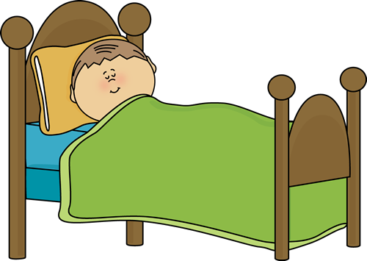

…………………………….…………………………….…………………………….…………………………….…………………………….
C) Fill in the blanks with the right preposition. (Boşlukları uygun edatlarla doldurunuz.) 12 P
IN - ON - UNDER - NEAR - BEHIND - IN FRONT OF
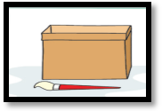  Where is the brush?  It is ……………................... the boX | 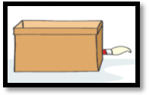  Where is the brush?  It is ……………............. the boX
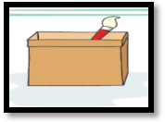  Where is the brush?  It is ……………............. the boX | 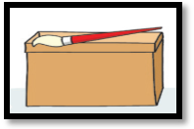  Where is the brush?  It is ……………............. the boX
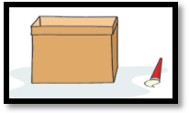  Where is the brush?  It is ……………............. the boX | 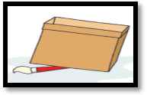  Where is the brush?  It is ……………............. the boX
D)Write the correct word. (Resimlerdeki boşlukları uygun kelimelerle doldurun.) 24P
POLICEMAN – FARM – TEACHER – POLICE STATION – FARMER – SCHOOL – CHEF – FIRE STATION – DOCTOR – RESTAURANT – HOSPITAL - FIREMAN

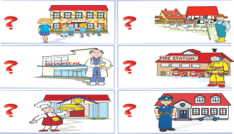

I am a ………………………………… I am a …………………………………….. I am a ……………………………………..
I work at ………………………….. I work on a ………………………………. I work at ………………………….

I am a ………………………………… I am a ………………………………… I am a …………………………………
I work at …………………………… I work at a ………………………….. I work at ………………………………
E) Write the words under the pictures below.(Resimlerin altına anlamlarını yazınız.) 16P.
Fold - Plant - Pour – Food colorings – Drop - Scientist - Goggles – Magnifier - Bottle

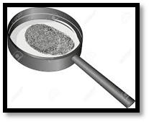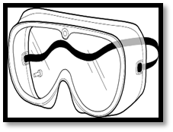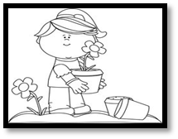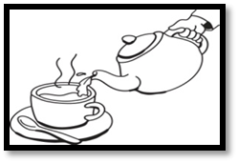

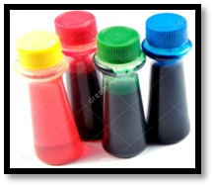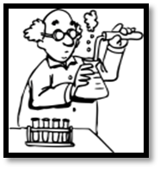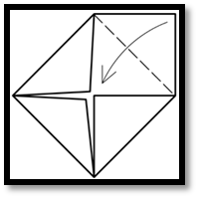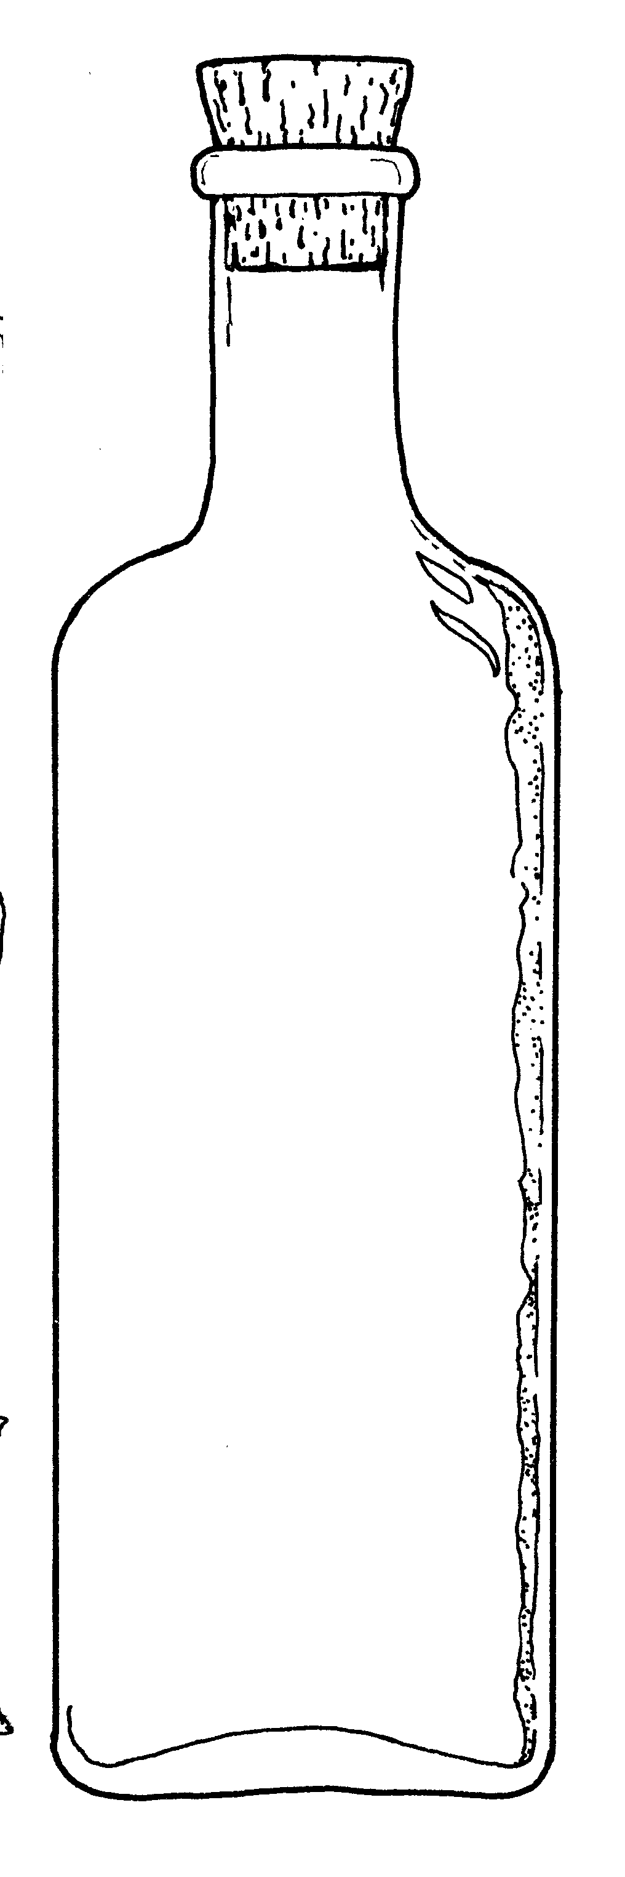

24 P
F. Read, Match and Write. 15P
Where are you from?
- A: …………………………………………………………………
B: I am a teacher.
- A: …………………………………………………………………
What can she do?
Do you like playing tennis?
B: I’m from Germany.
- A: …………………………………………………………………
What doeshe do?
B: He is a writer.
- A: …………………………………………………………………
B: She can speak English and French.
What’s your job?
- A: …………………………………………………………………
B: No, I dislike playing table tennis. ………………………………… – English Teacher

