A.Match the verbs with the pictures. (Resimlerlefiillerieşleştiriniz.) (20P)
1.GO SHOPPING 2.WAKE UP 3.DO HOMEWORK 4.BRUSH TEETH 5.WASH FACE 6.GO TO BED
7.HAVE LUNCH 8.GO TO SCHOOL 9.READ A BOOK 10. HAVE BREAKFAST

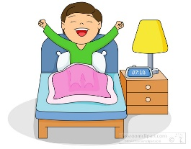
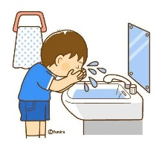

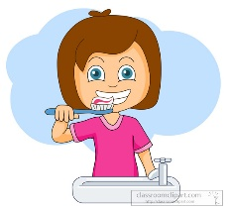
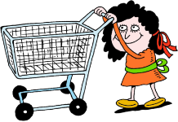





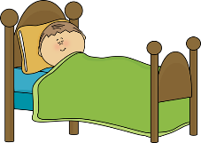

B. Fill in the blanks with the right words.(Boşluklarıuygunkelimelerledoldurunuz.) (20P)
IN - ON - NEAR - BEHIND - IN FRONT OF

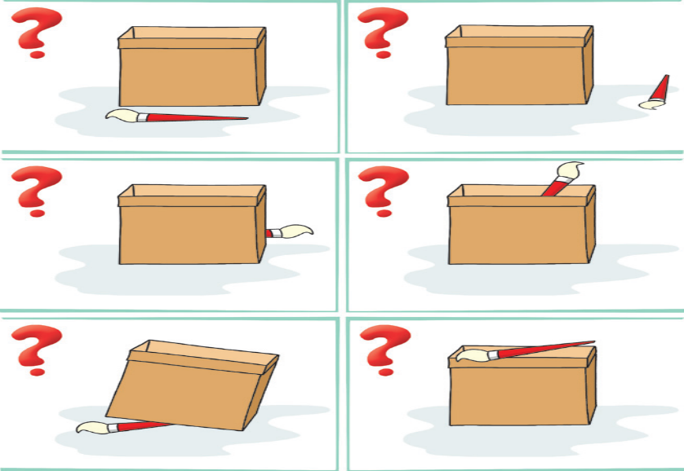  Where is the brush?  It is ……………................... the boX | Where is the brush?  It is ……………............. the boX
Where is the brush?  It is ……………............. the boX | Where is the brush?  It is ……………............. the boX
Where is the brush?
It is ……………............. the boX

C. Match the jobs with the pictures. (Resimlerlemesleklerieşleştiriniz.)(20P)
1. singer 2. nurse 3. fireman 4. chef 5. teacher 6. farmer
7. businessman 8. waiter 9. vet 10. postman
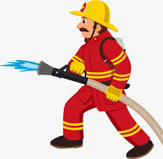




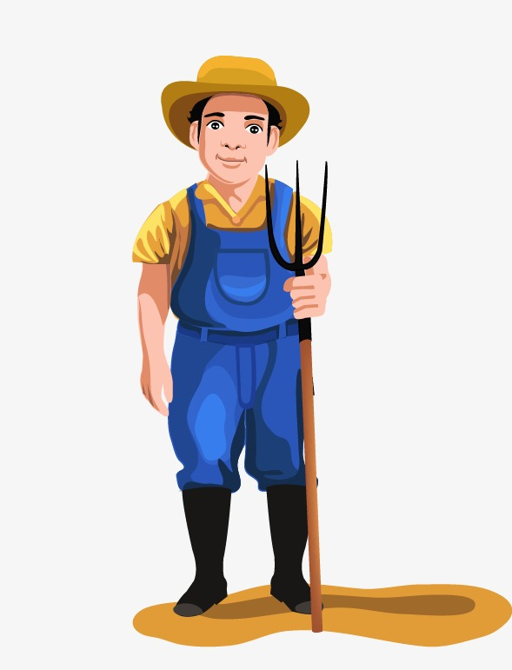

D. Match the words with the pictures. (Kelimelerleresimlerieşleştiriniz.)(20P)
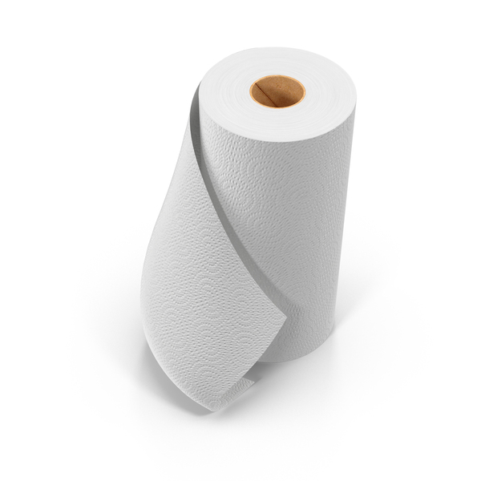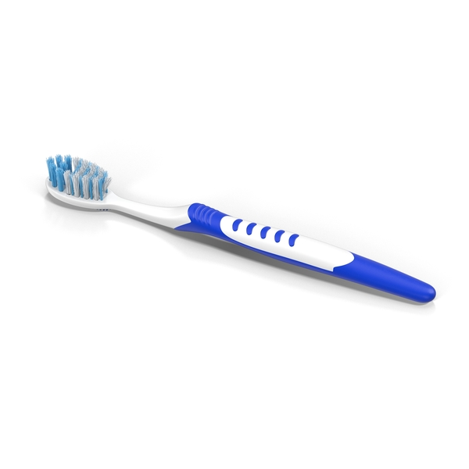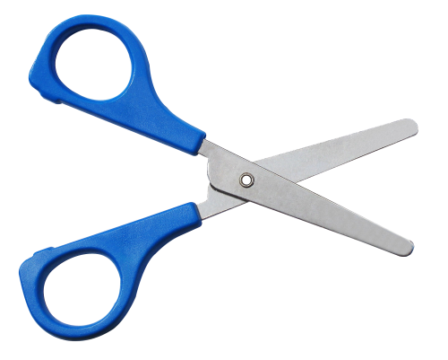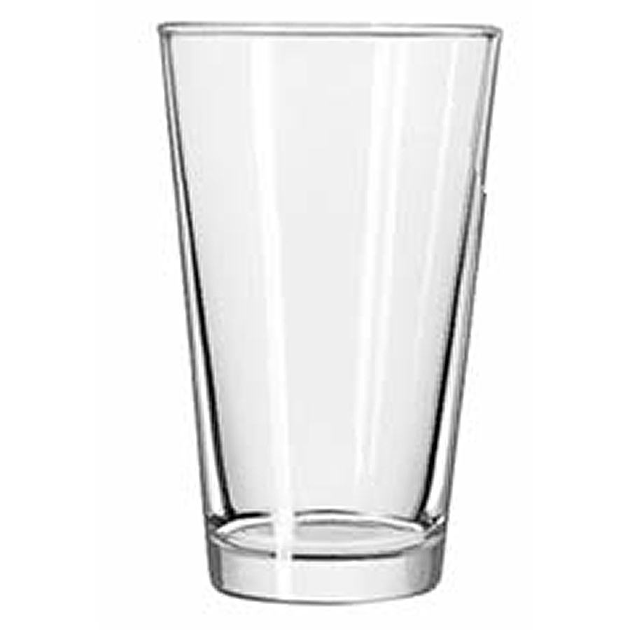1. glass 2. soil 3. paper towel 4. scissors 5.toothbrush

E. Match the times. (Saatlerieşleştiriniz.) (20P)
1. 08:00 a. It is six o’clock.
2. 10:00 b. It is four o’clock.
3. 04:00 c. It is seven o’clock
4. 06:00 d. It is eight o’clock
5. 07:00 e. It is ten o’clock.

