A) Resimlere bakarak hayvanların nerede olduğunu yazınız. 5x3=15

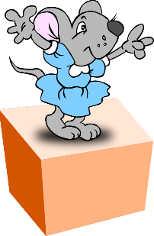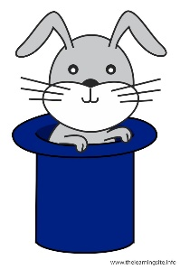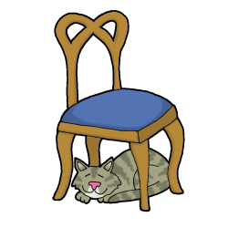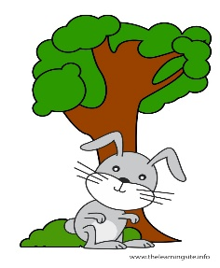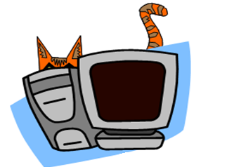
- Themouse is _____________ thebox.
- Therabbit is _______________ the hat.
- Thecat is ________________ thechair.
- Therabbit is _____________________ thetree.
- Thecat is _______________________ thecomputer.
B) Kutunun içindeki kelimeleri doğru resmin altına yazınız. Bir kelime fazla. 5x1=5
microscope - scissors - magnifier - labcoat - bottles - daisy

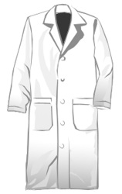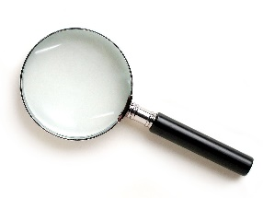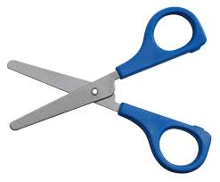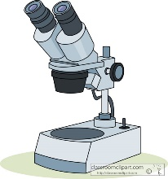
__________ __________ _____________ ______________ ___________
D) Karışık verilen kelimelerle anlamlı cümle oluşturunuz. 5x3=15
C) Kutunun içindeki kelimelerle boşlukları doldurunuz. 5x2=10

reads - go - works -washes - brush - mix

- She ______________ books in theevenings.
- I ______________ toschoolwithmybrother.
- He ______________ in a farmand he drives a tarctor.
- ______________ blackandwhite.
- I ______________ myteeth in themornings.
- She ______________ her faceandhandsafterdinner.

E) Soruların cevaplarını parantezin içine yazınız.5x3=15

1. bed / I / goto / night / at /. / ………………………………………………………………….
2. have / I / breakfast /mymother / with /. /………………………………………………………………
3. is / Where / bottle / the / ? /…………………………………………………….
4.does / work / Where / chef / a / ?/………………………………………………………………….
5. in / the / of / The / front / brush / is/ bottle/./
………………………………………………….

(___) 1) Where is Robert from? a) He drives a bus.
(___) 2) What’syourjob? b) I read a book.
(___) 3) Wheredoesshework? c) Sheworks in a hospital
(___) 4) What do you do afterschool? d) I’m a teacher.
(___) 5) Whatdoes he drive? e) He is fromLondon

F) Doğru olan seçeneği işaretleyiniz.20x2=40

1What is ‘scientist’………..Turkish?
A) of B) at C) on D) in

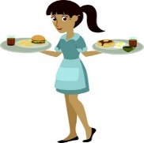
2. She likes……………
A) singing B) teaching children
C) serving food D) dancing
3. Aşağıdakilerdenhangisifarklıdır?
A) airport B) company C) farm D) fireman
4) Mike is a vet. He likes.....
A)flowers B) animals C) cars D) music
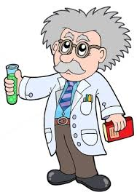
5)Resmianlatankelimeaşağıdakilerdenhangisidir?
A) fireman B) scientist
C) teacher D) worker
6. Don’tmakenoise!
A) Ayağa kalk! B) Camı aç!
C) Gürültü yapma! D) Sınıfta koşma!
7. I likehelpingpeople in thehospital. I am a/an…………….
A) worker B) vet C) nurse D) chef
8. I am a fireman. I like…………….…
A) puttingoutfires. B) doingexperiments
C) flyingplanes D) cooking
9. Mixredandyellow , youget………
A) Brown B) green C) pink D) orange
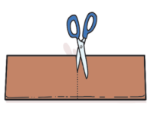
10.Resmianlatanifadeaşağıdakilerdenhangisidir?
A) shake the water B) cover the box
C) cut the paper D) water the plant
11.Aşağıdakilerdenhangisiolumsuzbiryönergedir?
A) Do the experiment B) Don't fold the paper
C) Water the plant D) Cut the paper
12. ………..- Wednesday- …………..-friday
A) Tuesday- Thursday B) Thursday- Tuesday
C) Saturday- Thursday D) Sunday – Monday
13. I wakeup in the……………………
A) evening B) afternoon C) morning D) night
14.What time is it?11:45
a. It is quarterpasteleven. c. It is halfpasteleven.
b. It is quartertotwelve. d. Itquartertotwenty.

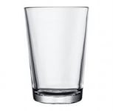
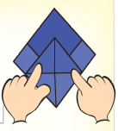
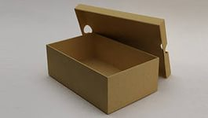

15.Yukarıdaki resimlere göre aşağıdaki
sıralamalardan hangisi doğrudur?
a) box – glass – magnifier-paper
b) glass – box – tape -paper
c) magnifier – box –bottle-glass
d) brush – bottle – magnifier- box
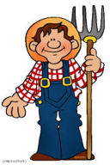
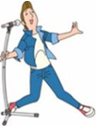
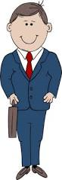
16.resimlerdeki meslekler sırasıyla hangi seçenekte verlmiştir?
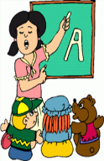


A) farmer-singer-businessman- teacher- waitress
B) teacher-businessman-singer-farmer-waitress
C) teacher- farmer-waitress-singer-businesswoman
D) nurse-doctor-pilot-chef- vet
17. Which is false?(Hangisiyanlış?)
A) Scientists do experiments
B) Policemen like helping people
C) Farmers teach English
D) Farmers like animals
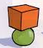
18.Where istheball?
A) It is on thebox. B) It is nexttothebox.
C) It is in thebox. D) It is underthebox
19.what is ‘birşey değil’ in English?
A) Youarewelcome B) Youarewelldone
C) wellcome D) Goodjob
20. Murat is a ……………………….. He likesstudyinglesson. He studies at a school.
A teacher B) student C) farmer D) scientist

