……………………SECONDARY SCHOOL
4thGRADES2ndTERM 1stENGLISHEXAMINATION
NAME & SURNAME: | CLASS & NUMBER: | Mark: .................
A) Match the times. (Saatlerinaltınaharfleriyazarakeşleştiriniz) 10 P
A. It’s half past three.
B. It’s five o’clock.
C. It’s half past nine.
D. It’s a quarter to eight.
E. It’s a quarter past two.
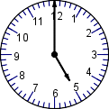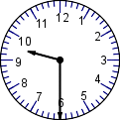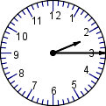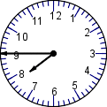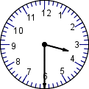

B) Write the verbs under the pictures. (Resimlerinaltınafiilleriyazınız.) 20 P
GO SHOPPING - GET UP - DO HOMEWORK - BRUSH TEETH - WASH FACE – GO TO BED–
HAVE LUNCH – GO TO SCHOOL – WATCH TV – HAVE BREAKFAST

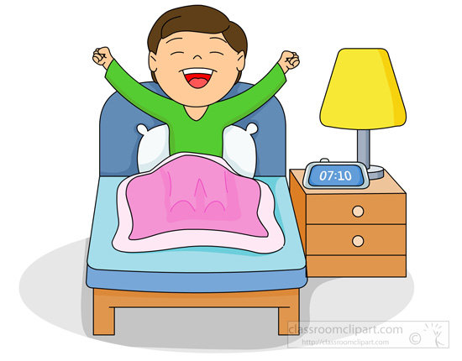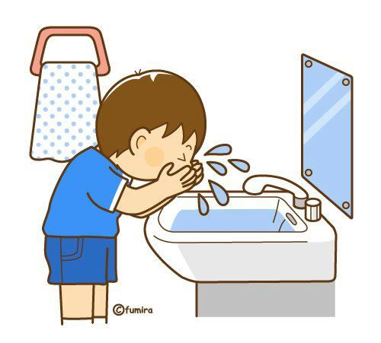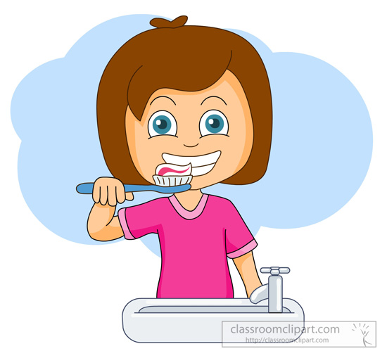
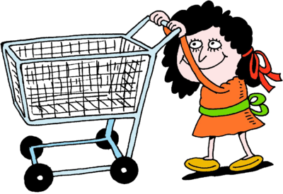

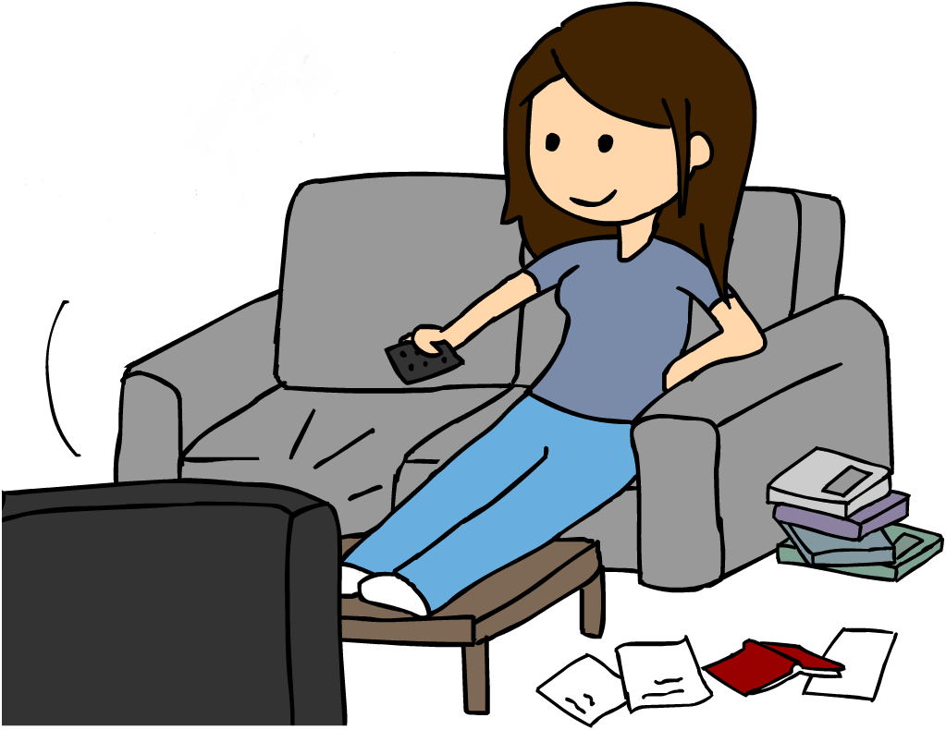…………………………….…………………………….…………………………….…………………………….…………………………….
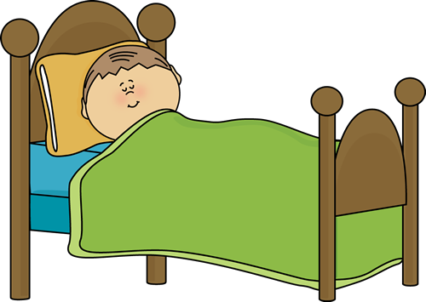

…………………………….…………………………….…………………………….…………………………….…………………………….
C) Fill in the blanks with the right preposition.(Boşluklarıuygunedatlarladoldurunuz.) 12 P
IN - ON - UNDER - NEAR - BEHIND - IN FRONT OF
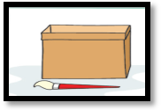  Where is the brush?  It is ……………................... the boX | 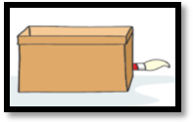  Where is the brush?  It is ……………............. the boX
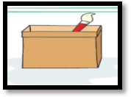  Where is the brush?  It is ……………............. the boX | 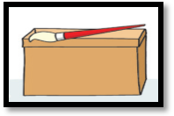  Where is the brush?  It is ……………............. the boX
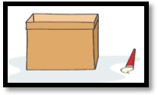  Where is the brush?  It is ……………............. the boX | 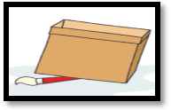  Where is the brush?  It is ……………............. the boX

D)Aşağıdakiresimlerdekiboşluklarıuygunkelimelerledoldurun. 18 P
POLICEMAN – FARM – TEACHER – POLICE STATION – FARMER – SCHOOL – CHEF – FIRE STATION – DOCTOR – RESTAURANT – HOSPITAL - FIREMAN

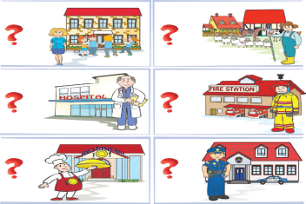

I am a ………………………………… I am a …………………………………….. I am a ……………………………………..
I work at ………………………….. I work on a ………………………………. I work at ………………………….

I am a ………………………………… I am a ………………………………… I am a …………………………………
I work at …………………………… I work at a ………………………….. I work at ………………………………
E) Write and group the MONTHs according to the Seasons below. (AY’larıMevsim’leregöreyaz) 24 P
MARCH – JANUARY – MAY – DECEMBER – NOVEMBER –FEBRUARY – JUNE – APRIL – OCTOBER – AUGUST – JULY - SEPTEMBER

SUMMER (Y)

AUTUMN (S.B)

WINTER (K)

SPRING (İ.B)

1.  2.  3. | 1.  2.  3. | 1.  2.  3. | 1.  2.  3.
F. Read, Match and Write. 15 P
Where are you from?
- A: …………………………………………………………………
B: I am a teacher.
- A: …………………………………………………………………
What can she do?
Do you like playing tennis?
B: I’m from Germany.
- A: …………………………………………………………………
What does she do?
B: He is a writer.
- A: …………………………………………………………………
B: She can speak English and French.
What’s your job?
- A: …………………………………………………………………
B: No, I dislike playing table tennis.

